1 The equation may be rewritten as
1)
2)
3)
4)

2 Which equation represents a graph that has a period of ?
1) | 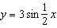
2)
3) | 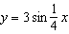
4)

3 Which equation is represented by the graph below?
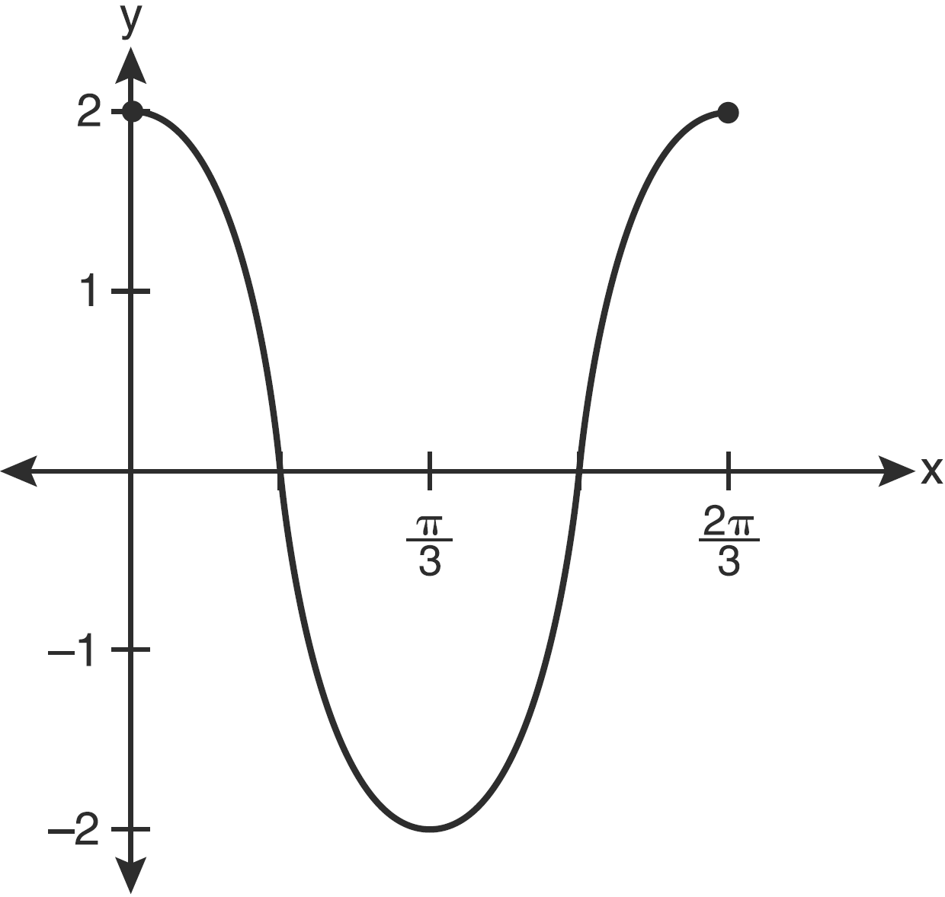
1)
2)
3) | 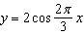
4) | 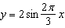

4 Which equation represents the graph below?
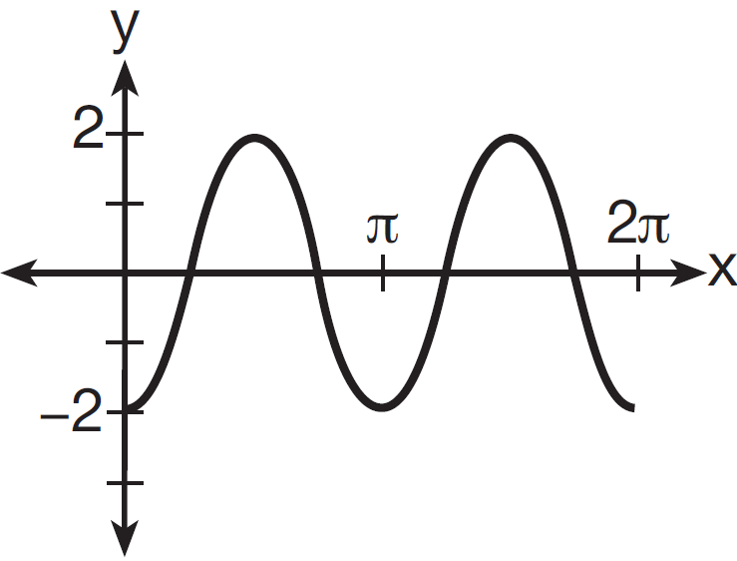
1)
2) | 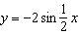
3)
4) | 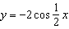

5 The accompanying diagram shows a section of a sound wave as displayed on an oscilloscope.

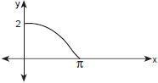

Which equation could represent this graph?
1) | 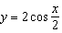
2) | 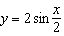
3) | 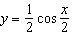
4) | 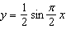

6 A radio transmitter sends a radio wave from the top of a 50-foot tower. The wave is represented by the accompanying graph.
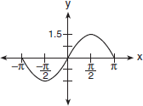

What is the equation of this radio wave?
1)
2)
3)
4)

7 Which equation is represented by the accompanying graph?
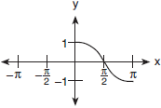
1)
2) | 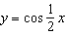
3)
4) | 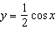

8 Which equation could be represented by the graph below?

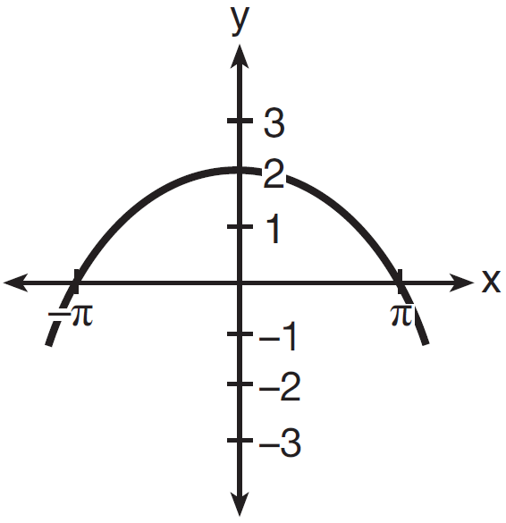
1) | 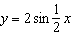
2) | 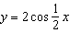
3) | 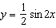
4) | 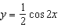

9 In physics class, Eva noticed the pattern shown in the accompanying diagram on an oscilloscope.

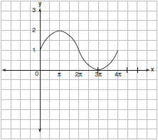

Which equation best represents the pattern shown on this oscilloscope?
1) | 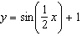
2)
3)
4) | 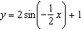

10 The accompanying graph represents a portion of a sound wave.

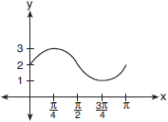

Which equation best represents this graph?
1)
2) | 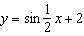
3)
4)

11 Which equation is graphed in the diagram below?

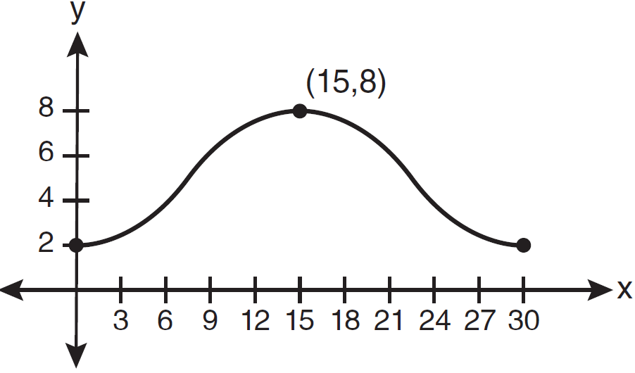
1) | 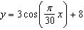
2) | 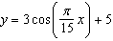
3) | 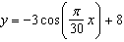
4) | 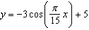

12 Which equation is represented by the graph below?

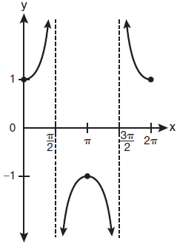
1)
2)
3)
4)

13 Which equation is sketched in the diagram below?

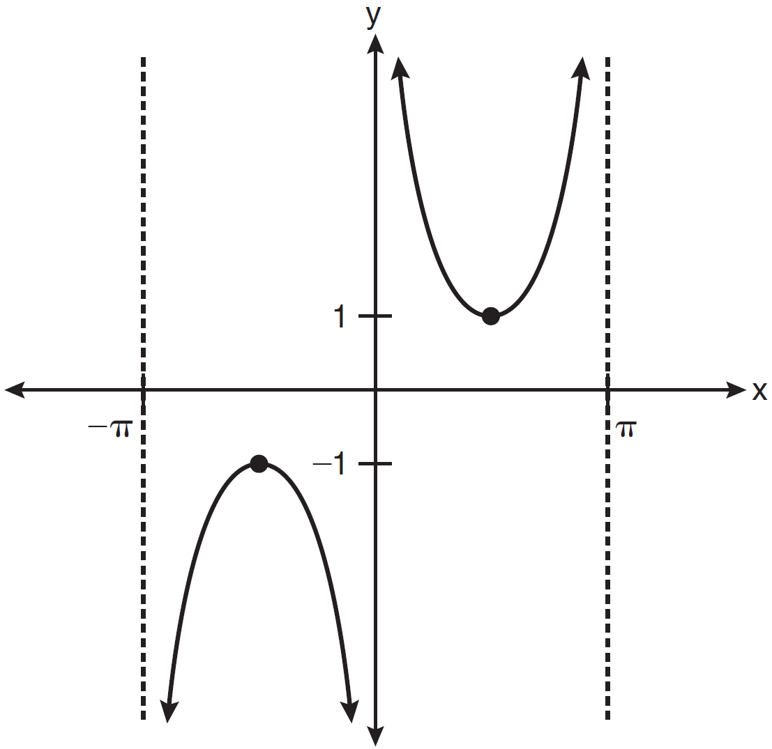
1)
2)
3)
4)

14 Write an equation for the graph of the trigonometric function shown below.

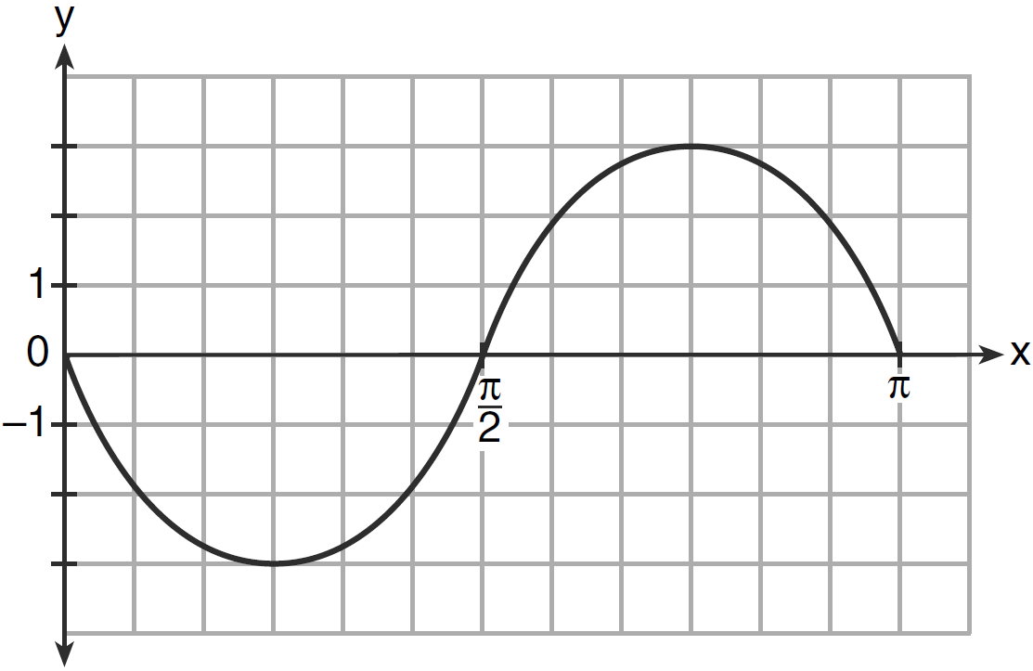

15 The accompanying graph shows a trigonometric function. State an equation of this function.

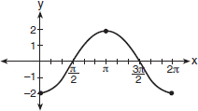

16 A student attaches one end of a rope to a wall at a fixed point 3 feet above the ground, as shown in the accompanying diagram, and moves the other end of the rope up and down, producing a wave described by the equation . The range of the rope’s height above the ground is between 1 and 5 feet. The period of the wave is . Write the equation that represents this wave.

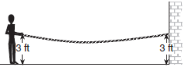

17 The periodic graph below can be represented by the trigonometric equation where a, b, and c are real numbers.

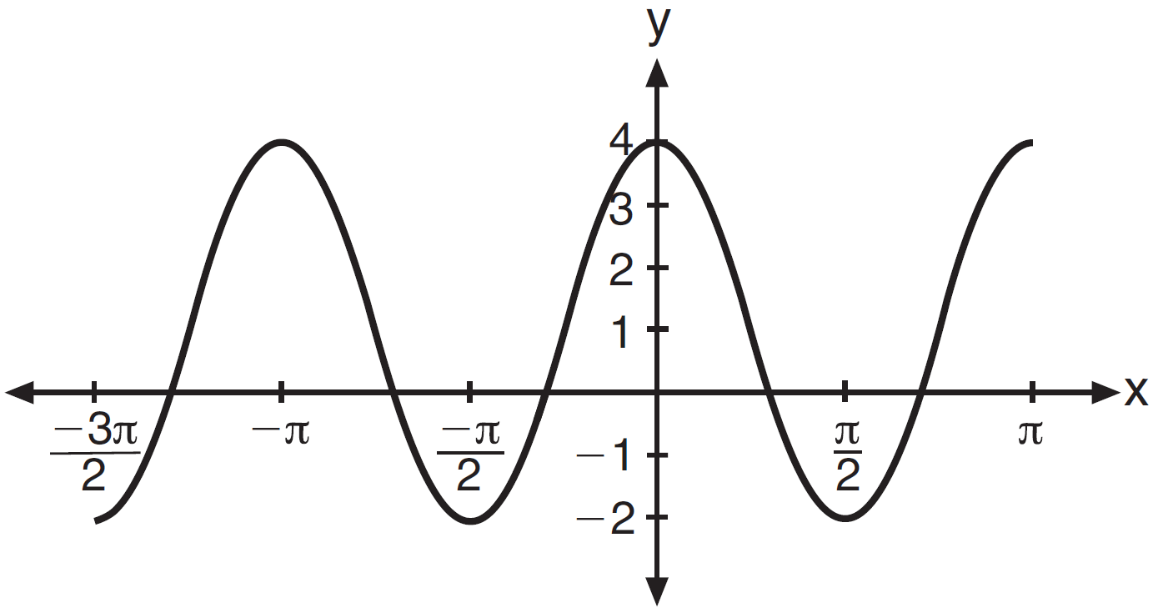

State the values of a, b, and c, and write an equation for the graph.

18 The times of average monthly sunrise, as shown in the accompanying diagram, over the course of a 12-month interval can be modeled by the equation . Determine the values of A, B, and D, and explain how you arrived at your values.

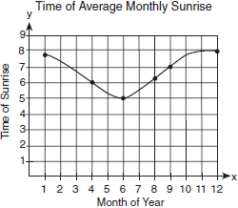

1 ANS: 4
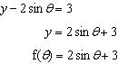

REF: fall0927a2

2 ANS: 1
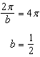

REF: 011425a2

3 ANS: 1 REF: 011320a2

4 ANS: 3 REF: 061306a2

5 ANS: 1
Since none of the answers has a translation, the point (0,2) must result from a dilation of 2 of the cosine function. At x = π, the function is complete, so the period is 4π. 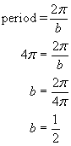.

REF: 010214b

6 ANS: 2
The maximum and minimum of this sine function indicates the amplitude is 1.5.

REF: 060608b

7 ANS: 1 REF: 060711b

8 ANS: 2 REF: 081607a2

9 ANS: 1
The sine function has been translated +1. Since the maximum is 2 and the minimum is 0, the amplitude is 1. .

REF: 010612b

10 ANS: 4
The sine function has been translated +2. Since the maximum is 3 and the minimum is 1, the amplitude is 1. 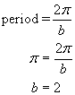.

REF: 080717b

11 ANS: 4
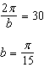

REF: 011227a2

12 ANS: 3
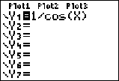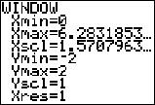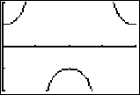

REF: 061020a2

13 ANS: 1
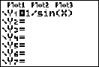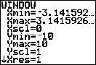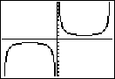

REF: 011123a2

14 ANS:
. The period of the function is , the amplitude is 3 and it is reflected over the x-axis.

REF: 061235a2

15 ANS:
. The period of the function is , the amplitude is 2 and it is reflected over the x-axis.

REF: 080926b

16 ANS:
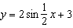. The range of the function is from a minimum of 1 to a maximum of 5. To compute c, average these values: 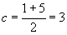. To compute a, the amplitude, find the distance from c to the minimum or maximum. . The period of the function is 4π. To compute b, 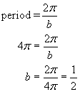

REF: 080330b

17 ANS:
.

REF: 011538a2

18 ANS:
1.5, , 6.5. The range of the function is from a minimum of 5 to a maximum of 8. To compute D, the translation of the function, average these values: 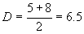. To compute A, the amplitude, find the distance from D to the minimum or maximum. . The period of the function is 4π. To compute B, 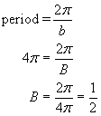

REF: 080127b

