1 Which function's graph has a period of 8 and reaches a maximum height of 1 if at least one full period is graphed?
1) | 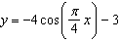
2) | 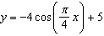
3)
4)

2 The voltage used by most households can be modeled by a sine function. The maximum voltage is 120 volts, and there are 60 cycles every second. Which equation best represents the value of the voltage as it flows through the electric wires, where t is time in seconds?
1)
2)
3)
4)

3 Which equation is represented by the graph shown below?

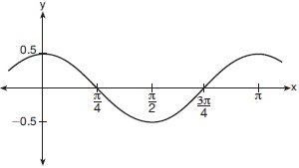
1) | 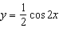
2)
3) | 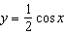
4) | 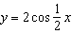

4 The function is plotted on the graph shown below.
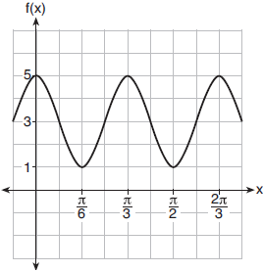
What are the values of a, b, and c?
1)
2)
3)
4) | 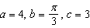

5 A cyclist pedals a bike at a rate of 60 revolutions per minute. The height, h, of a pedal at time t, in seconds, is plotted below.
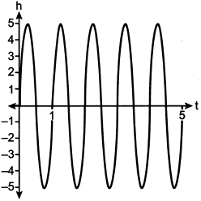
The graph can be modeled by the function , where k is equal to
1) | 1
2)
3) | 60
4)

6 Which equation is graphed in the diagram below?

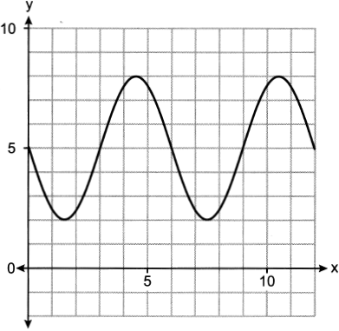

1) | 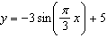
2) | 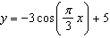
3) | 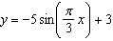
4) | 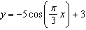

7 The depth of the water at a marker 20 feet from the shore in a bay is depicted in the graph below.

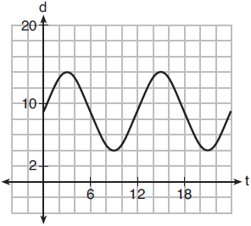

If the depth, d, is measured in feet and time, t, is measured in hours since midnight, what is an equation for the depth of the water at the marker?
1) | 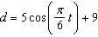
2) | 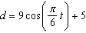
3) | 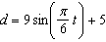
4) | 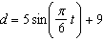

1 ANS: 1
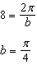

REF: 081820aii

2 ANS: 4
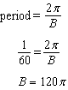

REF: 061624aii

3 ANS: 1 REF: 061708aii

4 ANS: 1
The cosine function has been translated +3. Since the maximum is 5 and the minimum is 1, the amplitude is 2. 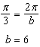.

REF: 011913aii

5 ANS: 2
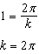

REF: 012313aii

6 ANS: 1
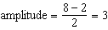, 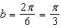, 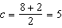

REF: 062403aii

7 ANS: 4
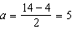, 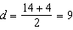

REF: 061810aii

