1 Which diagram represents an angle, , measuring radians drawn in standard position, and its reference angle, ?
1) | 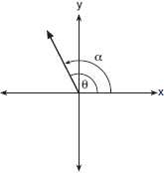
2) | 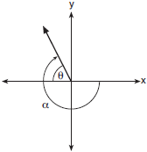
3) | 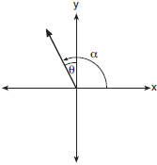
4) | 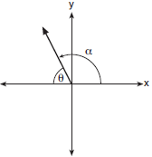

2 is equal to
1)
2)
3)
4)

3 Which expression is equivalent to ?
1)
2)
3)
4)

4 Expressed as a function of a positive acute angle, is equal to
1)
2)
3)
4)

5 The expression is equivalent to
1)
2)
3)
4)

6 Which expression is equivalent to ?
1)
2)
3)
4)

7 Expressed as a function of a positive acute angle, is equal to
1)
2)
3)
4)

8 Which expression is not equivalent to ?
1)
2)
3)
4)

9 Which expression is equivalent to ?
1)
2)
3)
4)

10 Two straight roads intersect at an angle whose measure is 125°. Which expression is equivalent to the cosine of this angle?
1)
2)
3)
4)

11 Expressed as a function of a positive acute angle, is equal to
1)
2)
3)
4)

12 The expression is equivalent to
1)
2)
3)
4)

13 Expressed as a function of a positive acute angle, is equivalent to
1)
2)
3)
4)

14 The expression is equivalent to
1)
2)
3)
4)

15 Express as a function of a positive acute angle.

16 Express as a function of a positive acute angle.

17 Express as a function of a positive acute angle.

18 Express as a function of a positive acute angle.

19 Express as a function of a positive acute angle.

20 Express as a function of a positive acute angle.

21 Sketch an angle of 250° in standard position and then express cos 250° as a cosine function of a positive acute angle.

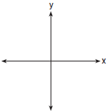

1 ANS: 4 REF: 081707aii

2 ANS: 3 REF: 068429siii

3 ANS: 1 REF: 088915siii

4 ANS: 2 REF: 081515a2

5 ANS: 3 REF: 010418siii

6 ANS: 2
The choices were originally: 1) ; 2) ; 3) ; 4) , so that (2) and (4) were correct responses.
REF: 018919siii

7 ANS: 1
Expressed as a positive angle, . . For the reference angle of a Quadrant II angle, .
REF: 060503b

8 ANS: 4 REF: 010120siii

9 ANS: 4 REF: 060215siii

10 ANS: 4
The terminal side of the angle lies in Quadrant II. 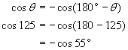
REF: 080511b

11 ANS: 2
REF: 061104a2

12 ANS: 3 REF: 068535siii

13 ANS: 2 REF: 080330siii

14 ANS: 3 REF: 069933siii

15 ANS:
or
REF: 068014siii

16 ANS:
or
REF: 068617siii

17 ANS:
or
REF: 088416siii

18 ANS:
or
REF: 018406siii

19 ANS:
or
REF: 068811siii

20 ANS:
or
REF: 068912siii

21 ANS:
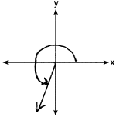
REF: 011734a2

