1 If 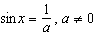, which statement must be true?
1)
2) | 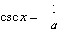
3)
4) | 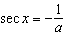

2 The expression is equivalent to
1)
2) | 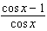
3) | 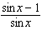
4) | 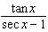

3 For all values of x for which the expressions are defined, is equivalent to
1) | 1
2)
3) | 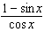
4) | 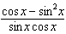

4 The expression is equivalent to
1) | 1
2) | 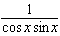
3)
4) | 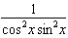

5 The expression is equal to
1) | 1
2) | 0
3)
4) | 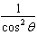

6 The expression is equivalent to
1) | 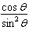
2) | 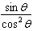
3)
4)

7 The expression is equivalent to
1)
2)
3)
4)

8 Expressed in simplest form, is equivalent to
1) | 1
2)
3)
4)

9 The expression is equivalent to
1)
2)
3)
4)

10 The expression is equivalent to
1)
2)
3)
4)

11 The expression is equivalent to
1)
2)
3)
4)

12 The expression is equivalent to
1) | 1
2)
3)
4)

13 The expression 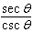 is equivalent to
1)
2)
3) | 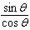
4) | 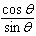

14 The expression 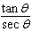 is equivalent to
1) | 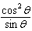
2)
3)
4)

15 For all values of for which the expression is defined, 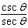 is equivalent to
1)
2)
3)
4)

16 The expression 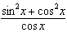 is equal to
1)
2)
3)
4)

17 The expression 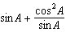 is equivalent to
1) | 1
2)
3)
4)

18 The expression 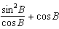 is equivalent to
1) | 1
2) | 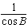
3) | 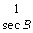
4)

19 If , what is the value of ?
1)
2) | 2
3)
4)

20 If , a value of x is
1) | 35
2) | 45
3) | 55
4) | 70

21 If , then is
1) | 28
2) | 32
3) | 45
4) | 84

22 If , a value of x is
1) | 10
2) | 20
3) | 30
4) | 40

1 : 1
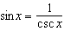.

REF: 060904b

2 ANS: 2
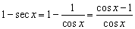

REF: 080813b

3 ANS: 3 REF: 068623siii

4 ANS: 4 REF: 089428siii

5 ANS: 1 REF: 060220siii

6 ANS: 3
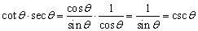

REF: 010915b

7 ANS: 2 REF: 010122siii

8 ANS: 1 REF: 069921siii

9 ANS: 3 REF: 010427siii

10 ANS: 1 REF: 068731siii

11 ANS: 4 REF: 060018siii

12 ANS: 3

REF: 010608b

13 ANS: 3
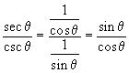

REF: 010402b

14 ANS: 4
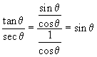

REF: 010508b

15 ANS: 3 REF: 080318siii

16 ANS: 2 REF: 089316siii

17 ANS: 4
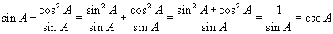

REF: 060720b

18 ANS: 2 REF: 019530siii

19 ANS: 3
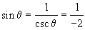

REF: 080703b

20 ANS: 1 REF: 080118siii

21 ANS: 2 REF: 088932siii

22 ANS: 2 REF: 089328siii

