1 Which equation is not true?
1)
2)
3)
4)

2 Which trigonometric expression does not simplify to 1?
1)
2)
3)
4)

3 The expression 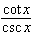 is equivalent to
1)
2)
3)
4)

4 The expression 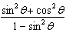 is equivalent to
1)
2)
3)
4)

5 Express , in terms of .

6 Express 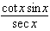 as a single trigonometric function, in simplest form, for all values of x for which it is defined.

7 Show that 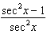 is equivalent to .

8 The exact value of is
1) | 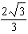
2) | 2
3) | 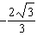
4)

9 Which expression has a value of ?
1)
2)
3)
4)

10 Express the exact value of , with a rational denominator.

11 If angles A and B are complementary, then equals
1)
2)
3)
4)

12 If is acute and 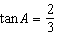, then
1) | 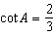
2) | 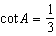
3) | 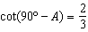
4) | 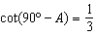

13 If , find the smallest positive value of a, in degrees.

14 Using the unit circle below, explain why 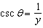.

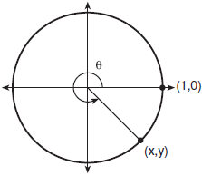

15 Which ratio represents in the diagram below?

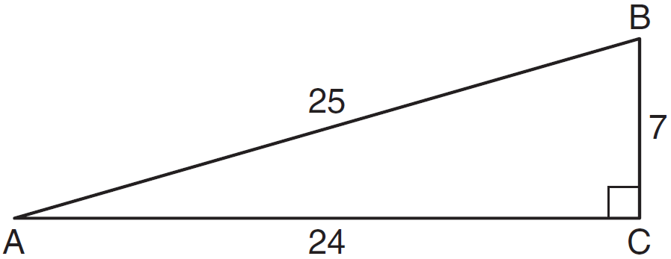
1)
2)
3)
4)

16 In the diagram below of right triangle JTM, , , and .

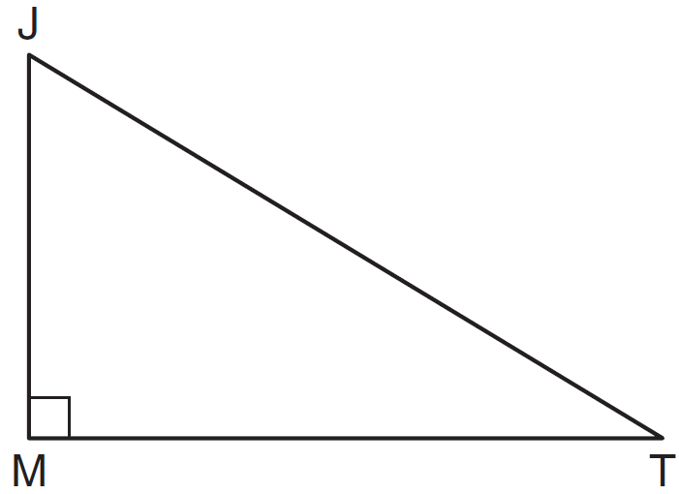

What is the value of ?
1)
2) | 2
3)
4)

1 ANS: 1
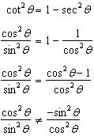

REF: 061626a2

2 ANS: 3
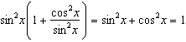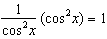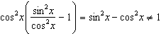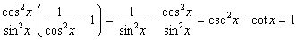

REF: 011515a2

3 ANS: 2
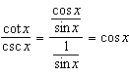

REF: 061410a2

4 ANS: 3
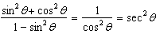

REF: 061123a2

5 ANS:
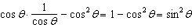

REF: 061230a2

6 ANS:
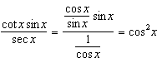

REF: 061334a2

7 ANS:
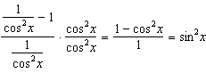

REF: 081533a2

8 ANS: 1
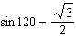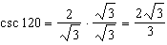

REF: 081505a2

9 ANS: 1 REF: 081613a2

10 ANS:
. If 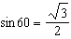, then 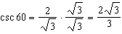

REF: 011235a2

11 ANS: 3
Cofunctions secant and cosecant are complementary
REF: 011625a2

12 ANS: 3
Cofunctions tangent and cotangent are complementary
REF: 061014a2

13 ANS:
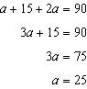
REF: 011330a2

14 ANS:
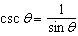, and on a unit circle represents the y value of a point on the unit circle. Since , .
REF: 011727aii

15 ANS: 2 REF: 081010a2

16 ANS: 1
. 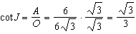
REF: 011120a2

