1 If is an angle in standard position and is a point on the terminal side of , what is the value of ?
1)
2)
3)
4)

2 If the terminal side of angle q, in standard position, passes through point , what is the numerical value of ?
1)
2)
3)
4)

3 If the terminal side of angle passes through point , what is the value of ?
1)
2)
3)
4)

4 A circle centered at the origin has a radius of 10 units. The terminal side of an angle, , intercepts the circle in Quadrant II at point C. The y-coordinate of point C is 8. What is the value of ?
1)
2)
3)
4)

5 Circle O has a radius of 2 units. An angle with a measure of radians is in standard position. If the terminal side of the angle intersects the circle at point B, what are the coordinates of B?
1) | 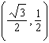
2) | 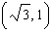
3) | 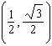
4) | 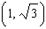

6 If is an angle in standard position whose terminal side passes through the point , what is the numerical value of ?
1)
2)
3) | 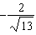
4) | 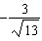

7 Angle is in standard position and is a point on the terminal side of . What is the value of ?
1)
2)
3) | 0
4) | undefined

8 If the terminal side of angle passes through point , what is the value of ?
1)
2)
3)
4)

9 If is an angle in standard position whose terminal side passes through the point , which statement is true?
1)
2)
3)
4)

10 The origin of a coordinate grid is labeled A. Line segment AB forms an angle of 30° with the x-axis. If , the coordinates of B are:
1)
2)
3)
4)

11 An angle, , is in standard position and its terminal side passes through the point . Find the exact value of .

12 If is an angle in standard position and its terminal side passes through the point , find the exact value of .

13 Determine the exact value of if P is an angle in standard position and its terminal side passes through the point .

1 ANS: 3
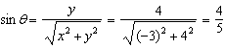

REF: 010616b

2 ANS: 1
A reference triangle can be sketched using the coordinates in the second quadrant to find the value of . 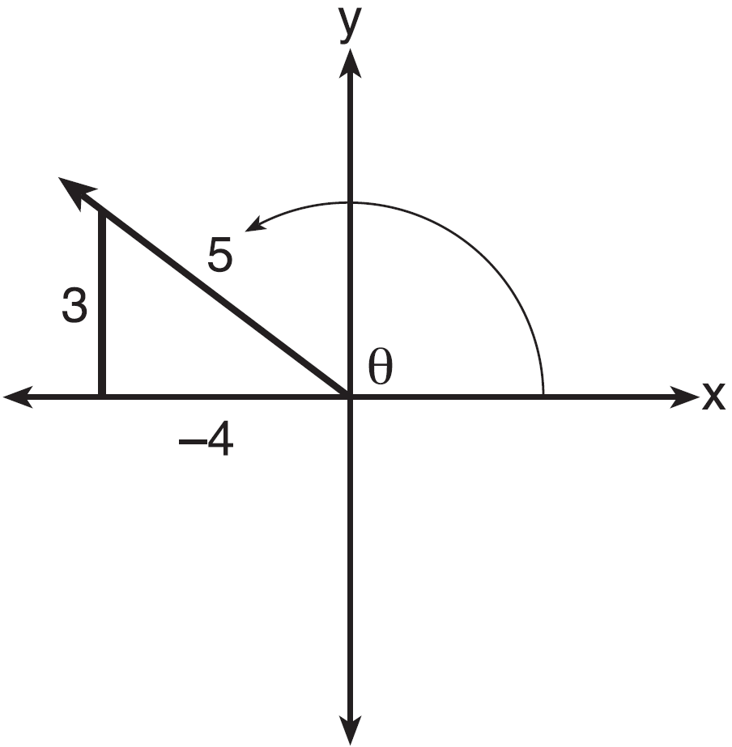

REF: spr1503aii

3 ANS: 4
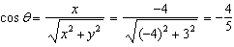

REF: 068628siii

4 ANS: 1
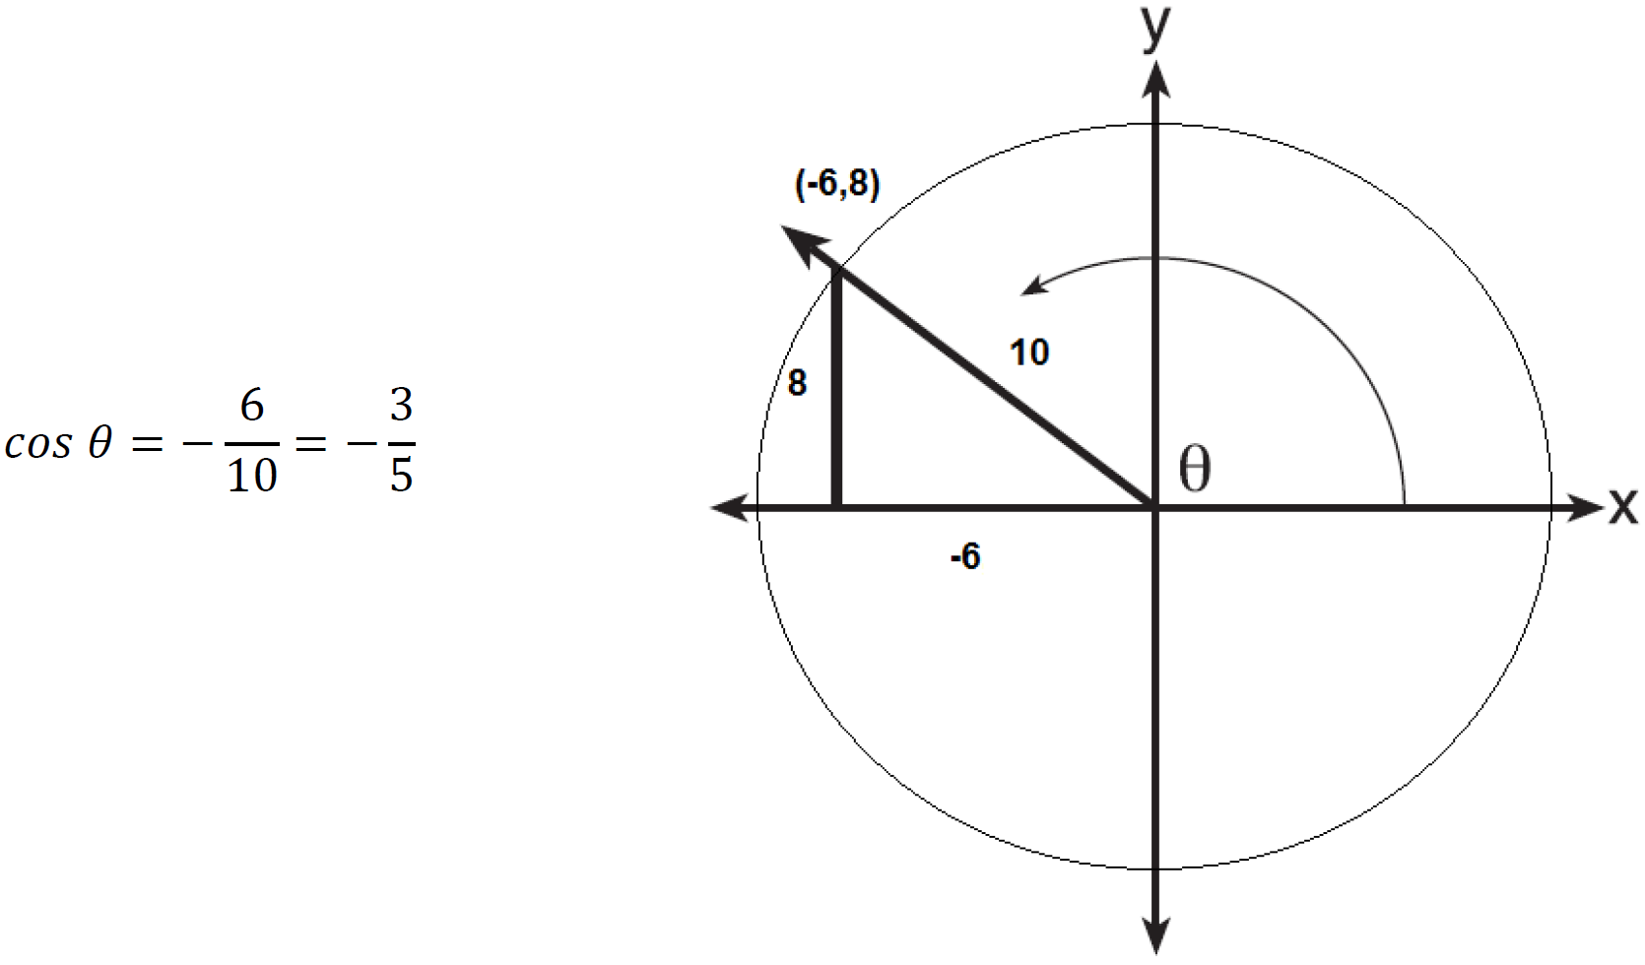

REF: 061617aii

5 ANS: 2
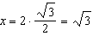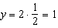

REF: 061525a2

6 ANS: 2
; 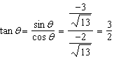

REF: 062304aii

7 ANS: 2
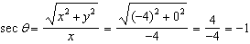

REF: 011520a2

8 ANS: 2
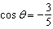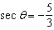

REF: 011621a2

9 ANS: 4
Since the terminal side of passes through , . 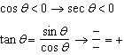

REF: 082420aii

10 ANS: 2 REF: fall9920b

11 ANS:
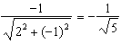

REF: 061832aii

12 ANS:
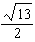. 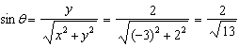. 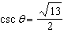.

REF: fall0933a2

13 ANS:
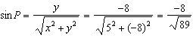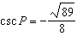

REF: 081634a2

