1 Find the value of 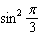.

2 Find the value of 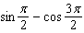.

3 If , find the numerical value of .

4 If , find 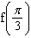.

5 If 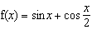, find .

6 If , find 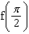.

7 If , find the value of when 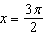.

8 Evaluate: 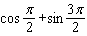

9 If 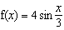, find .

10 If , find 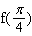.

11 If , find the value of 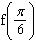.

12 If , what is ?

13 If 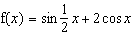, evaluate .

14 If , find the value of .

15 If , find the value of .

16 Find the value of 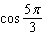.

17 If , evaluate .

18 What is the numerical value of the product 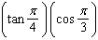?

19 If , find .

20 If , evaluate 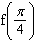.

1 ANS:

REF: 018402siii

2 ANS:
1

REF: 068415siii

3 ANS:

REF: 018511siii

4 ANS:
1

REF: 088711siii

5 ANS:

REF: 010408siii

6 ANS:

REF: 019012siii

7 ANS:

REF: 069406siii

8 ANS:

REF: 019507siii

9 ANS:

REF: 069510siii

10 ANS:
1

REF: 019606siii

11 ANS:
2

REF: 019812siii

12 ANS:

REF: 019905siii

13 ANS:

REF: 069909siii

14 ANS:
0

REF: 010011siii

15 ANS:
0

REF: 060002siii

16 ANS:
0.5

REF: 068018siii

17 ANS:
1

REF: 089902siii

18 ANS:

REF: 068814siii

19 ANS:
2

REF: 089936siii

20 ANS:
1

REF: 010102siii

