1 If , which diagram represents drawn in standard position?
1) | 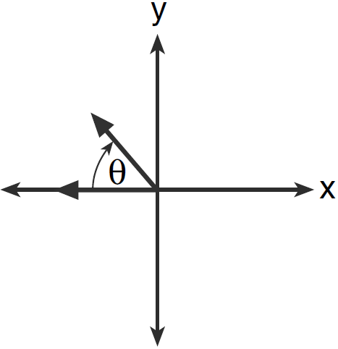
2) | 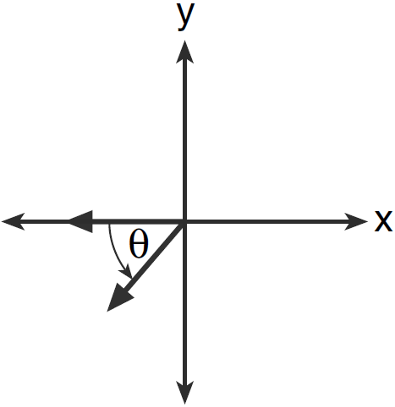
3) | 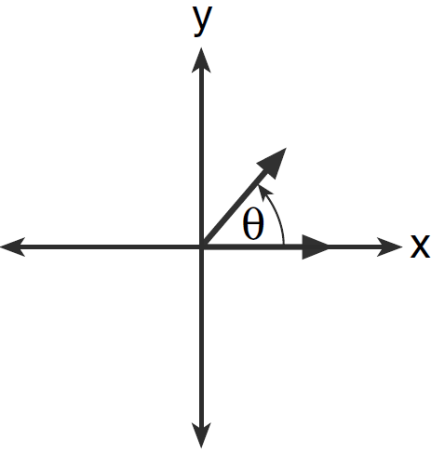
4) | 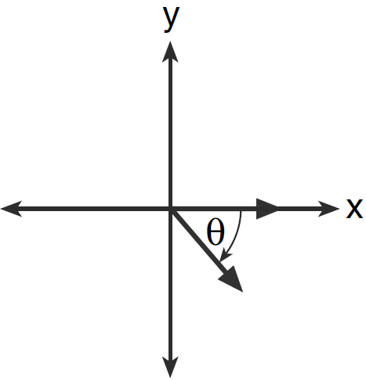

2 In which graph is coterminal with an angle of ?
1) | 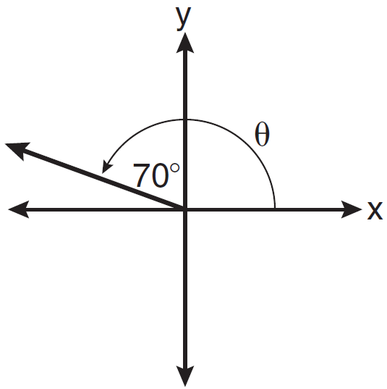
2) | 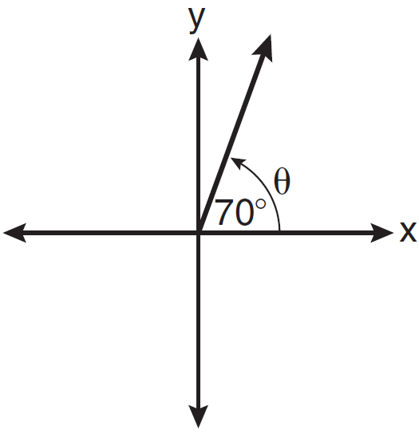
3) | 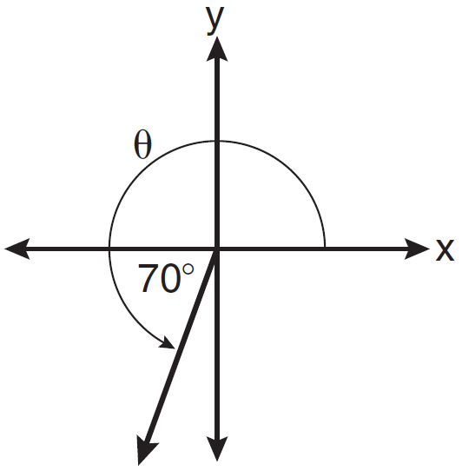
4) | 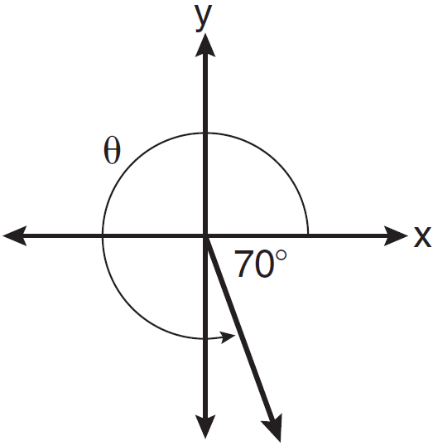

3 Which diagram shows an angle rotation of 1 radian on the unit circle?
1) | 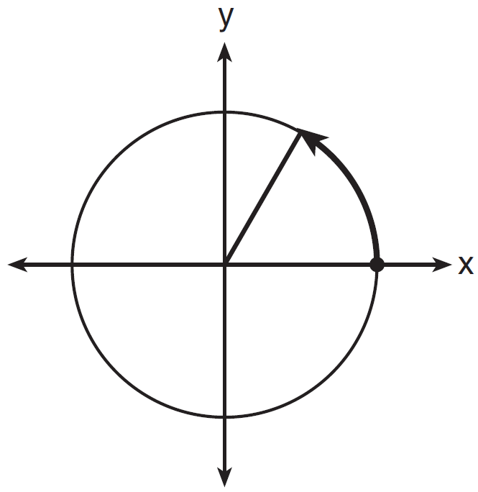
2) | 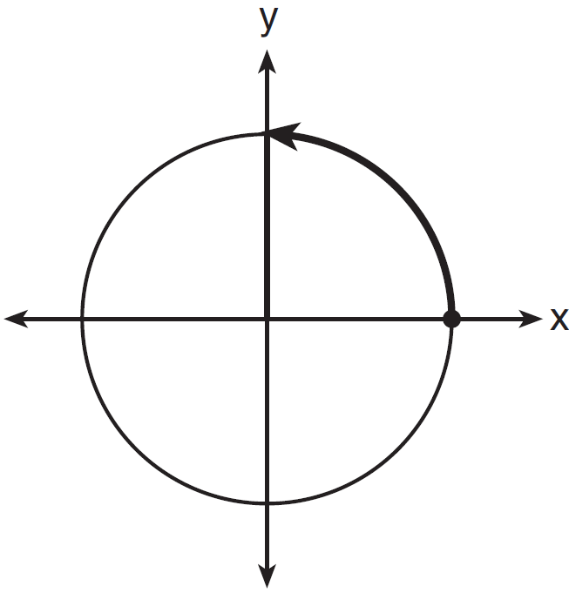
3) | 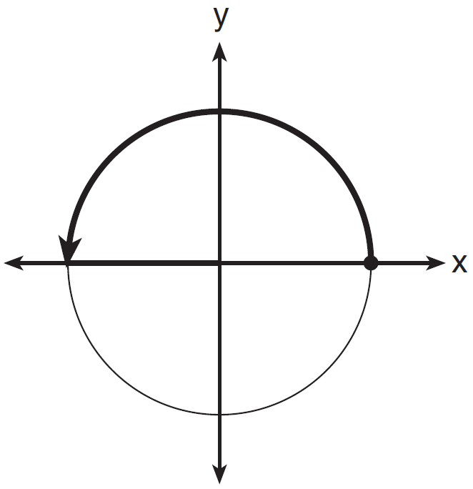
4) | 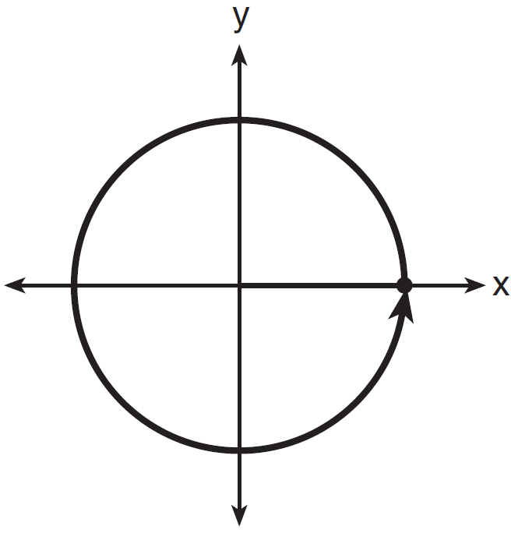

4 An angle, , is rotated counterclockwise on the unit circle, with its terminal side in the second quadrant, as shown in the diagram below.

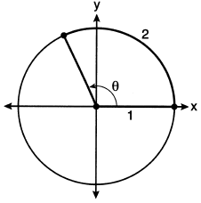

Which value represents the radian measure of angle ?
1) | 1
2) | 2
3) | 65.4
4) | 114.6

5 Which angle is coterminal with an angle of 125°?
1) | –125°
2) | –235°
3) | 235°
4) | 425°

6 Which angle has the same terminal side as an angle of 155°?
1)
2)
3)
4)

7 Which angle does not terminate in Quadrant IV when drawn on a unit circle in standard position?
1)
2)
3)
4)

8 The terminal side of an angle measuring radians lies in Quadrant
1) | I
2) | II
3) | III
4) | IV

9 An angle that measures radians is drawn in standard position. In which quadrant does the terminal side of the angle lie?

10 An angle that measures radians is drawn in standard position. In which quadrant does the terminal side of the angle lie?

11 An angle with measure radians is in standard position. In which quadrant does its terminal side lie?

1 ANS: 4 REF: 061206a2

2 ANS: 4 REF: 081005a2

3 ANS: 1 REF: 081616aii

4 ANS: 2 REF: 062219aii

5 ANS: 2
Coterminal angles differ by multiples of 360°. .

REF: 080417b

6 ANS: 1

REF: 061614a2

7 ANS: 1
, which terminates in Quadrant I.

REF: 011602a2

8 ANS: 2 REF: 061502a2

9 ANS:
II

REF: 069602siii

10 ANS:
IV

REF: 080005siii

11 ANS:
IV

REF: 089305siii

