1 Express 15º in radian measure.

2 Express 45º in radian measure.

3 Express 54º in radian measure.

4 Express 72° in radian measure.

5 Express 75° in radian measure.

6 Express 105º in radian measure.

7 Express 150º in radian measure.

8 Express 160° in radian measure.

9 Express 198º in radian measure.

10 Express 220º in radian measure.

11 Express 225º in radian measure.

12 What is 235°, expressed in radian measure?
1)
2)
3)
4)

13 Express 240º in radian measure.

14 Express 260º in radian measure.

15 Express 300º in radian measure.

16 Express 315º in radian measure.

17 Express 330º in radian measure.

18 Express 405º in radian measure.

19 Express 450º in radian measure.

20 What is 510° expressed in radian measure?
1) | 2.83
2)
3)
4)

21 What is the radian measure of an angle whose measure is ?
1)
2)
3)
4)

22 To the nearest thousandth, what is , in radian measure?
1) | 0.416
2) | 0.415
3) | 0.410
4) | 0.409

23 Find, to the nearest tenth, the radian measure of 216º.

24 Express in radian measure, to the nearest hundredth.

25 Through how many radians does the minute hand of a clock turn in 24 minutes?
1) | 0.2π
2) | 0.4π
3) | 0.6π
4) | 0.8π

26 What is the radian measure of the angle formed by the hands of a clock at 2:00 p.m.?
1)
2)
3)
4)

27 What is the radian measure of the smaller angle formed by the hands of a clock at 7 o’clock?
1)
2)
3)
4)

28 Kristine is riding in car 4 of the Ferris wheel represented in the accompanying diagram. The Ferris wheel is rotating in the direction indicated by the arrows. The eight cars are equally spaced around the circular wheel. Express, in radians, the measure of the smallest angle through which she will travel to reach the bottom of the Ferris wheel.

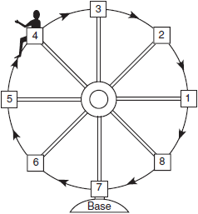

29 An art student wants to make a string collage by connecting six equally spaced points on the circumference of a circle to its center with string. What would be the radian measure of the angle between two adjacent pieces of string, in simplest form?

1 ANS:

REF: 068804siii

2 ANS:

REF: 060207siii

3 ANS:

REF: 069407siii

4 ANS:

REF: 068001siii

5 ANS:

REF: 019908siii

6 ANS:

REF: 068601siii

7 ANS:

REF: 088503siii

8 ANS:

REF: 089703siii

9 ANS:

REF: 080103siii

10 ANS:

REF: 089904siii

11 ANS:

REF: 019402siii

12 ANS: 4
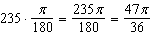

REF: 080704b

13 ANS:

REF: 010304siii

14 ANS:

REF: 018401siii

15 ANS:

REF: 060101siii

16 ANS:

REF: 089505siii

17 ANS:

REF: 068405siii

18 ANS:

REF: 069906siii

19 ANS:

REF: 019502siii

20 ANS: 3
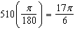

REF: 011701a2

21 ANS: 1
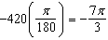

REF: 081002a2

22 ANS: 1
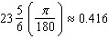

REF: 061618a2

23 ANS:
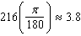

REF: 061232a2

24 ANS:
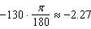

REF: 011632a2

25 ANS: 4
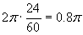

REF: 060120b

26 ANS: 2
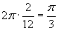

REF: 010615b

27 ANS: 3
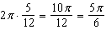
REF: 061125a2

28 ANS:
. 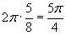
REF: 010421b

29 ANS:
. 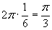
REF: 080223b

