1 In a circle, an arc of length 5 is subtended by a central angle of radians. What is the radius of the circle?
1)
2)
3) | 3
4) | 5

2 In a circle, a central angle whose measure is radians intercepts an arc whose length is centimeters. How many centimeters are in the radius of the circle?
1) | 1
2) | 2
3) | 3
4) | 4

3 In a circle, a central angle containing 1.5 radians intercepts an arc whose measure is 18 centimeters. The length of the radius is
1) | 6 cm
2) | 12 cm
3) | 24 cm
4) | 27 cm

4 A central angle of a circular garden measures 2.5 radians and intercepts an arc of 20 feet. What is the radius of the garden?
1) | 8 ft
2) | 50 ft
3) | 100 ft
4) | 125 ft

5 In a circle, a central angle of 2 radians intercepts an arc of 6 centimeters. Find the length of the radius in centimeters.

6 In a circle, a central angle of 2 radians intercepts an arc of length 12 centimeters. Find the length of the radius in centimeters.

7 In circle O, a central angle of 2 radians intercepts an arc of 28 meters. Find the length, in meters, of the radius of the circle?

8 In a circle, a central angle of 3 radians intercepts an arc of length 12. What is the length of the radius of the circle?

9 In a circle, a central angle of 3 radians intercepts an arc of 18 centimeters. What is the radius, in centimeters, of the circle?

10 In a circle, a central angle of 3 radians intercepts an arc of length 21. Find the length of the radius of the circle.

11 In circle O, a central angle of 3 radians intercepts an arc of 27 meters. Find the number of meters in the length of the radius.

12 An arc of a circle that is 6 centimeters in length intercepts a central angle of 1.5 radians. Find the number of centimeters in the radius of the circle.

13 In a circle, a central angle of 3.5 radians intercepts an arc of 24.5 centimeters. Find the number of centimeters in the radius of the circle.

14 The pendulum of a clock swings through an angle of 2.5 radians as its tip travels through an arc of 50 centimeters. Find the length of the pendulum, in centimeters.

15 The tip of a pendulum describes an arc 18 centimeters long when the pendulum swings through an angle of of a radian. Find the length, in centimeters, of the pendulum.

16 In a circle, an arc of length 10 is intercepted by a central angle of radian. Find the radius of the circle.

17 In a circle, a central angle of radians intercepts an arc of length 10. What is the length of the radius of the circle?

18 An angle of radians at the center of a circle intercepts an arc of 18 inches. Find the length of the radius in inches.

19 A central angle whose measure is radians intercepts an arc with a length of feet. Find the radius of the circle, in feet.

20 In a circle, an arc length of 6.6 is intercepted by a central angle of radians. Determine the length of the radius.
1 ANS: 3
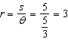
REF: 060234siii

2 ANS: 3
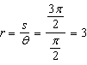
REF: 060123siii

3 ANS: 2
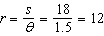
REF: 019023siii

4 ANS: 1
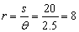
REF: 010910b

5 ANS:
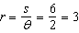
REF: 088912siii

6 ANS:
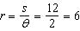
REF: 068106siii

7 ANS:
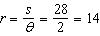
REF: 088412siii

8 ANS:
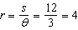
REF: 018409siii

9 ANS:
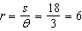
REF: 068003siii

10 ANS:
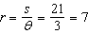
REF: 088505siii

11 ANS:
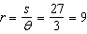
REF: 069907siii

12 ANS:
4. 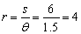
REF: 010526b

13 ANS:
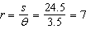
REF: 069508siii

14 ANS:
20. 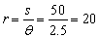
REF: 060626b

15 ANS:
24. 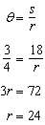
REF: 061026b

16 ANS:
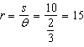
REF: 068618siii

17 ANS:
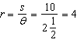
REF: 018715siii

18 ANS:
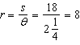
REF: 060312siii

19 ANS:
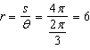
REF: 061632a2

20 ANS:
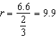
REF: 081532a2

