1 If , then x is equal to
1) 9 2) 3) 4)

2 What is the solution of the equation ?
1) 6.4 2) 2.56 3) 4)

3 If , what is the value of a?
1) 1 2) 2 3) 3 4) 4

4 If 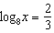, find the value of x.

5 Solve for x: 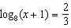

6 Find x if 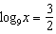.

7 Solve algebraically for x: 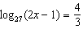

8 If , what is the value of x?
1) 81 2) 3) 3 4)

9 Which expression could be used to determine the value of y in the equation ?
1) 2) 3) 4)

10 If 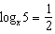, find the value of x.

11 Solve algebraically for x: 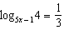

12 If 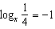, find x.

13 If 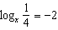, find x.

14 If and 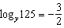, find the numerical value of , in simplest form.

15 The temperature, T, of a given cup of hot chocolate after it has been cooling for t minutes can best be modeled by the function below, where is the temperature of the room and k is a constant.
A cup of hot chocolate is placed in a room that has a temperature of 68°. After 3 minutes, the temperature of the hot chocolate is 150°. Compute the value of k to the nearest thousandth. [Only an algebraic solution can receive full credit.] Using this value of k, find the temperature, T, of this cup of hot chocolate if it has been sitting in this room for a total of 10 minutes. Express your answer to the nearest degree. [Only an algebraic solution can receive full credit.]

1 ANS: 3 REF: 088624siii

2 ANS: 4
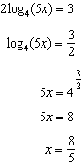
REF: fall0921a2

3 ANS: 1
Let Then and Then which is true only if 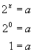 or 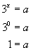
REF: 080720b

4 ANS:
4
REF: 068404siii

5 ANS:
3. 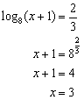
REF: 060925b

6 ANS:
27
REF: 018407siii

7 ANS:
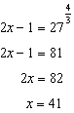
REF: 061329a2

8 ANS: 4
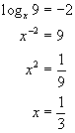
REF: 010819b

9 ANS: 2
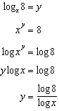
REF: 081621a2

10 ANS:
25
REF: 068813siii

11 ANS:
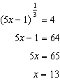
REF: 061433a2

12 ANS:
4
REF: 089006siii

13 ANS:
2
REF: 019818siii

14 ANS:
800. . 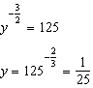. 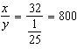
REF: 011237a2

15 ANS:
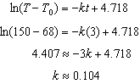. 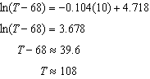.
REF: 011139a2

