1 If , then x equals
1)
2)
3)
4)

2 The equation where and is equivalent to
1)
2)
3)
4)

3 The function is equivalent to
1)
2)
3)
4)

4 If , then x is equal to
1) | 7
2) | 12
3) | 64
4) | 81

5 If , what is the value of ?
1)
2)
3) | 5
4) | 25

6 What is the value of x in the equation ?
1) | 1.16
2) | 20
3) | 625
4) | 1,024

7 If , then the solution set for x is
1)
2)
3)
4)

8 If , find x.

9 If , find the value of m.

10 If , find x.

11 Find the value of x that satisfies the equation .

12 Solve for x:

13 Solve for x: 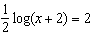

14 If , find the value of N, to the nearest integer.

15 The relationship between the relative size of an earthquake, S, and the measure of the earthquake on the Richter scale, R, is given by the equation . If an earthquake measured 3.2 on the Richter scale, what was its relative size to the nearest hundredth?

16 Solve for the positive value of x:

17 Solve for x:

18 If , find the value of n.

19 Solve for x:

20 Solve algebraically for all values of x:

21 If , find the value of x.

22 If , find the value of x.

23 Solve algebraically for x: 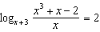

24 Solve for x to the nearest tenth:

25 The solution of is
1)
2)
3)
4)

26 Solve algebraically for the exact value of x:

1 ANS: 4 REF: 060409b

2 ANS: 3 REF: 011503a2

3 ANS: 2 REF: 080607b

4 ANS: 3 REF: 019920siii

5 ANS: 3
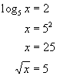

REF: 010519b

6 ANS: 3

REF: 061106a2

7 ANS: 1 REF: 069919siii

8 ANS:
64

REF: 068017siii

9 ANS:
32

REF: 018508siii

10 ANS:
16

REF: 060206siii

11 ANS:
81

REF: 080307siii

12 ANS:
7. 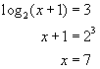

REF: 060623b

13 ANS:
9998

REF: 019442siii

14 ANS:
7259

REF: 088715siii

15 ANS:
1,584.89. 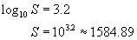

REF: 010324b

16 ANS:
3

REF: 018703siii

17 ANS:
6

REF: 068904siii

18 ANS:
2

REF: 089813siii

19 ANS:
5

REF: 069604siii

20 ANS:
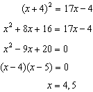

REF: 011336a2

21 ANS:
2

REF: 069004siii

22 ANS:
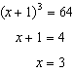

REF: 061531a2

23 ANS:
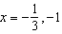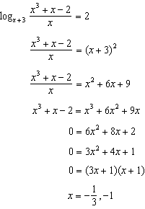

REF: 081039a2

24 ANS:
1.7

REF: 018439siii

25 ANS: 2 REF: 080228siii

26 ANS:
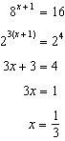

REF: 011630a2

