1 Given 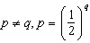, expressed in logarithmic form, is equivalent to
1) | 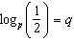 | 3)
2) | 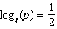 | 4)

1 ANS: 3 REF: 012404aii

