1 The growth of bacteria in a dish is modeled by the function 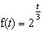. For which value of t is ?
1) | 8
2) | 2
3) | 15
4) | 16

2 A population of rabbits doubles every 60 days according to the formula 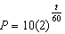, where P is the population of rabbits on day t. What is the value of t when the population is 320?
1) | 240
2) | 300
3) | 660
4) | 960

3 Susie invests $500 in an account that is compounded continuously at an annual interest rate of 5%, according to the formula , where A is the amount accrued, P is the principal, r is the rate of interest, and t is the time, in years. Approximately how many years will it take for Susie’s money to double?
1) | 1.4
2) | 6.0
3) | 13.9
4) | 14.7

4 Akeem invests $25,000 in an account that pays 4.75% annual interest compounded continuously. Using the formula , where the amount in the account after t years, principal invested, and the annual interest rate, how many years, to the nearest tenth, will it take for Akeem’s investment to triple?
1) | 10.0
2) | 14.6
3) | 23.1
4) | 24.0

5 Given a starting population of 100 bacteria, the formula can be used to find the number of bacteria, b, after t periods of time. If each period is 15 minutes long, how many minutes will it take for the population of bacteria to reach 51,200?

6 In the equation , y represents the number of snowboarders in millions and x represents the number of years since 1988. Find the year in which the number of snowboarders will be 10 million for the first time. (Only an algebraic solution will be accepted.)

7 Drew’s parents invested $1,500 in an account such that the value of the investment doubles every seven years. The value of the investment, V, is determined by the equation 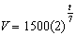, where t represents the number of years since the money was deposited. How many years, to the nearest tenth of a year, will it take the value of the investment to reach $1,000,000?

8 Growth of a certain strain of bacteria is modeled by the equation , where:
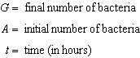
In approximately how many hours will 4 bacteria first increase to 2,500 bacteria? Round your answer to the nearest hour.

9 The number of houses in Central Village, New York, grows every year according to the function , where H represents the number of houses, and t represents the number of years since January 1995. A civil engineering firm has suggested that a new, larger well must be built by the village to supply its water when the number of houses exceeds 1,000. During which year will this first happen?

10 The number of bacteria present in a Petri dish can be modeled by the function , where N is the number of bacteria present in the Petri dish after t hours. Using this model, determine, to the nearest hundredth, the number of hours it will take for N to reach 30,700.

11 Currently, the population of the metropolitan Waterville area is 62,700 and is increasing at an annual rate of 3.25%. This situation can be modeled by the equation , where represents the total population and t represents the number of years from now. Find the population of the Waterville area, to the nearest hundred, seven years from now. Determine how many years, to the nearest tenth, it will take for the original population to reach 100,000. [Only an algebraic solution can receive full credit.]

12 Sean invests $10,000 at an annual rate of 5% compounded continuously, according to the formula , where A is the amount, P is the principal, , r is the rate of interest, and t is time, in years. Determine, to the nearest dollar, the amount of money he will have after 2 years. Determine how many years, to the nearest year, it will take for his initial investment to double.

13 Since January 1980, the population of the city of Brownville has grown according to the mathematical model , where x is the number of years since January 1980. Explain what the numbers 720,500 and 1.022 represent in this model. If this trend continues, use this model to predict the year during which the population of Brownville will reach 1,548,800. [The use of the grid is optional.]



14 After an oven is turned on, its temperature, T, is represented by the equation , where m represents the number of minutes after the oven is turned on and T represents the temperature of the oven, in degrees Fahrenheit. How many minutes does it take for the oven's temperature to reach 300°F? Round your answer to the nearest minute. [The use of the grid is optional.]

15 Kristen invests $5,000 in a bank. The bank pays 6% interest compounded monthly. To the nearest tenth of a year, how long must she leave the money in the bank for it to double? (Use the formula 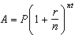, where A is the amount accrued, P is the principal, r is the interest rate, , and t is the length of time, in years.) [The use of the grid is optional.]

16 An amount of P dollars is deposited in an account paying an annual interest rate r (as a decimal) compounded n times per year. After t years, the amount of money in the account, in dollars, is given by the equation . Rachel deposited $1,000 at 2.8% annual interest, compounded monthly. In how many years, to the nearest tenth of a year, will she have $2,500 in the account? [The use of the grid is optional.]

17 The amount A, in milligrams, of a 10-milligram dose of a drug remaining in the body after t hours is given by the formula . Find, to the nearest tenth of an hour, how long it takes for half of the drug dose to be left in the body.

18 Depreciation (the decline in cash value) on a car can be determined by the formula , where V is the value of the car after t years, C is the original cost, and r is the rate of depreciation. If a car’s cost, when new, is $15,000, the rate of depreciation is 30%, and the value of the car now is $3,000, how old is the car to the nearest tenth of a year?

19 The equation for radioactive decay is 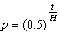, where p is the part of a substance with half-life H remaining radioactive after a period of time, t. A given substance has a half-life of 6,000 years. After t years, one-fifth of the original sample remains radioactive. Find t, to the nearest thousand years.

20 An archaeologist can determine the approximate age of certain ancient specimens by measuring the amount of carbon-14, a radioactive substance, contained in the specimen. The formula used to determine the age of a specimen is 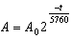, where A is the amount of carbon-14 that a specimen contains, is the original amount of carbon-14, t is time, in years, and 5760 is the half-life of carbon-14. A specimen that originally contained 120 milligrams of carbon-14 now contains 100 milligrams of this substance. What is the age of the specimen, to the nearest hundred years?

21 The current population of Little Pond, New York, is 20,000. The population is decreasing, as represented by the formula , where population, , in years, and population. What will the population be 3 years from now? Round your answer to the nearest hundred people. To the nearest tenth of a year, how many years will it take for the population to reach half the present population? [The use of the grid is optional.]

1 ANS: 3
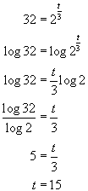. 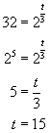. 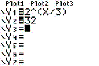. 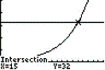

REF: 080502b

2 ANS: 2
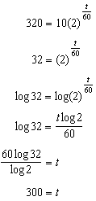

REF: 011205a2

3 ANS: 3
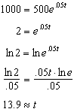

REF: 061313a2

4 ANS: 3
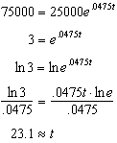

REF: 061117a2

5 ANS:
135. 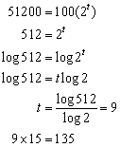

REF: 010923b

6 ANS:
2004. 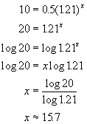. 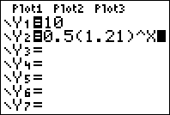. 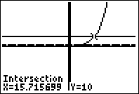

REF: fall9930b

7 ANS:
65.7. 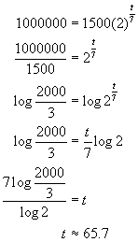. 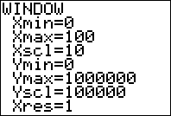. 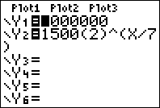. 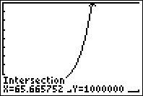

REF: 080729b

8 ANS:
11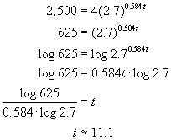 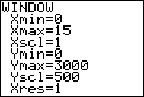 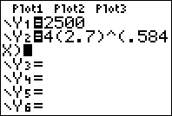 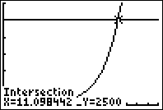

REF: 060224b

9 ANS:
2011. 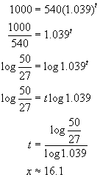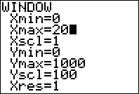 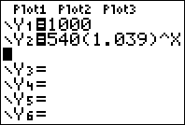 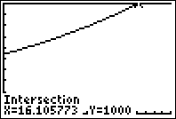

REF: 010828b

10 ANS:
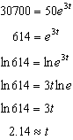

REF: 011333a2

11 ANS:
78,400, 14.6

REF: 011031b

12 ANS:
11052, 14. 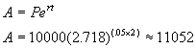. 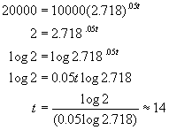. 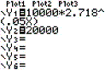. 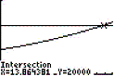

REF: 060330b

13 ANS:
720,500 is the population in 1980, 1.022 represents a growth rate of 2.2%, 2015. 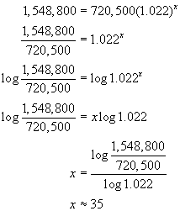. 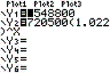. 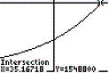. 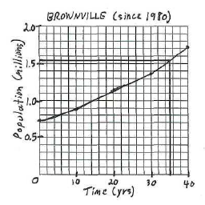

REF: 010728b

14 ANS:
11. 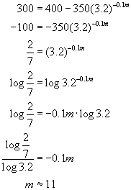. 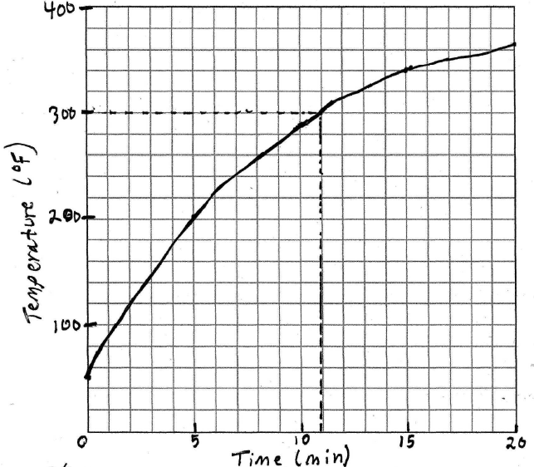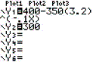. 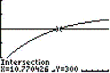.

REF: 080632b

15 ANS:
11.6. 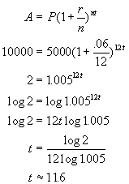. 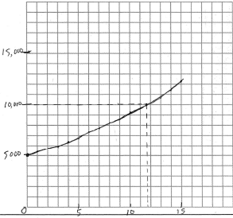. 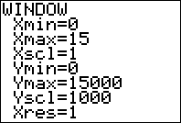. 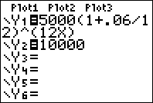. 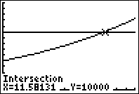

REF: 080832b

16 ANS:
32.8. 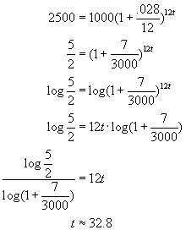. 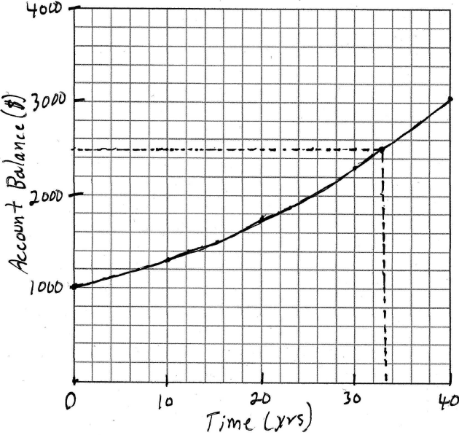. 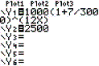. 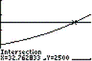

REF: 080428b

17 ANS:
3.1. Half the dose is left, 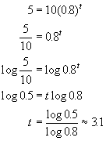. 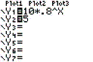. 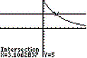

REF: 080132b

18 ANS:
4.5. 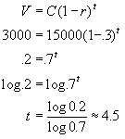. 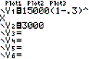. 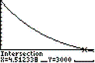

REF: 010230b

19 ANS:
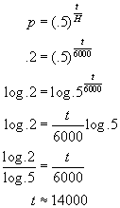

REF: 010429b

20 ANS:
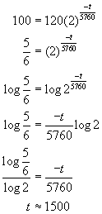

REF: 060431b

21 ANS:
16,600, 11.3. . Half of Little Pond’s present population is 10,000. 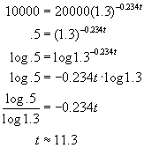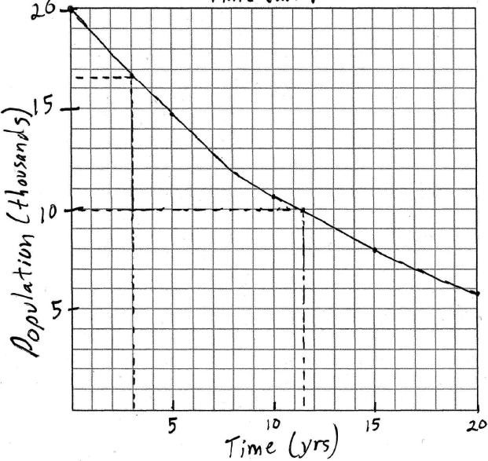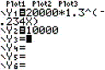 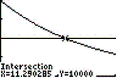

REF: 010632b

