1 A population of rabbits doubles every 60 days according to the formula 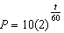, where P is the population of rabbits on day t. What is the value of t when the population is 320?
1) | 240
2) | 300
3) | 660
4) | 960

2 The growth of bacteria in a dish is modeled by the function 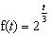. For which value of t is ?
1) | 8
2) | 2
3) | 15
4) | 16

3 Given a starting population of 100 bacteria, the formula can be used to find the number of bacteria, b, after t periods of time. If each period is 15 minutes long, how many minutes will it take for the population of bacteria to reach 51,200?

4 Drew’s parents invested $1,500 in an account such that the value of the investment doubles every seven years. The value of the investment, V, is determined by the equation 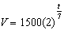, where t represents the number of years since the money was deposited. How many years, to the nearest tenth of a year, will it take the value of the investment to reach $1,000,000?

5 A local university has a current enrollment of 12,000 students. The enrollment is increasing continuously at a rate of 2.5% each year. Which logarithm is equal to the number of years it will take for the population to increase to 15,000 students?
1) | 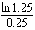
2) | 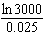
3) | 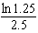
4) | 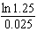

6 Susie invests $500 in an account that is compounded continuously at an annual interest rate of 5%, according to the formula , where A is the amount accrued, P is the principal, r is the rate of interest, and t is the time, in years. Approximately how many years will it take for Susie’s money to double?
1) | 1.4
2) | 6.0
3) | 13.9
4) | 14.7

7 Akeem invests $25,000 in an account that pays 4.75% annual interest compounded continuously. Using the formula , where the amount in the account after t years, principal invested, and the annual interest rate, how many years, to the nearest tenth, will it take for Akeem’s investment to triple?
1) | 10.0
2) | 14.6
3) | 23.1
4) | 24.0

8 Determine, to the nearest tenth of a year, how long it would take an investment to double at a 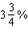 interest rate, compounded continuously.

9 Sean invests $10,000 at an annual rate of 5% compounded continuously, according to the formula , where A is the amount, P is the principal, , r is the rate of interest, and t is time, in years. Determine, to the nearest dollar, the amount of money he will have after 2 years. Determine how many years, to the nearest year, it will take for his initial investment to double.

10 Judith puts $5000 into an investment account with interest compounded continuously. Which approximate annual rate is needed for the account to grow to $9110 after 30 years?
1) | 2%
2) | 2.2%
3) | 0.02%
4) | 0.022%

11 In New York State, the minimum wage has grown exponentially. In 1966, the minimum wage was $1.25 an hour and in 2015, it was $8.75. Algebraically determine the rate of growth to the nearest percent.

12 A house purchased 5 years ago for $100,000 was just sold for $135,000. Assuming exponential growth, approximate the annual growth rate, to the nearest percent.

13 The number of bacteria present in a Petri dish can be modeled by the function , where N is the number of bacteria present in the Petri dish after t hours. Using this model, determine, to the nearest hundredth, the number of hours it will take for N to reach 30,700.

14 When observed by researchers under a microscope, a smartphone screen contained approximately 11,000 bacteria per square inch. Bacteria, under normal conditions, double in population every 20 minutes.
a) Assuming an initial value of 11,000 bacteria, write a function, , that can be used to model the population of bacteria, p, on a smartphone screen, where t represents the time in minutes after it is first observed under a microscope.
b) Using from part a, determine algebraically, to the nearest hundredth of a minute, the amount of time it would take for a smartphone screen that was not touched or cleaned to have a population of 1,000,000 bacteria per square inch.

15 After sitting out of the refrigerator for a while, a turkey at room temperature (68°F) is placed into an oven at 8 a.m., when the oven temperature is 325°F. Newton’s Law of Heating explains that the temperature of the turkey will increase proportionally to the difference between the temperature of the turkey and the temperature of the oven, as given by the formula below:

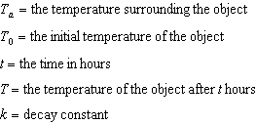

The turkey reaches the temperature of approximately 100° F after 2 hours. Find the value of k, to the nearest thousandth, and write an equation to determine the temperature of the turkey after t hours. Determine the Fahrenheit temperature of the turkey, to the nearest degree, at 3 p.m.
1 ANS: 2
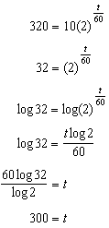

REF: 011205a2

2 ANS: 3
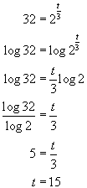. 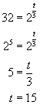. 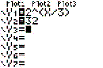. 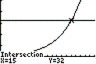

REF: 080502b

3 ANS:
135. 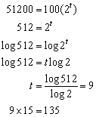

REF: 010923b

4 ANS:
65.7. 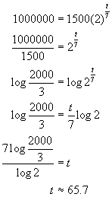. 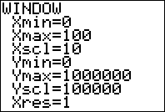. 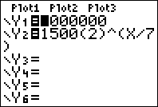. 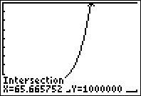

REF: 080729b

5 ANS: 4
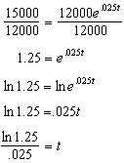

REF: 082209aii

6 ANS: 3
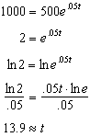

REF: 061313a2

7 ANS: 3
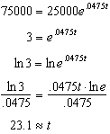

REF: 061117a2

8 ANS:
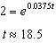

REF: 081835aii

9 ANS:
11052, 14. 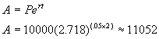. 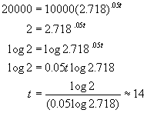. 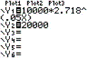. 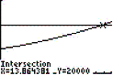

REF: 060330b

10 ANS: 1
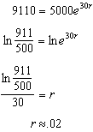

REF: 011810aii

11 ANS:
4% 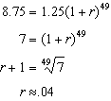 or 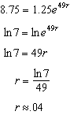

REF: 081730aii

12 ANS:
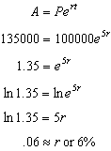

REF: 061632aii

13 ANS:
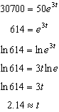

REF: 011333a2

14 ANS:
a) 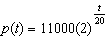; b) 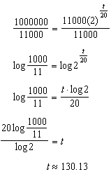

REF: 082233aii

15 ANS:
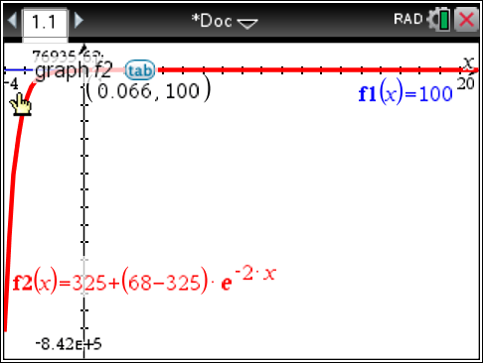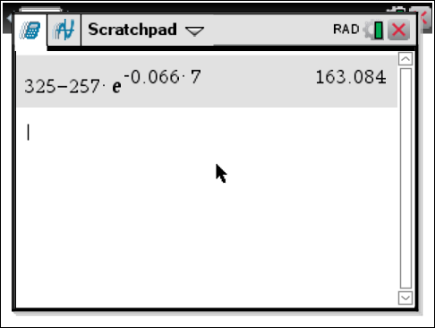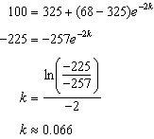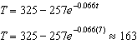

REF: fall1513aii

