1 The value of x in the equation is
1) 1 2) 2 3) 5 4)

2 Which value of k satisfies the equation ?
1) 2) 3) 4)

3 What is the value of b in the equation ?
1) 2) 3) 4)

4 The solution of is
1) 2) 3) 4)

5 Solve for x:
1) 2) 3) 4) 0

6 Solve algebraically for x:

7 Solve for x:

8 Solve for x:

9 If , what is the value of x?

10 Solve for x:

11 Solve for x:

12 Solve for x:

13 Solve algebraically for x:

14 Solve for x:
1 ANS: 2
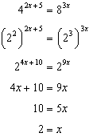.

REF: 061105a2

2 ANS: 4
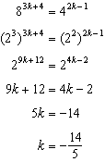.

REF: 011309a2

3 ANS: 3
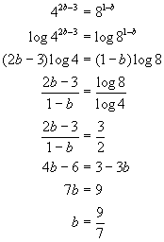. 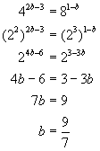. 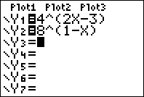. 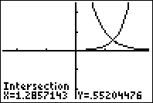. 

REF: 010709b

4 ANS: 1
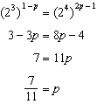

REF: 061611a2

5 ANS: 2
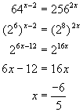. 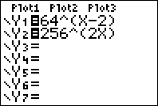. 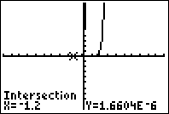. 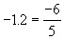

REF: fall9907b

6 ANS:
2. 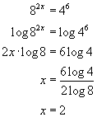. 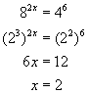. 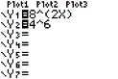. 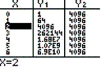

REF: 010626b

7 ANS:
1

REF: 088705siii

8 ANS:
3

REF: 069506siii

9 ANS:
3

REF: 069905siii

10 ANS:

REF: 080309siii

11 ANS:
2

REF: 089913siii

12 ANS:
11

REF: 010409siii

13 ANS:
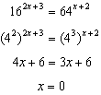

REF: 011128a2

14 ANS:
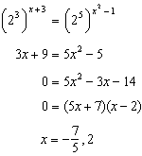

REF: 081636a2

