1 The solution set of is
1)
2)
3)
4)

2 If , which expression is equivalent to x?
1)
2)
3) | 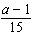
4) | 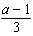

3 The solution set of is
1)
2)
3)
4)

4 The solution set of is
1)
2)
3)
4)

5 If , what does x equal?
1) | 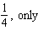
2) | 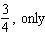
3) | 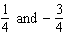
4) | 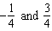

6 Solve for x:

7 Solve for x:

8 If , what is the value of x?

9 Solve for y: 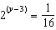

10 Solve for x: 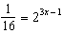

11 Solve for x:

12 If , find the value of x.

13 Solve for x:

14 If , find the value of x.

15 Solve for x:

16 Solve for x:

17 Solve for x:

18 Solve for x:

19 If , what is the value of x?

20 Solve for x:

21 Solve for x: 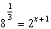

22 Solve for x:

23 Solve for x:

24 Solve for x:
1 ANS: 2 REF: 019916siii

2 ANS: 2
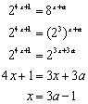

REF: 060814b

3 ANS: 2
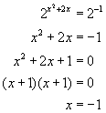. 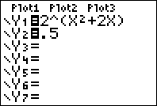. 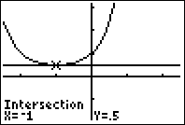

REF: 060612b

4 ANS: 3
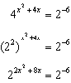. 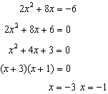

REF: 061015a2

5 ANS: 4
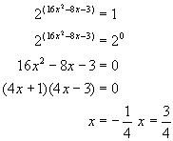. 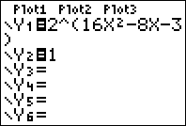. 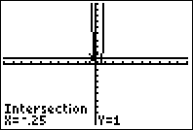

REF: 080819b

6 ANS:
0

REF: 018706siii

7 ANS:
3

REF: 068901siii

8 ANS:
4

REF: 010101siii

9 ANS:

REF: 019810siii

10 ANS:
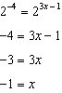

REF: 081529a2

11 ANS:
4

REF: 089609siii

12 ANS:
2

REF: 018415siii

13 ANS:
1

REF: 068416siii

14 ANS:

REF: 088410siii

15 ANS:
3

REF: 018906siii

16 ANS:

REF: 089309siii

17 ANS:

REF: 060107siii

18 ANS:
4

REF: 080204siii

19 ANS:
1

REF: 088506siii

20 ANS:
3

REF: 088608siii

21 ANS:
0

REF: 068707siii

22 ANS:
3

REF: 019406siii

23 ANS:
3

REF: 069607siii

24 ANS:

REF: 069704siii

