1 The Fahrenheit temperature, , of a heated object at time t, in minutes, can be modeled by the function below. is the surrounding temperature, is the initial temperature of the object, and k is a constant.
Coffee at a temperature of 195°F is poured into a container. The room temperature is kept at a constant 68°F and . Coffee is safe to drink when its temperature is, at most, 120°F. To the nearest minute, how long will it take until the coffee is safe to drink?
1) | 7
2) | 10
3) | 11
4) | 18

2 The half-life of iodine-131 is 8 days. The percent of the isotope left in the body d days after being introduced is 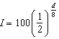. When this equation is written in terms of the number e, the base of the natural logarithm, it is equivalent to . What is the approximate value of the constant, k?
1)
2) | 0.087
3)
4) | 11.542

3 The equation for radioactive decay is 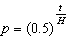, where p is the part of a substance with half-life H remaining radioactive after a period of time, t. A given substance has a half-life of 6,000 years. After t years, one-fifth of the original sample remains radioactive. Find t, to the nearest thousand years.

4 One of the medical uses of Iodine–131 (I–131), a radioactive isotope of iodine, is to enhance x-ray images. The half-life of I–131 is approximately 8.02 days. A patient is injected with 20 milligrams of I–131. Determine, to the nearest day, the amount of time needed before the amount of I–131 in the patient’s body is approximately 7 milligrams.

5 The half-life of a radioactive substance is 15 years. Write an equation that can be used to determine the amount, , of 200 grams of this substance that remains after t years. Determine algebraically, to the nearest year, how long it will take for of this substance to remain.

6 An archaeologist can determine the approximate age of certain ancient specimens by measuring the amount of carbon-14, a radioactive substance, contained in the specimen. The formula used to determine the age of a specimen is 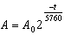, where A is the amount of carbon-14 that a specimen contains, is the original amount of carbon-14, t is time, in years, and 5760 is the half-life of carbon-14. A specimen that originally contained 120 milligrams of carbon-14 now contains 100 milligrams of this substance. What is the age of the specimen, to the nearest hundred years?

7 A radioactive substance has a mass of 140 g at 3 p.m. and 100 g at 8 p.m. Write an equation in the form 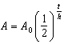 that models this situation, where h is the constant representing the number of hours in the half-life, is the initial mass, and A is the mass t hours after 3 p.m. Using this equation, solve for h, to the nearest ten thousandth. Determine when the mass of the radioactive substance will be 40 g. Round your answer to the nearest tenth of an hour.
1 ANS: 4
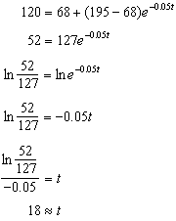

REF: 081918aii

2 ANS: 1
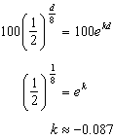

REF: 061818aii

3 ANS:
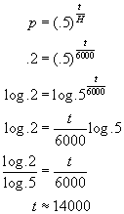

REF: 010429b

4 ANS:
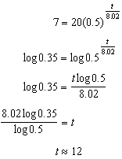

REF: 081634aii

5 ANS:
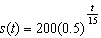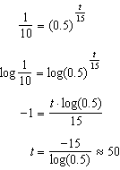

REF: 061934aii

6 ANS:
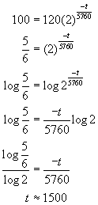

REF: 060431b

7 ANS:
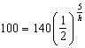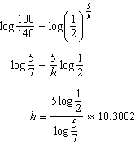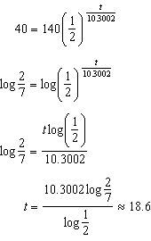

REF: 061737aii

