1 Which function will have the greatest value when ?
1) |  | 3)
2) |  | 4)

2 As x increases beyond 25, which function will have the largest value?
1) |  | 3)
2) |  | 4)

3 If and , at which value of x is ?
1) |  | 3)
2) | 2 | 4) | 4

4 What is the largest integer, x, for which the value of will be greater than the value of ?
1) | 7 | 3) | 9
2) | 8 | 4) | 10

5 Nancy has just been hired for her first job. Her company gives her four choices for how she can collect her annual salary over the first eight years of employment. Each function below represents the four choices she has for her annual salary in thousands of dollars, where t represents the number of years after she is hired.
Which pay plan should Nancy choose in order to have the highest salary in her eighth year?
1) |  | 3)
2) |  | 4)

6 Alicia has invented a new app for smart phones that two companies are interested in purchasing for a 2-year contract. Company A is offering her $10,000 for the first month and will increase the amount each month by $5000. Company B is offering $500 for the first month and will double their payment each month from the previous month. Monthly payments are made at the end of each month. For which monthly payment will company B’s payment first exceed company A’s payment?
1) | 6 | 3) | 8
2) | 7 | 4) | 9

7 The table below shows the weights of Liam's pumpkin, , and Patricia's pumpkin, , over a four-week period where w represents the number of weeks. Liam's pumpkin grows at a constant rate. Patricia's pumpkin grows at a weekly rate of approximately 52%.

Weeks  w | Weight in Pounds  l(w) | Weight in Pounds  p(w)
6 | 2.4 | 2.5
7 | 5.5 | 3.8
8 | 8.6 | 5.8
9 | 11.7 | 8.8

Assume the pumpkins continue to grow at these rates through week 13. When comparing the weights of both Liam's and Patricia's pumpkins in week 10 and week 13, which statement is true?
1) | Liam's pumpkin will weigh more in week 10 and week 13. | 3) | Liam's pumpkin will weigh more in week 10, and Patricia's pumpkin will weigh more in week 13.
2) | Patricia's pumpkin will weigh more in week 10 and week 13. | 4) | Patricia's pumpkin will weigh more in week 10, and Liam's pumpkin will weigh more in week 13.

8 Michael has $10 in his savings account. Option 1 will add $100 to his account each week. Option 2 will double the amount in his account at the end of each week. Write a function in terms of x to model each option of saving. Michael wants to have at least $700 in his account at the end of 7 weeks to buy a mountain bike. Determine which option(s) will enable him to reach his goal. Justify your answer.

9 Graph and for on the set of axes below.

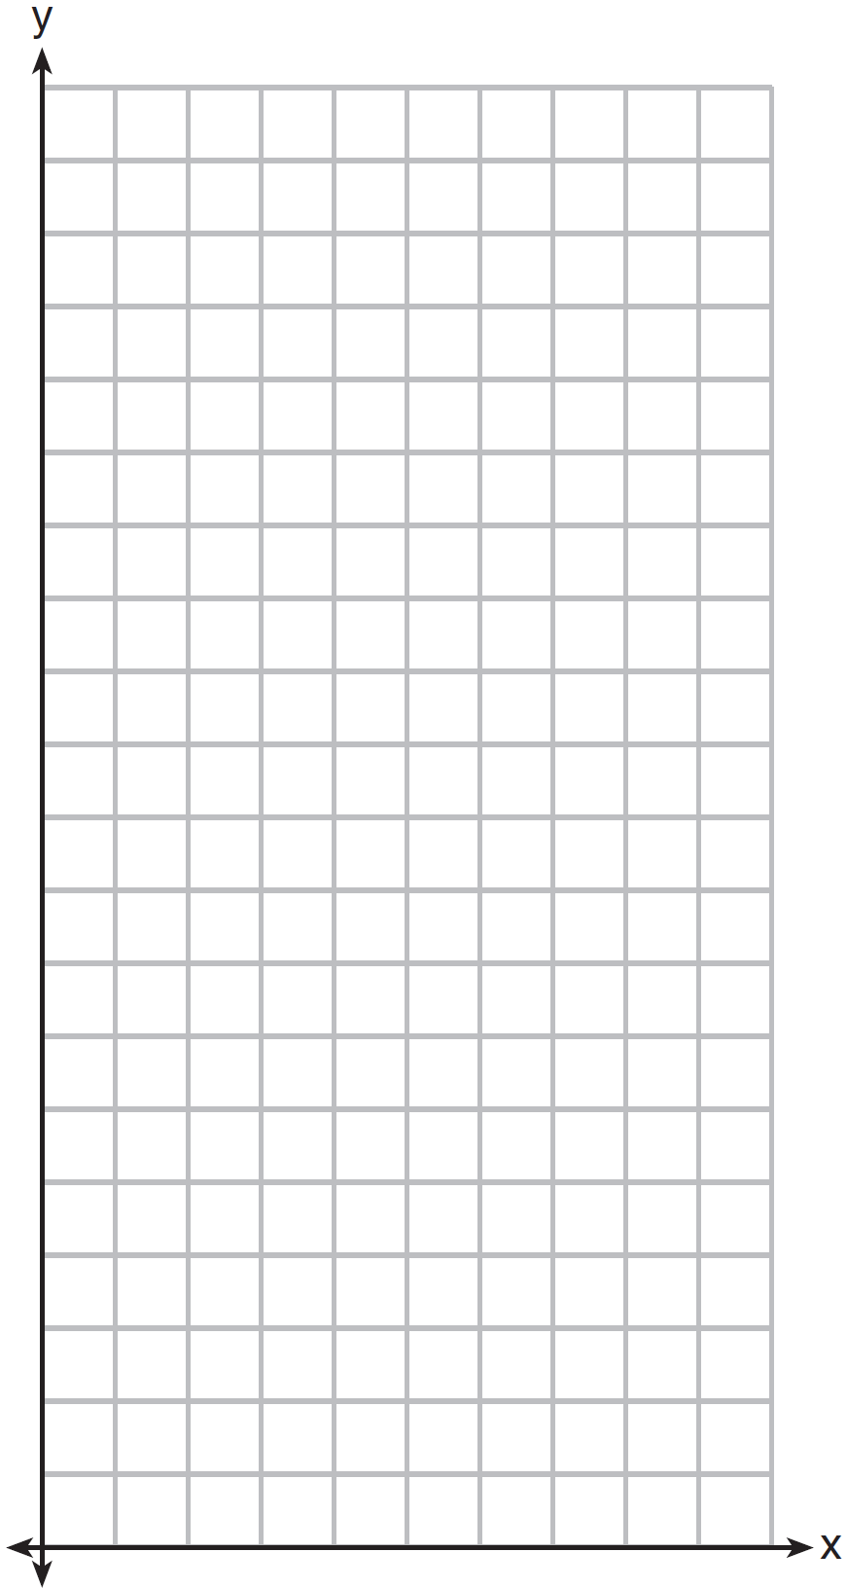

State which function, or , has a greater value when . Justify your reasoning.
1 ANS: 1 REF: 062307ai

2 ANS: 1 REF: 081618ai

3 ANS: 1
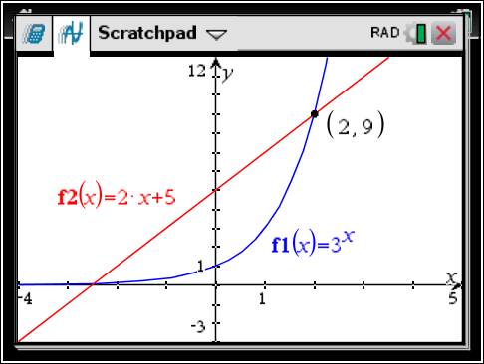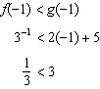

REF: 061515ai

4 ANS: 3
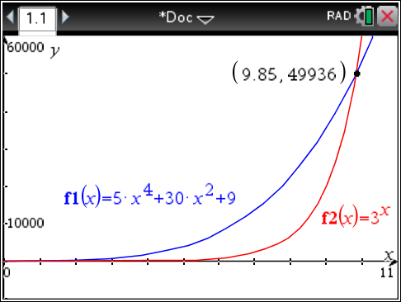

REF: 061621ai

5 ANS: 1

REF: 062411ai

6 ANS: 3
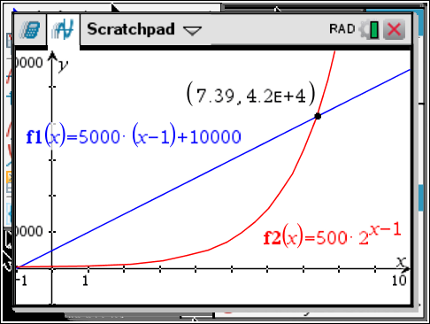

x
6 | 35,000 | 16,000
7 | 40,000 | 32,000
8 | 45,000 | 64,000
9 | 50,000 | 128,000

REF: 081518ai

7 ANS: 3
, , ; , ,

REF: 011916ai

8 ANS:
, ; both, since and

REF: 061736ai

9 ANS:
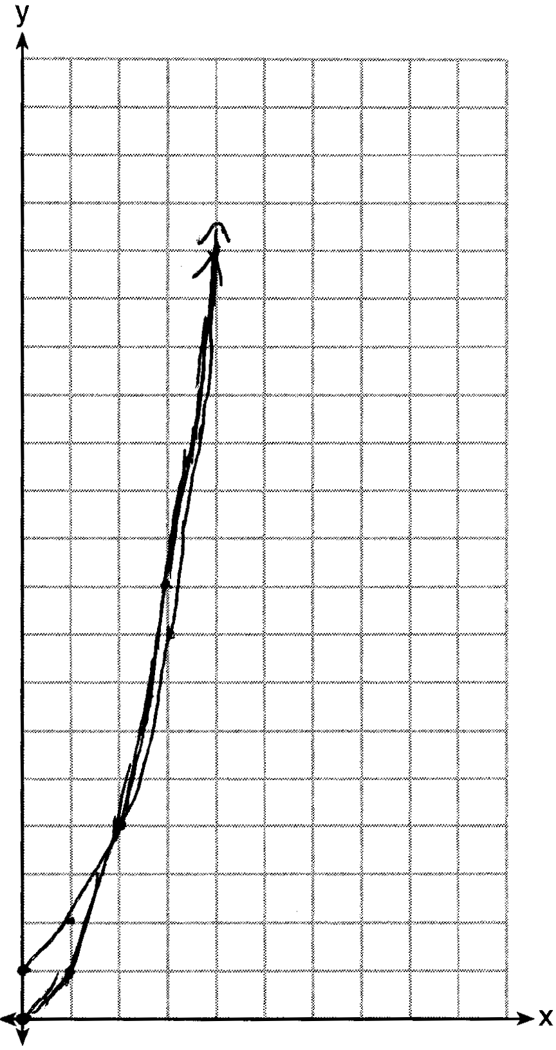 has a greater value:

REF: 081533ai

