1 Which chart could represent the function ?
1) | 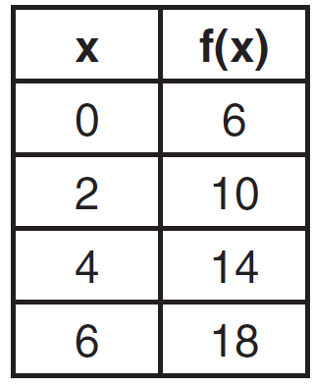
2) | 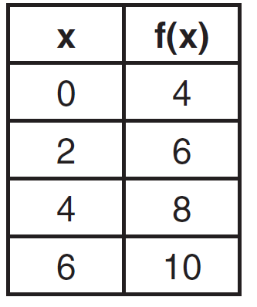
3) | 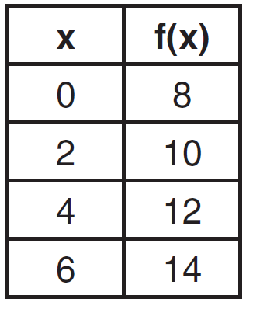
4) | 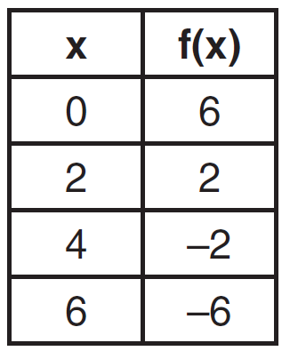

2 Which equation expresses the relationship between x and y, as shown in the accompanying table?

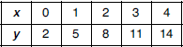
1)
2)
3)
4)

3 If x and y are defined as indicated by the accompanying table, which equation correctly represents the relationship between x and y?

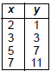
1)
2)
3)
4)

4 Which linear equation represents the data in the accompanying table?

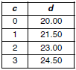
1)
2)
3)
4)

5 Each day Toni records the height of a plant for her science lab. Her data are shown in the table below.

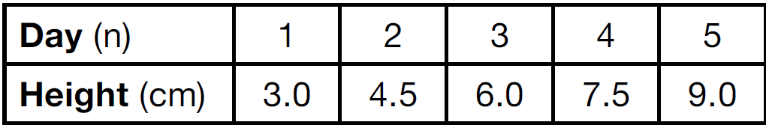

The plant continues to grow at a constant daily rate. Write an equation to represent , the height of the plant on the nth day.

6 Tanya is making homemade greeting cards. The data table below represents the amount she spends in dollars, , in terms of the number of cards she makes, x.

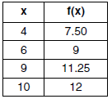

Write a linear function, , that represents the data. Explain what the slope and y-intercept of mean in the given context.

7 Which equation is represented by the graph below?

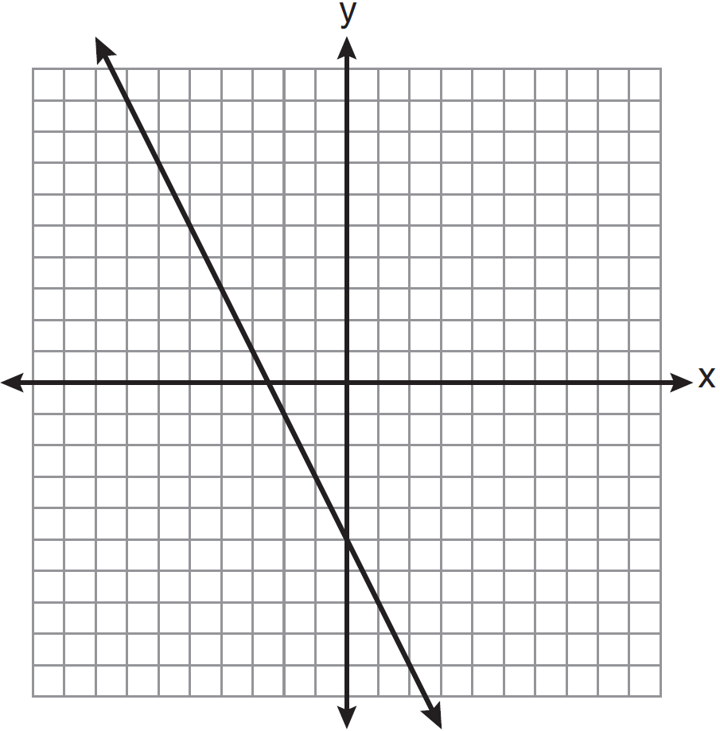
1)
2)
3)
4)

8 Write the equation for the line shown in the accompanying graph. Explain your answer.

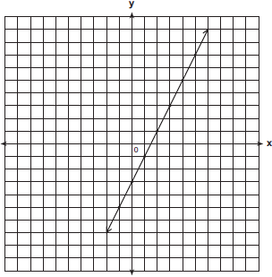

1 ANS: 4 REF: 081604ai

2 ANS: 3 REF: 010813a

3 ANS: 4 REF: 010211a

4 ANS: 2 REF: 080420a

5 ANS:

REF: 081525ai

6 ANS:
. Each card costs 75¢ and start-up costs were $4.50.

REF: 011735ai

7 ANS: 4

REF: 061221ia

8 ANS:
. The y-intercept is -3, and the line has a slope of 2. The equation for the line is
.

REF: 060225a

