1 What is the equation of the graph shown below?

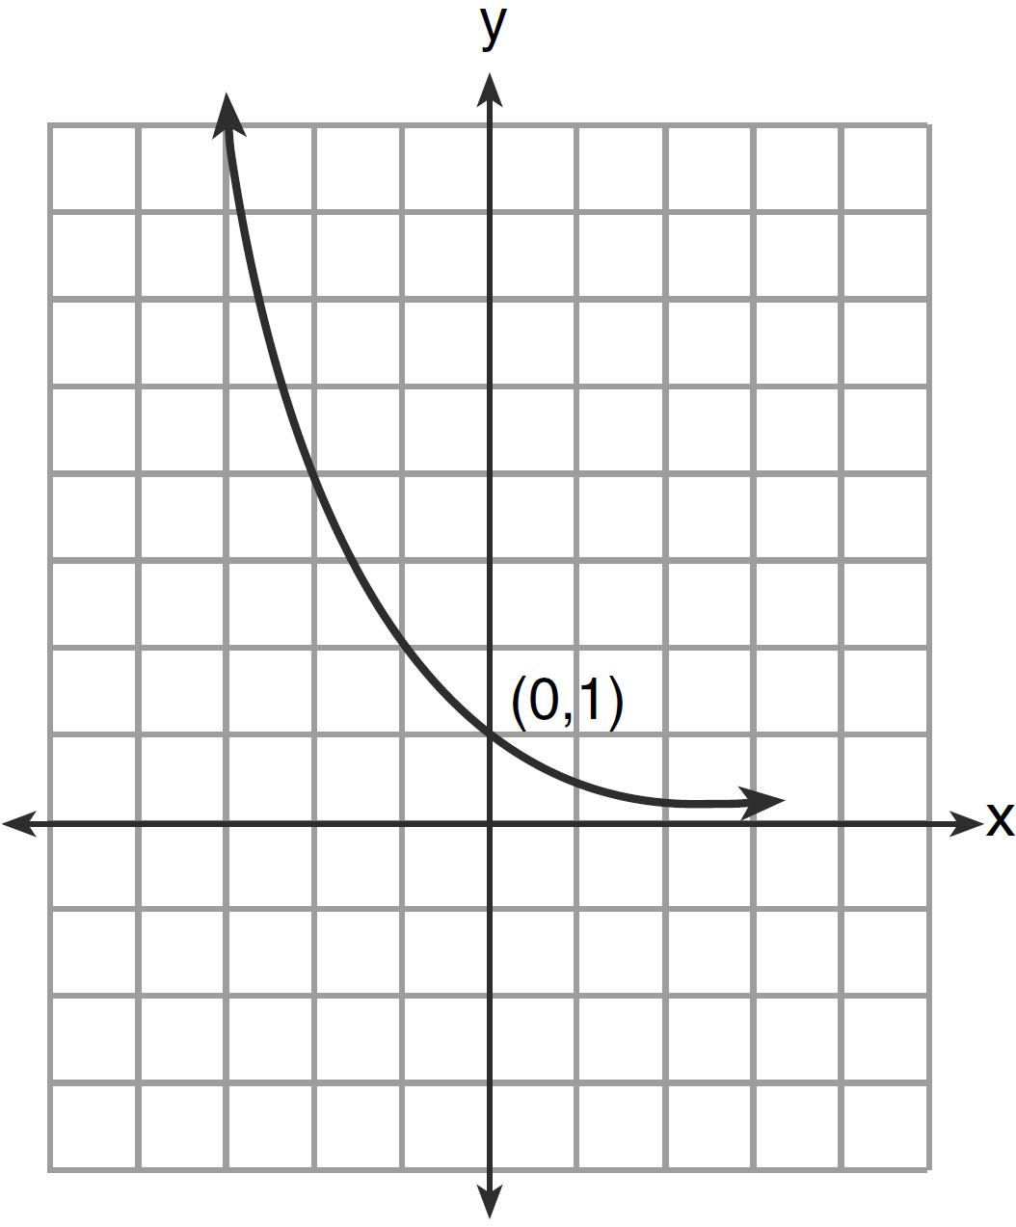
1) |  | 3)
2) |  | 4)

2 Which equation is represented by the graph below?

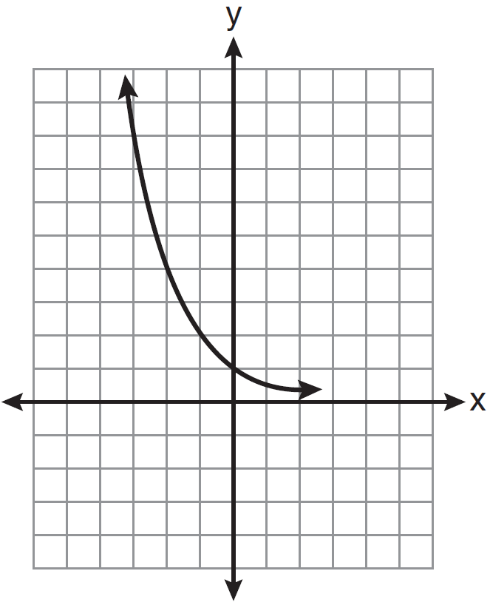
1) |  | 3)
2) |  | 4)

3 Write an exponential equation for the graph shown below.

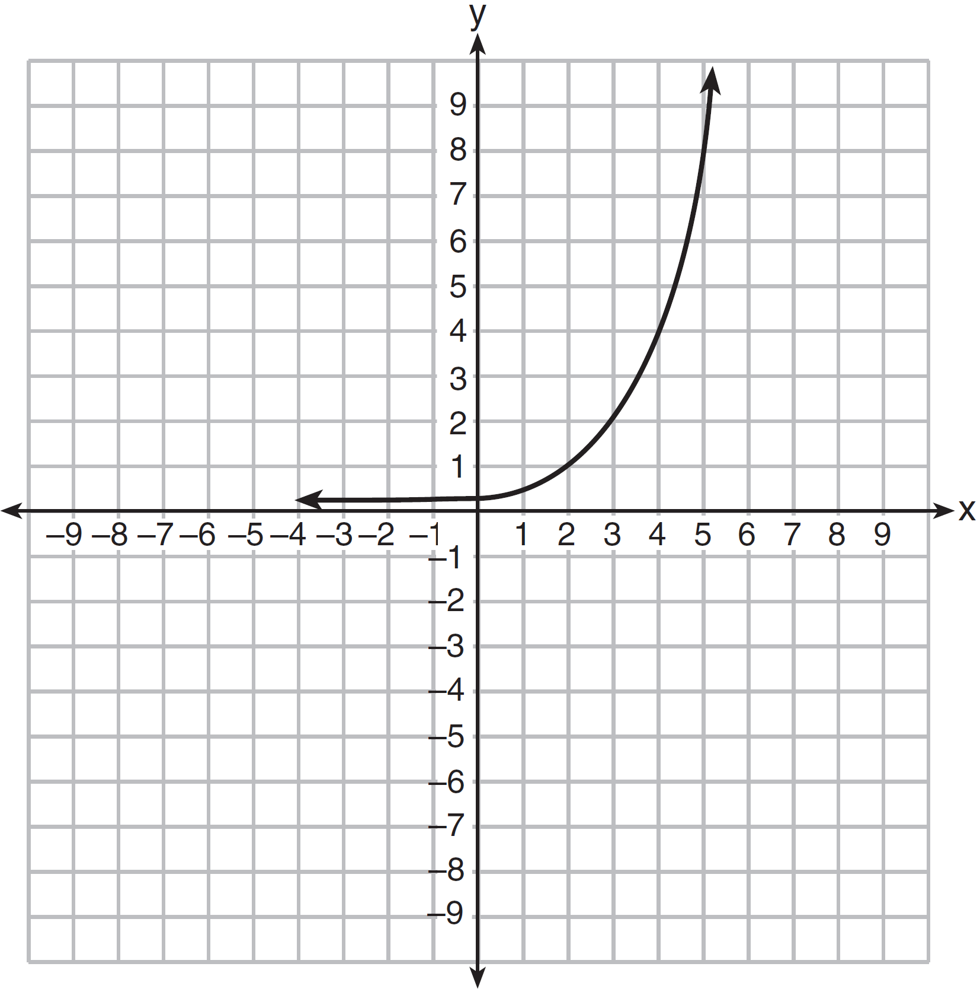

Explain how you determined the equation.

4 The table below shows the temperature, , of a cup of hot chocolate that is allowed to chill over several minutes, m.

Time, m (minutes) | 0 | 2 | 4 | 6 | 8
Temperature, T(m) (ºF) | 150 | 108 | 78 | 56 | 41

Which expression best fits the data for ?
1) |  | 3)
2) |  | 4)

5 Marc bought a new laptop for $1250. He kept track of the value of the laptop over the next three years, as shown in the table below.

Years After Purchase | Value in Dollars
1 | 1000
2 | 800
3 | 640

Which function can be used to determine the value of the laptop for x years after the purchase?
1) |  | 3)
2) |  | 4)

6 Jill invests $400 in a savings bond. The value of the bond, , in hundreds of dollars after x years is illustrated in the table below.

x | V(x)
0 | 4
1 | 5.4
2 | 7.29
3 | 9.84

Which equation and statement illustrate the approximate value of the bond in hundreds of dollars over time in years?
1) | and it grows. | 3) | and it grows.
2) | and it decays. | 4) | and it decays.

7 Mike knows that and are points on the graph of an exponential function, , and he wants to find another point on the graph of this function. First, he subtracts 6.5 from 17.55 to get 11.05. Next, he adds 11.05 and 17.55 to get 28.6. He states that is a point on . Is he correct? Explain your reasoning.
1 ANS: 2 REF: 011301a2

2 ANS: 2 REF: 061108a2

3 ANS:
. I inputted the four integral values from the graph into my graphing calculator and determined the exponential regression equation.

REF: 011532ai

4 ANS: 1 REF: 081617ai

5 ANS: 4 REF: 011912ai

6 ANS: 3
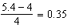

REF: 011802ai

7 ANS:
No. He found another point if were a linear function.

REF: 062129ai

