1 The graph below represents the relationship of transported particle size to water velocity? The graph best models which type of function?

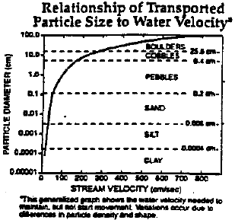
1) | linear | 3) | logarithmic
2) | quadratic | 4) | trigonometric

2 The accompanying graph represents the value of a bond over time.

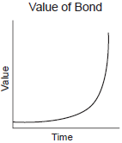

Which type of function does this graph best model?
1) | trigonometric | 3) | quadratic
2) | logarithmic | 4) | exponential

3 The shaded portion of the accompanying map indicates areas of night, and the unshaded portion indicates areas of daylight at a particular moment in time.

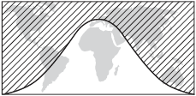

Which type of function best represents the curve that divides the area of night from the area of daylight?
1) | quadratic | 3) | tangent
2) | cosine | 4) | logarithmic

4 Which type of function could be used to model the data shown in the accompanying graph?

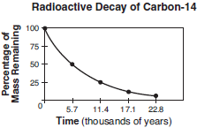
1) | exponential | 3) | trigonometric
2) | quadratic | 4) | linear

5 The family of curves shown in the accompanying graph illustrates the transformations of a function.

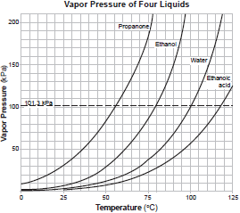

Which type of function could be the original function?
1) | linear | 3) | exponential
2) | tangent | 4) | sinusoidal

6 The accompanying graph shows the average daily readership, in thousands, of the newspaper “El Diario La Prensa.”

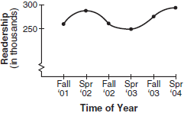

Which type of function best represents this graph?
1) | exponential | 3) | trigonometric
2) | logarithmic | 4) | quadratic

7 Perry invested in property that cost him $1500. Five years later it was worth $3000, and 10 years from his original purchase, it was worth $6000. Assuming the growth rate remains the same, which type of function could he create to find the value of his investment 30 years from his original purchase?
1) | exponential function | 3) | quadratic function
2) | linear function | 4) | trigonometric function

8 Which function is shown in the table below?

x | f(x)
0 | 1
1 | 3
2 | 9
3 | 27

1) |  | 3)
2) |  | 4)

9 Which table best represents an exponential relationship?
1) | 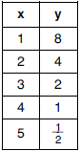 | 3) | 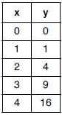
2) | 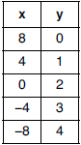 | 4) | 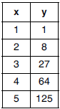

10 Vinny collects population data, , about a specific strain of bacteria over time in hours, h, as shown in the graph below.

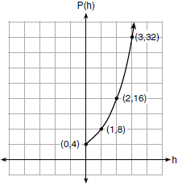

Which equation represents the graph of ?
1) |  | 3)
2) | 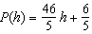 | 4) | 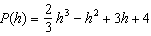

11 The graph of is shown below.

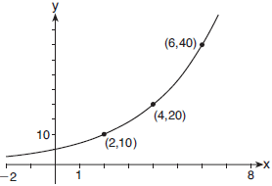

Which expression defines ?
1) |  | 3) | 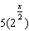
2) |  | 4)

12 Which is the equation of the graph shown below?

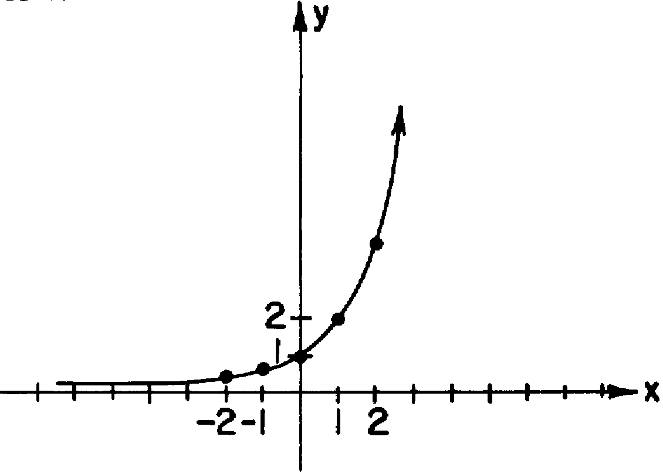
1) |  | 3)
2) |  | 4)

13 Which equation is represented by the accompanying graph?

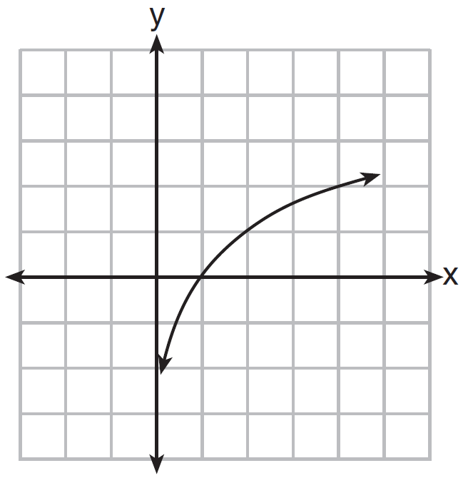
1) |  | 3)
2) |  | 4)

14 Four points on the graph of the function are shown below.
Which equation represents ?
1) |  | 3)
2) |  | 4)

1 ANS: 3 REF: fall9901b

2 ANS: 4 REF: 010203b

3 ANS: 2 REF: 010502b

4 ANS: 1 REF: 080710b

5 ANS: 3 REF: 080808b

6 ANS: 3 REF: 060913b

7 ANS: 1 REF: 081903aii

8 ANS: 4 REF: 011616ai

9 ANS: 1
2) linear, 3) quadratic, 4) cubic

REF: 061920aii

10 ANS: 1 REF: 061707ai

11 ANS: 3 REF: 061906aii

12 ANS: 3 REF: 088629siii

13 ANS: 4 REF: 061016b

14 ANS: 1 REF: 061004a2

