1 Which equation is represented by the accompanying graph?

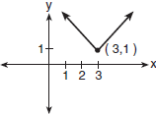
1)
2)
3)
4)

2 Which equation is represented by the graph below?

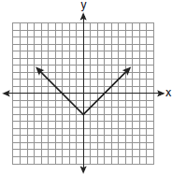
1)
2)
3)
4)

3 Which equation represents a quadratic function?
1)
2)
3)
4)

4 Which equation is best represented by the accompanying graph?

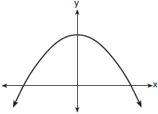
1)
2)
3)
4)

5 The graph below can be represented by which equation?

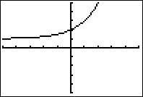
1)
2)
3)
4)

6 Which equation best represents the accompanying graph?

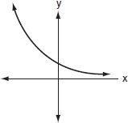
1)
2)
3)
4)

7 Which equation is represented by the accompanying graph?

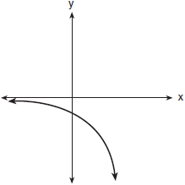
1)
2)
3)
4)

8 The table below represents the function F.

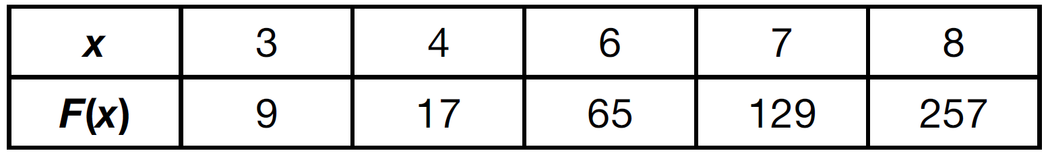

The equation that represents this function is
1)
2)
3)
4)

9 Which equation could represent the relationship between the x and y values shown in the accompanying table?

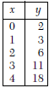
1)
2)
3)
4)

10 Which equation models the data in the accompanying table?

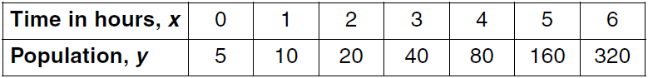
1)
2)
3)
4)

11 A laboratory technician studied the population growth of a colony of bacteria. He recorded the number of bacteria every other day, as shown in the partial table below.

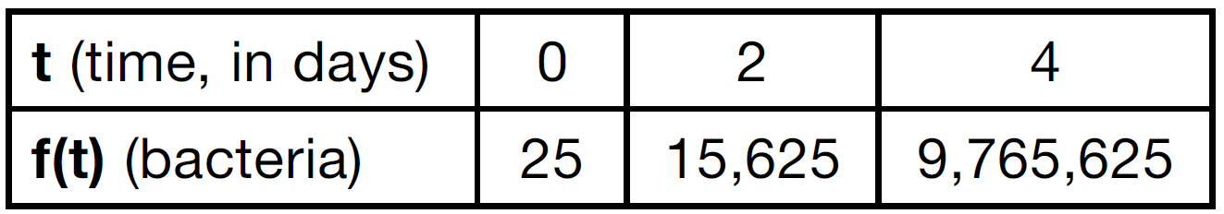

Which function would accurately model the technician's data?
1)
2)
3)
4)

12 If a population of 100 cells triples every hour, which function represents , the population after t hours?
1)
2)
3)
4)

13 The accompanying diagram represents the biological process of cell division.

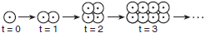

If this process continues, which expression best represents the number of cells at any time, t?
1)
2)
3)
4)

1 ANS: 4 REF: 060314b

2 ANS: 3 REF: 080925ia

3 ANS: 3 REF: 081118ia

4 ANS: 4 REF: 060703b

5 ANS: 4 REF: fall9902b

6 ANS: 3 REF: 010701b

7 ANS: 2 REF: 080901b

8 ANS: 3 REF: 061415ai

9 ANS: 2 REF: 010113a

10 ANS: 4 REF: 060411b

11 ANS: 2 REF: 061513ai

12 ANS: 2 REF: 081714ai

13 ANS: 4 REF: 060909b

