1 Which type of graph is shown in the diagram below?

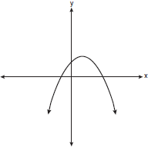
1) | absolute value | 3) | linear
2) | exponential | 4) | quadratic

2 Which type of function is represented by the graph shown below?

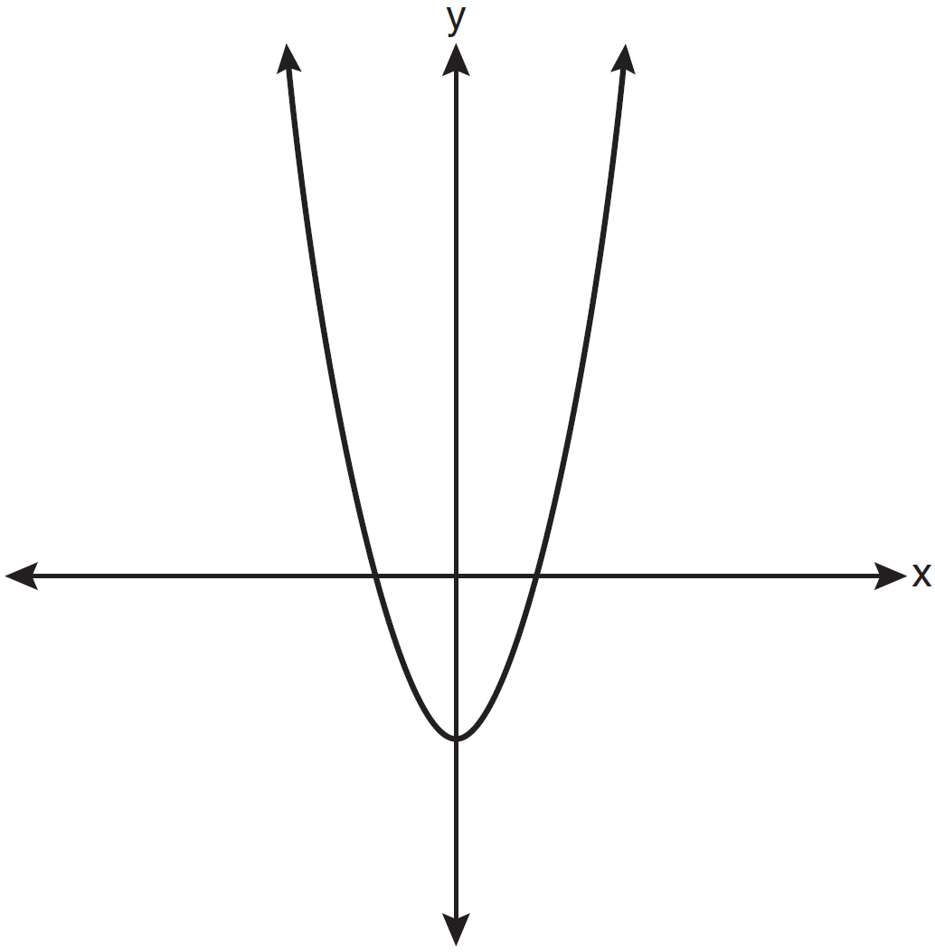
1) | absolute value | 3) | linear
2) | exponential | 4) | quadratic

3 Which type of function is graphed below?

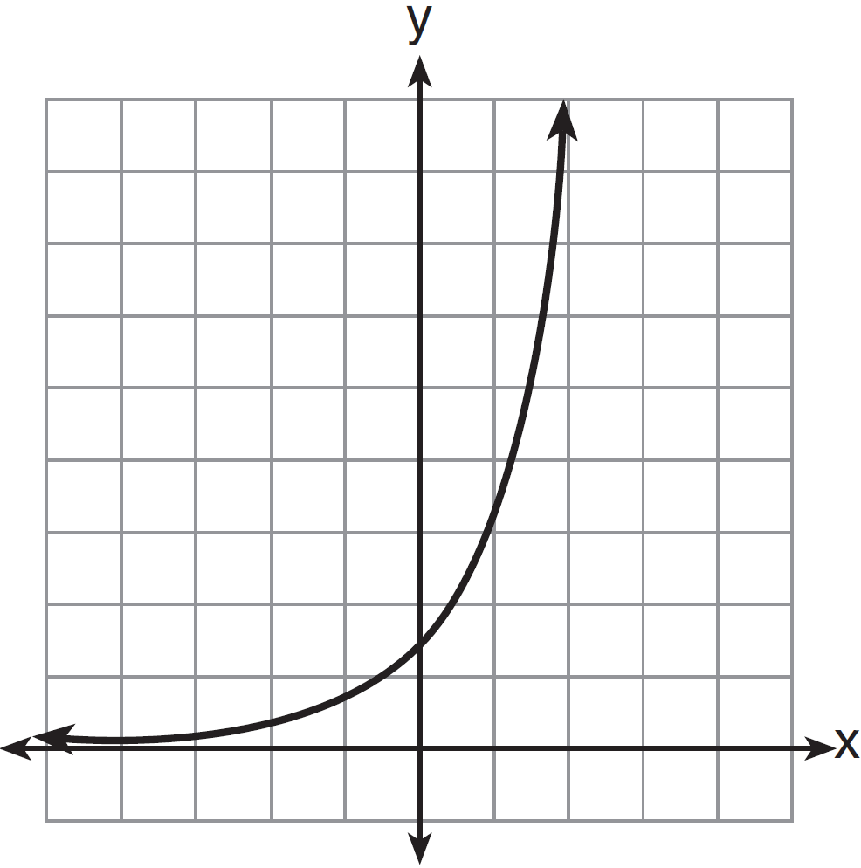
1) | linear | 3) | exponential
2) | quadratic | 4) | absolute value

4 Which graph represents a linear function?
1) | 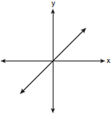 | 3) | 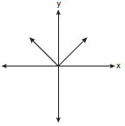
2) | 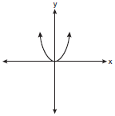 | 4) | 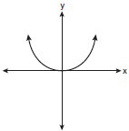

5 Which graph represents the exponential decay of a radioactive element?
1) | 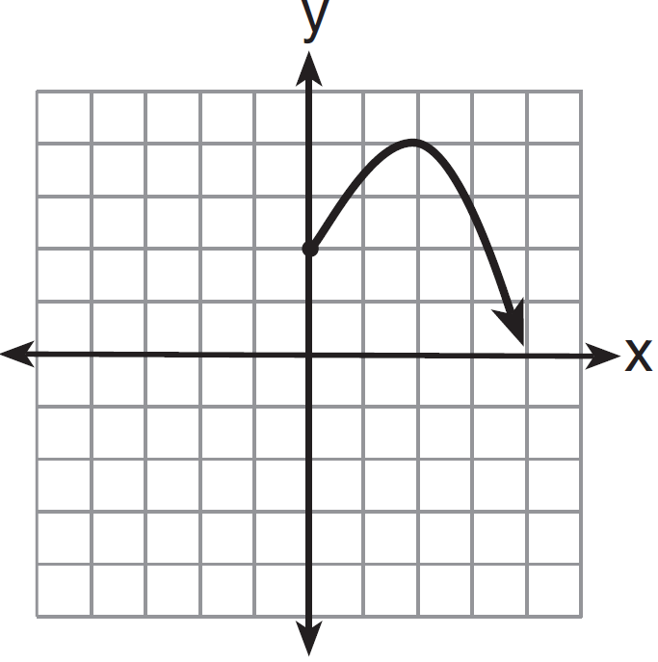 | 3) | 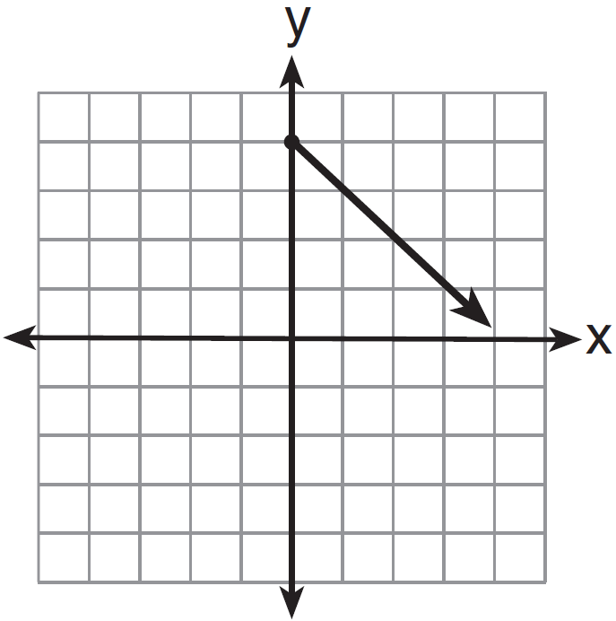
2) | 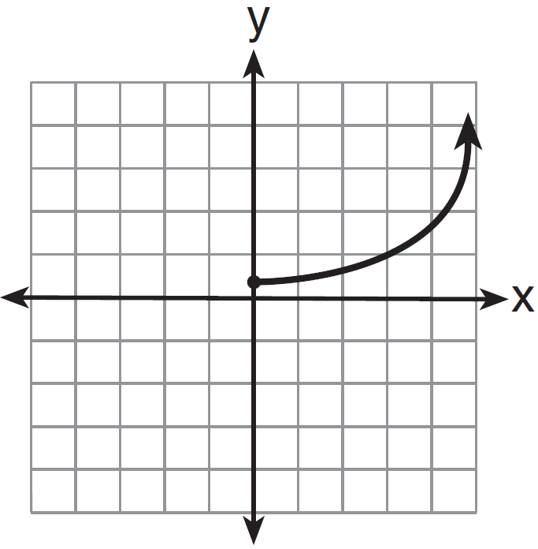 | 4) | 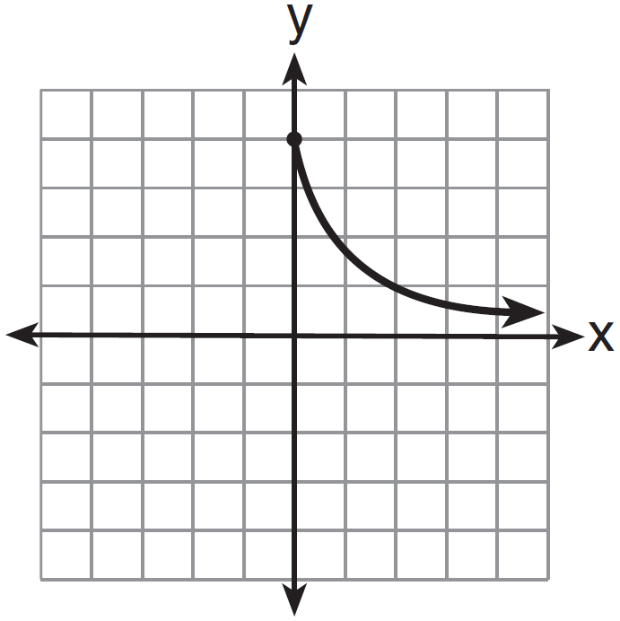

6 On January 1, a share of a certain stock cost $180. Each month thereafter, the cost of a share of this stock decreased by one-third. If x represents the time, in months, and y represents the cost of the stock, in dollars, which graph best represents the cost of a share over the following 5 months?
1) | 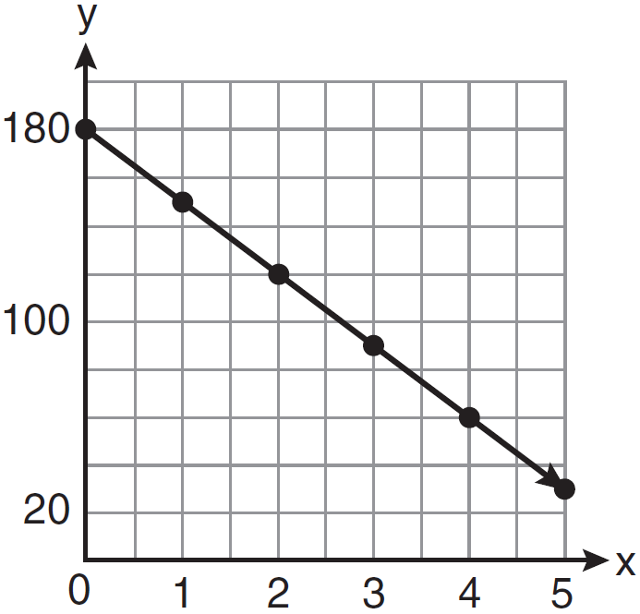 | 3) | 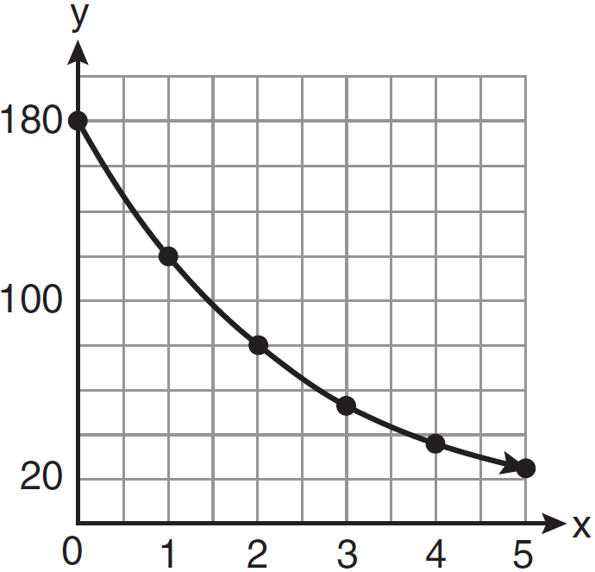
2) | 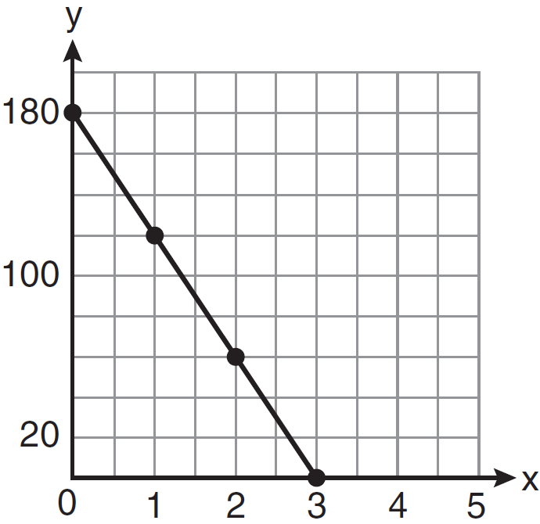 | 4) | 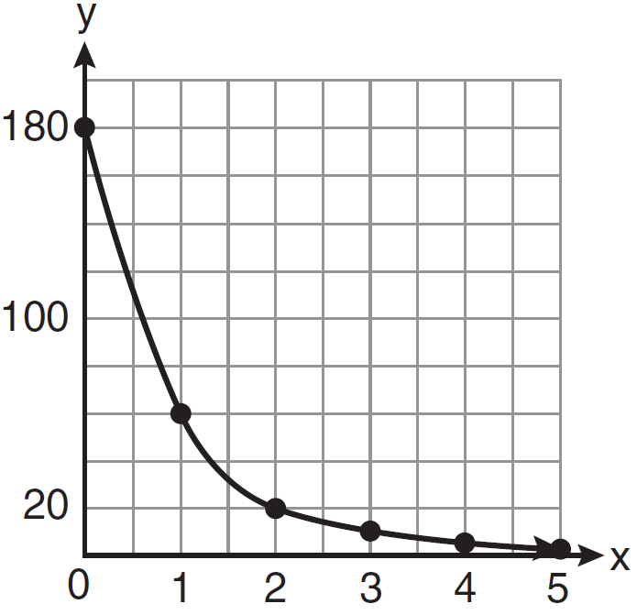

7 Antwaan leaves a cup of hot chocolate on the counter in his kitchen. Which graph is the best representation of the change in temperature of his hot chocolate over time?
1) | 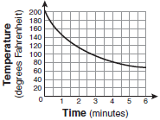 | 3) | 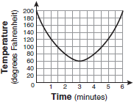
2) | 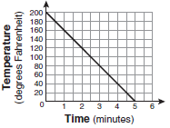 | 4) | 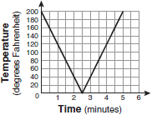

8 An investment is earning 5% interest compounded quarterly. The equation represents the total amount of money, A, where P is the original investment, r is the interest rate, t is the number of years, and n represents the number of times per year the money earns interest. Which graph could represent this investment over at least 50 years?
1) | 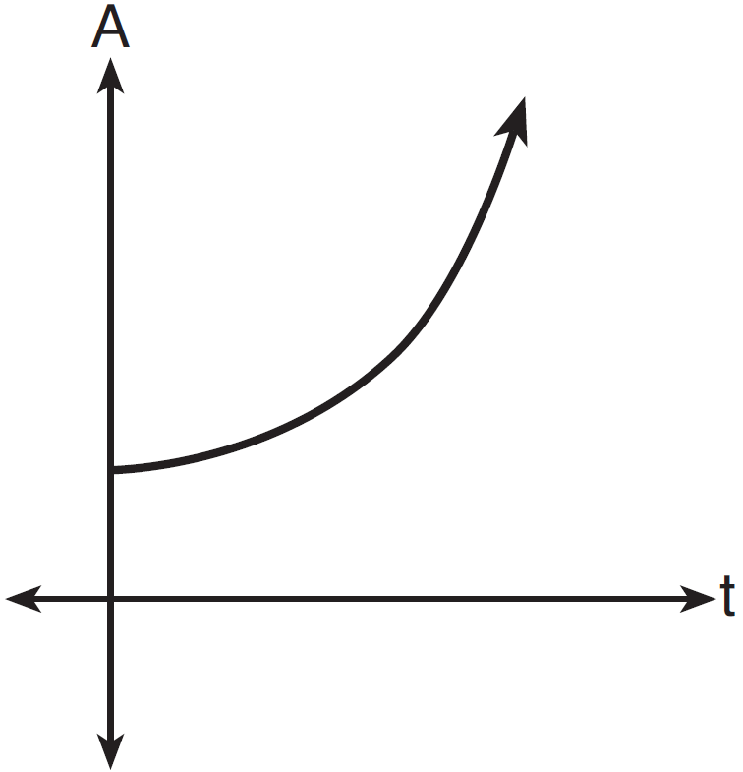 | 3) | 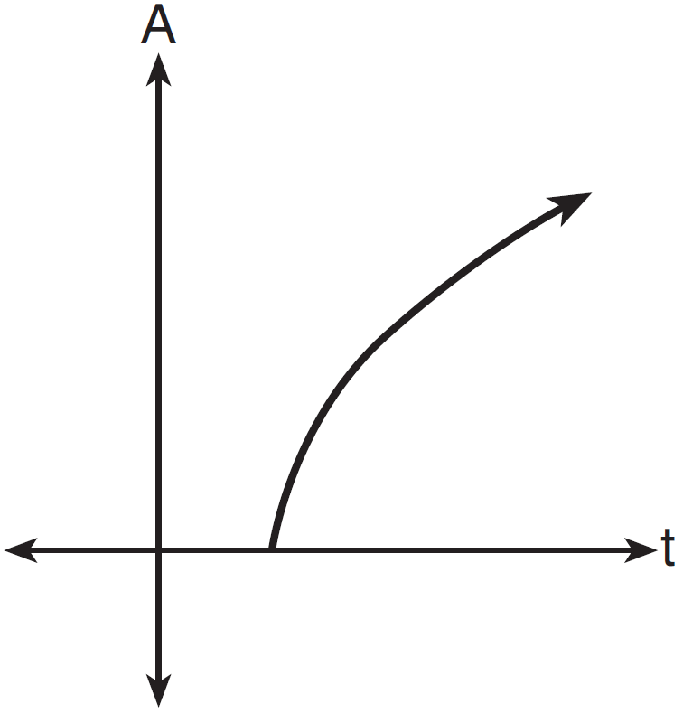
2) | 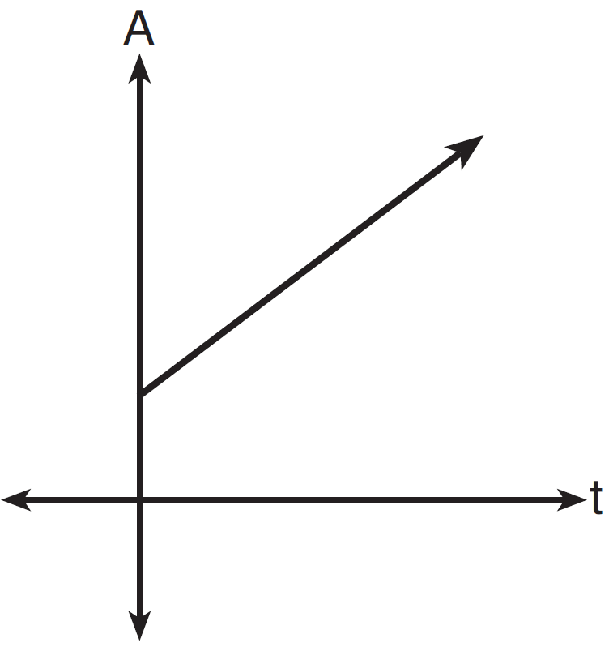 | 4) | 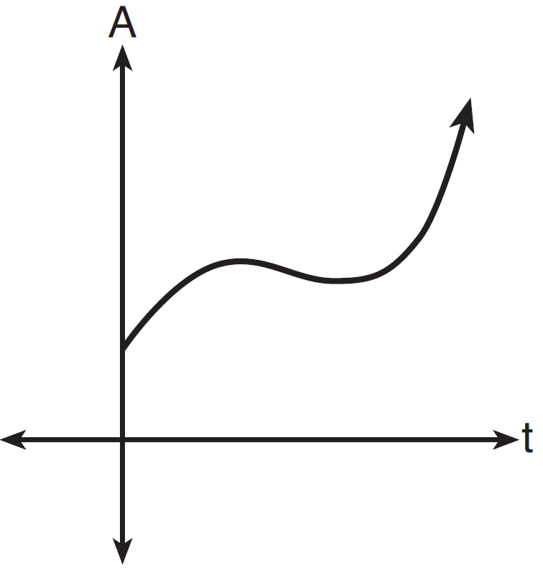

9 Which graph represents an exponential equation?
1) | 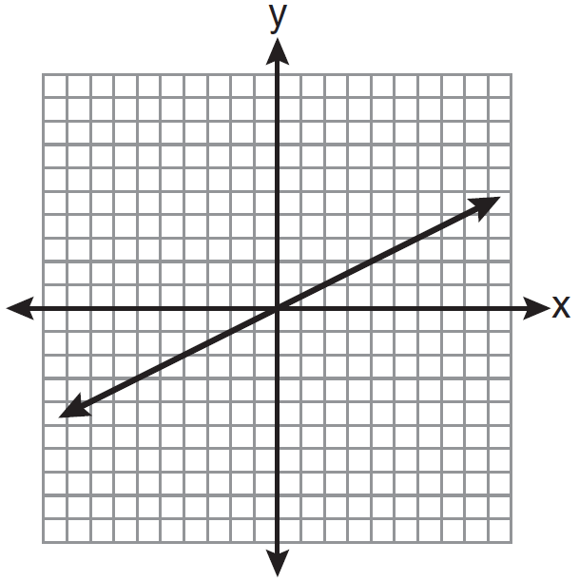 | 3) | 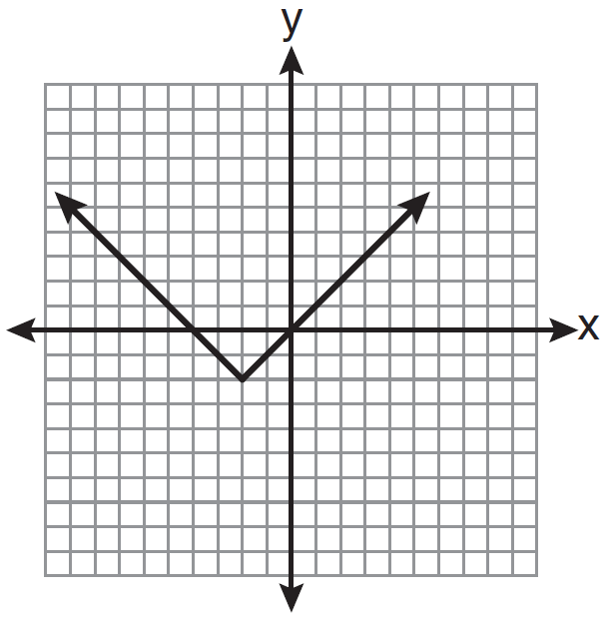
2) | 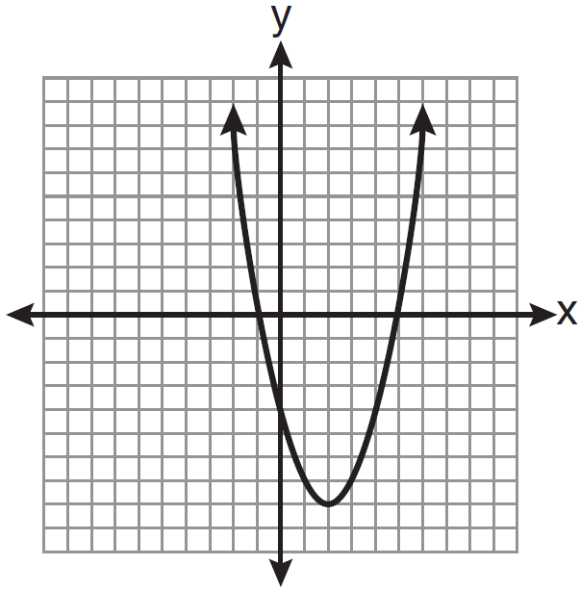 | 4) | 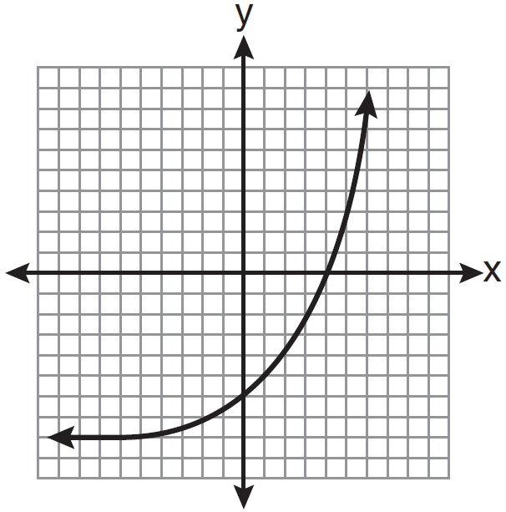

10 Which graph represents an absolute value equation?
1) | 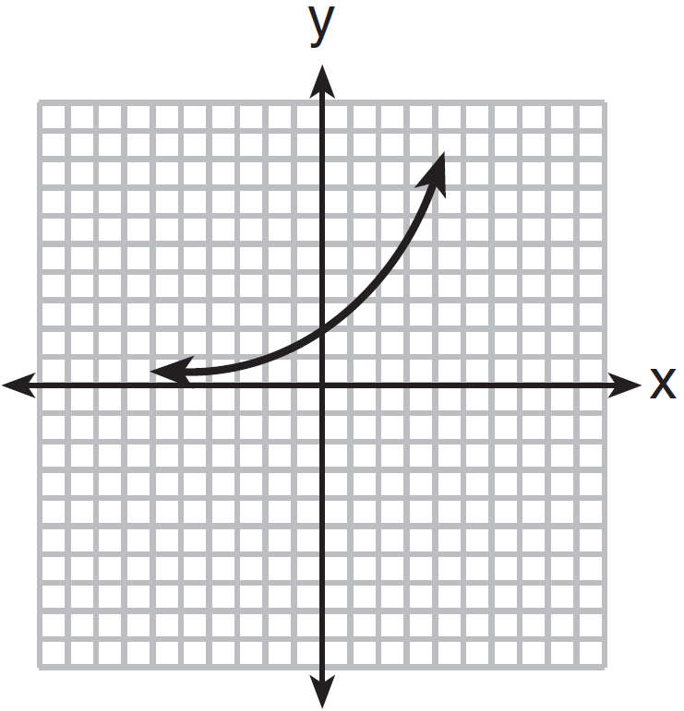 | 3) | 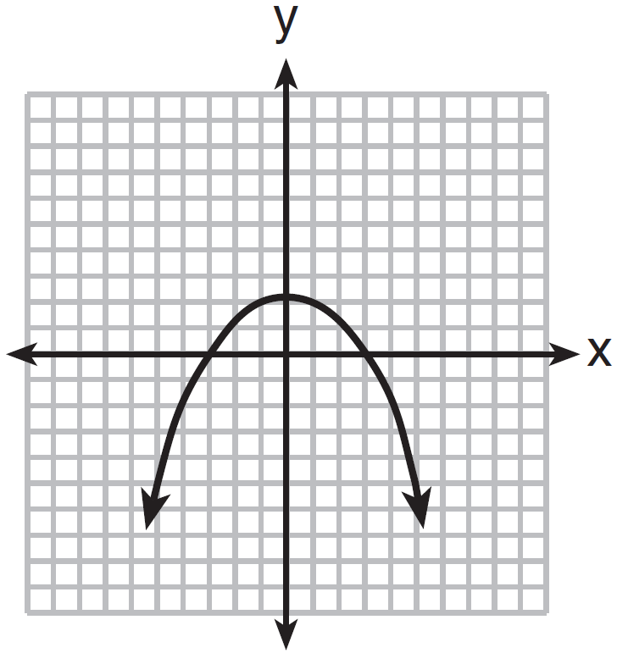
2) | 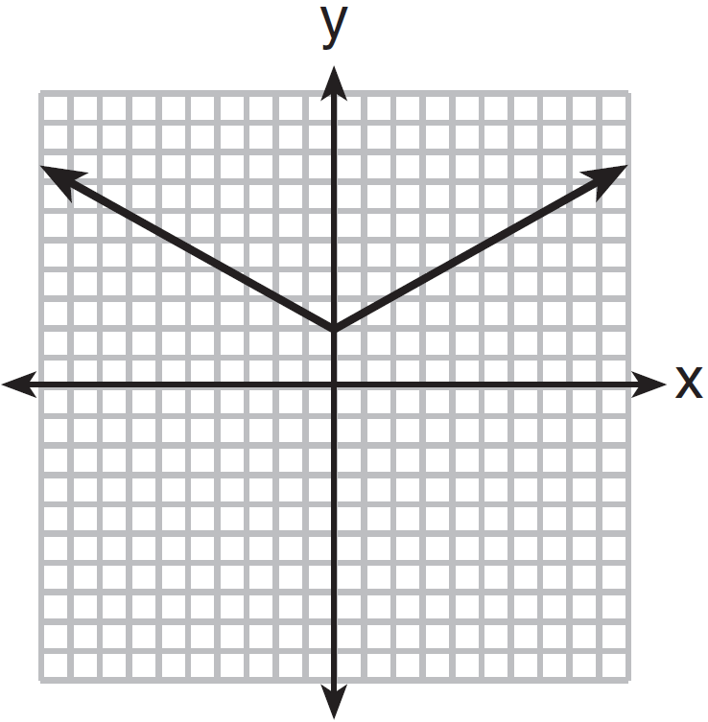 | 4) | 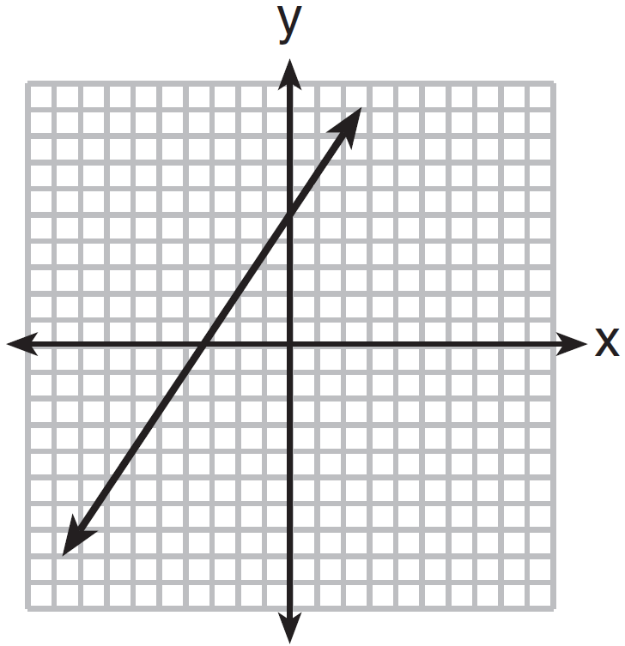

1 ANS: 4 REF: fall0717ia

2 ANS: 4 REF: 061111ia

3 ANS: 3 REF: 061318ia

4 ANS: 1 REF: 060801ia

5 ANS: 4 REF: 011423ia

6 ANS: 3 REF: 011119a2

7 ANS: 1 REF: 010905ia

8 ANS: 1 REF: 011505a2

9 ANS: 4 REF: 081025ia

10 ANS: 2 REF: 061423ia

