1 Which quadratic function has the largest maximum over the set of real numbers?
1) |  | 3)
2) | 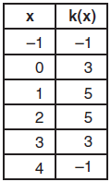 | 4) | 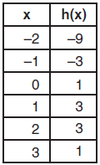

2 Which quadratic function has the largest maximum?
1) |  | 3)
2) | 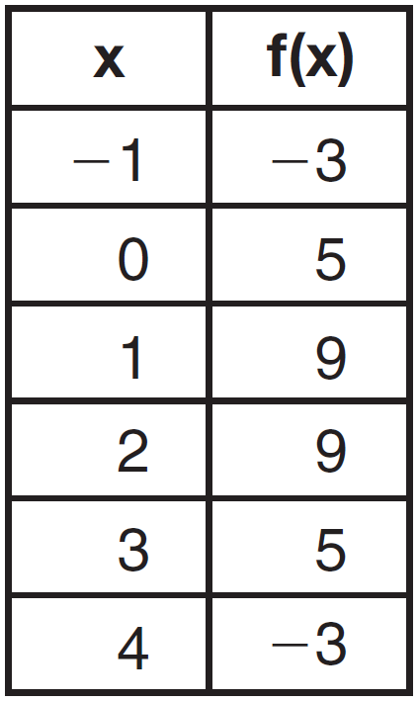 | 4) | 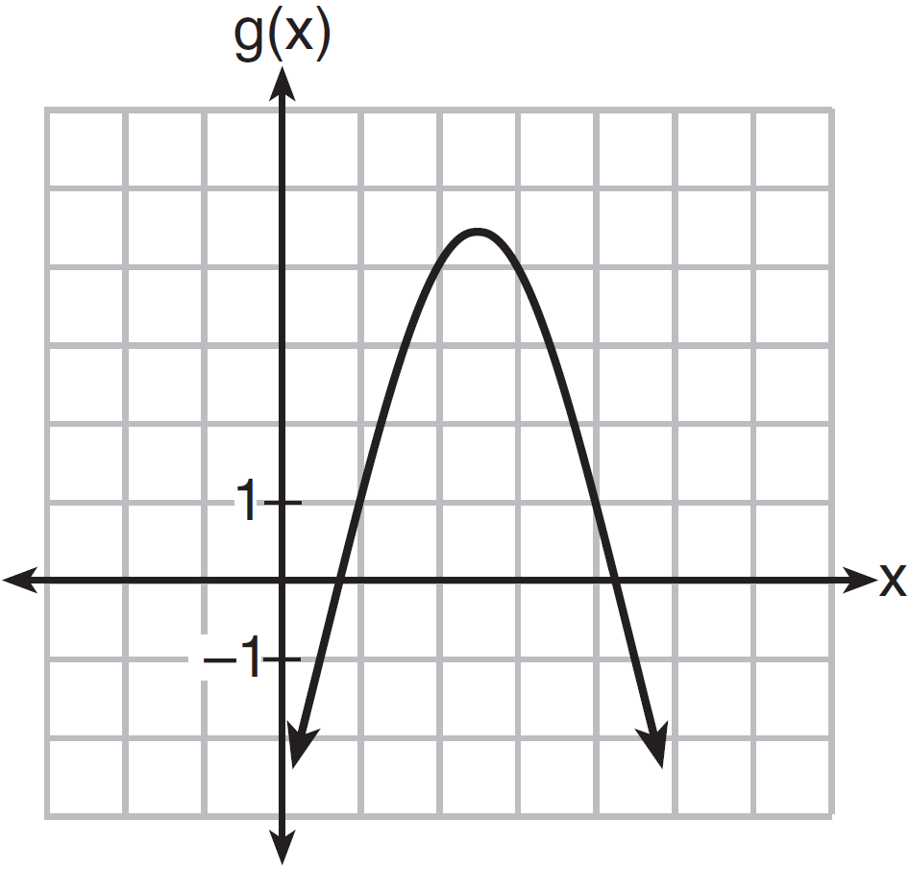

3 Which of the quadratic functions below has the smallest minimum value?
1) |  | 3)
2) | 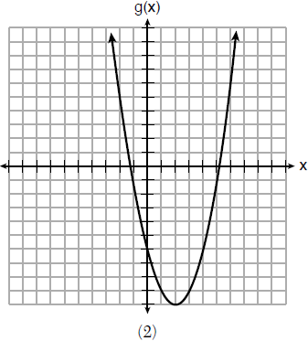 | 4) | 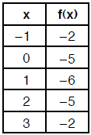

4 Four quadratic functions are represented below.

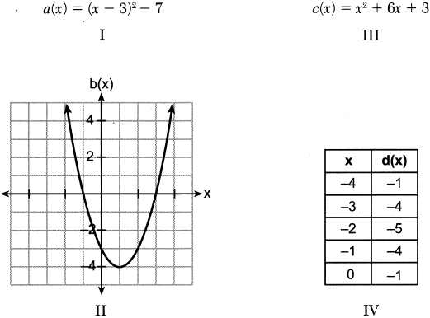

Which function has the smallest minimum value?
1) | I | 3) | III
2) | II | 4) | IV

5 Which quadratic function has the smallest minimum value?
1) |  | 3)
2) | 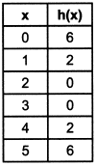 | 4) | 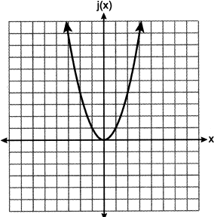

6 The quadratic functions and are given below.

x | r(x)
0
1 | 7

The function with the smaller minimum value is
1) | , and the value is | 3) | , and the value is
2) | , and the value is | 4) | , and the value is

7 Four quadratic functions are shown below.
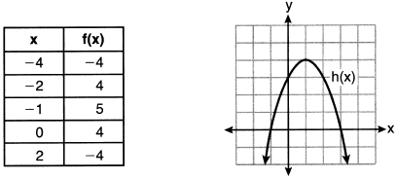

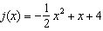
Which statement is true?
1) | The maximum of f(x) is less than the maximum of j(x). | 3) | The maximum of f(x) equals the maximum of g(x).
2) | The maximum of g(x) is less than the maximum of h(x). | 4) | The maximum of h(x) equals the maximum of j(x).

8 Three quadratic functions are given below.

I.

II.
x |  |  |  |  | 0 | 1
g(x) |  | 2 | 5 | 5 | 2

III.
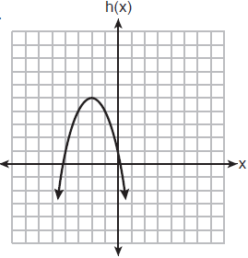

Which of these functions have the same vertex?
1) | I and II, only | 3) | I and III, only
2) | II and III, only | 4) | I, II, and III

9 Which statement is true about the quadratic functions , shown in the table below, and ?

x | g(x)
0 | 4
1
2
3
4
5
6 | 4

1) | They have the same vertex. | 3) | They have the same axis of symmetry.
2) | They have the same zeros. | 4) | They intersect at two points.

10 Which statement is true about the functions and , given below?

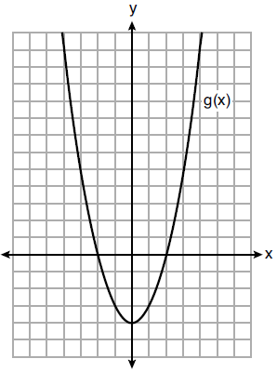

1) | The minimum value of is greater than the maximum value of . | 3) | and have the same roots.
2) | and have the same y-intercept. | 4) | when .

11 Given the following quadratic functions:
and
x |  |  |  | 0 | 1 | 2 | 3 | 4 | 5
n(x) |  | 0 | 5 | 8 | 9 | 8 | 5 | 0

Which statement about these functions is true?
1) | Over the interval , the average rate of change for is less than that for . | 3) | The function has a greater maximum value than .
2) | The y-intercept of is greater than the y-intercept for . | 4) | The sum of the roots of is greater than the sum of the roots of .

12 Let f be the function represented by the graph below.

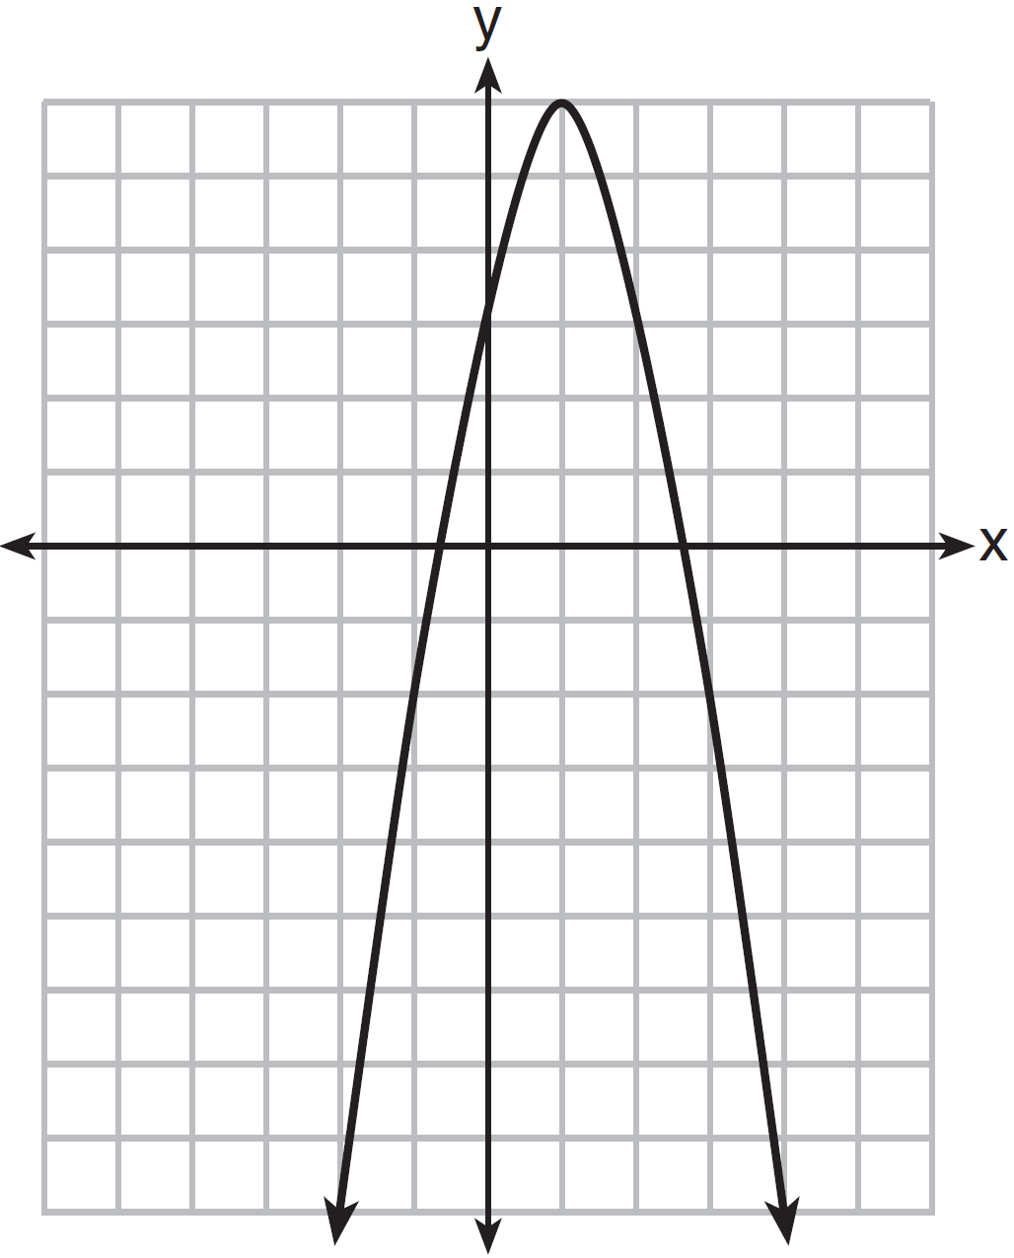

Let g be a function such that 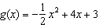. Determine which function has the larger maximum value. Justify your answer.
1 ANS: 2
1) 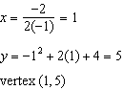; 2) 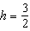 Using , 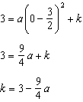; Using , 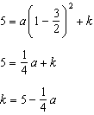 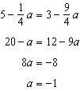 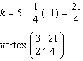; 3) vertex ; 4) Using 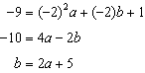 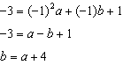 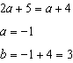 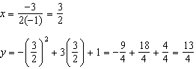 vertex 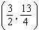

REF: 011823ai

2 ANS: 3
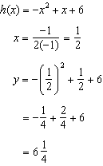Maximum of 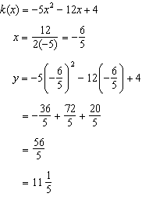 Maximum of

REF: 061514ai

3 ANS: 2
1) 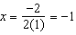, ; 2) ; 3) 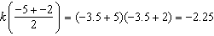; 4)

REF: 061813ai

4 ANS: 1
1) ; 2) ; 3) 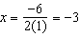, ; 4)

REF: 062414ai

5 ANS: 1
1) 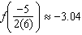; 2) ; 3) ; 4) 0

REF: 012320ai

6 ANS: 3
The minimum of is . The minimum of is 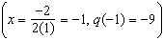.

REF: 081917ai

7 ANS: 3
Maximum of Maximum of Maximum of 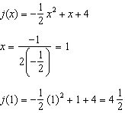

REF: 062219ai

8 ANS: 3
f and h’s vertex is . g’s axis of symmetry is .

REF: 062319ai

9 ANS: 3

REF: 061717ai

10 ANS: 2
The y-intercept of both and is .

REF: 012013ai

11 ANS: 4
1) 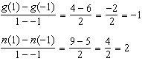 2) 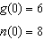 3) 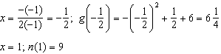
4) 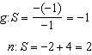

REF: 081521ai

12 ANS:
g. The maximum of f is 6. For g, the maximum is 11. 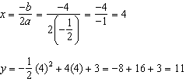

REF: 081429ai

