1 Which function has the greatest y-intercept?
1) |  | 3) | the line that has a slope of 2 and passes through
2) |  | 4) | 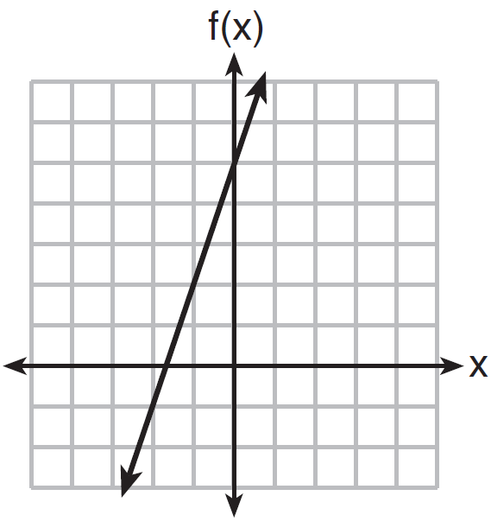

2 Which function has the largest y-intercept?
1) |  | 3)
2) | 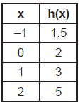 | 4) | 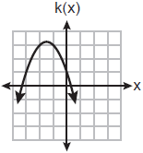

3 For which function is the value of the y-intercept the smallest?
1) | 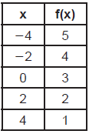 | 3) | 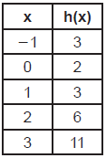
2) |  | 4)

4 Which function has the smallest y-intercept?
1) |  | 3)
2) | 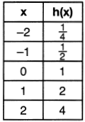 | 4) | 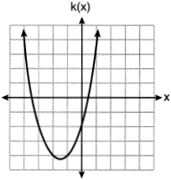

5 Which function has the smallest y-intercept value?
1) | 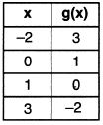 | 3) | 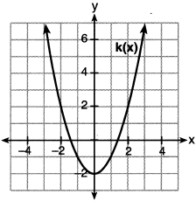
2) |  | 4)

6 Three functions are shown below.

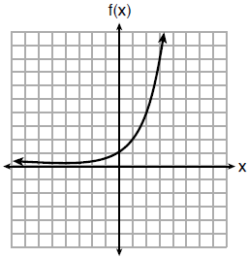

x | h(x)
 | 30
 | 14
 | 6
 | 2
 | 0
0
1
2

Which statement is true?
1) | The y-intercept for is greater than the y-intercept for . | 3) | The y-intercept for is greater than the y-intercept for both and .
2) | The y-intercept for is greater than the y-intercept for . | 4) | The y-intercept for is greater than the y-intercept for both and .

7 The graph representing a function is shown below.

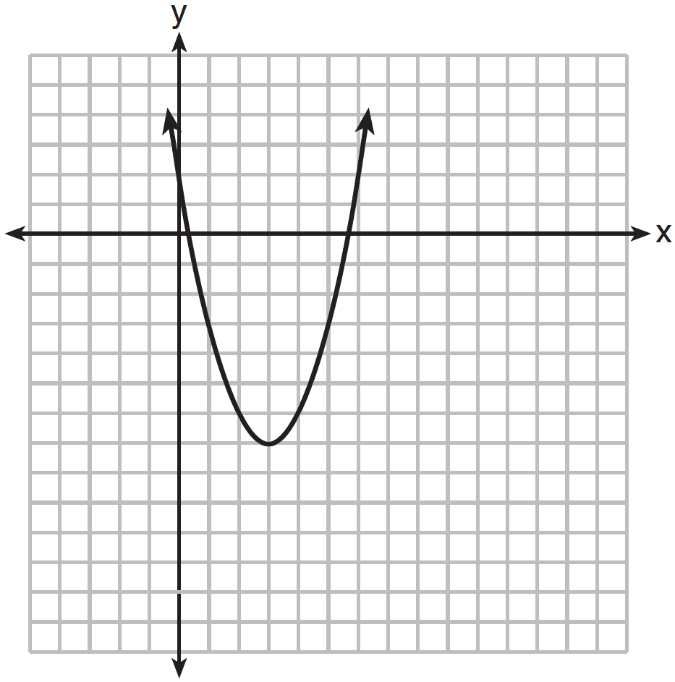

Which function has a minimum that is less than the one shown in the graph?
1) |  | 3)
2) |  | 4)

8 Three functions are shown below.
A: 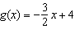
B:
C: 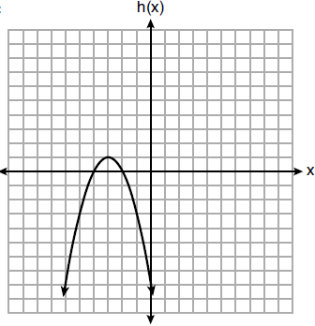
Which statement is true?
1) | B and C have the same zeros. | 3) | B has a minimum and C has a maximum.
2) | A and B have the same y-intercept. | 4) | C has a maximum and A has a minimum.

9 The function , which is graphed below, and the function are given.
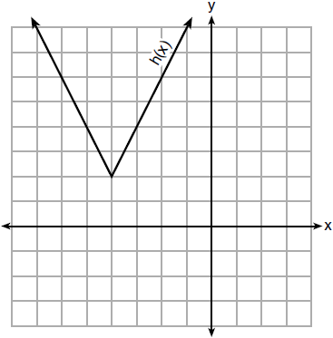
Which statements about these functions are true?
I. has a lower minimum value than .
II. For all values of x, .
III. For any value of x, .
1) | I and II, only | 3) | II and III, only
2) | I and III, only | 4) | I, II, and III

10 The functions and are shown below.
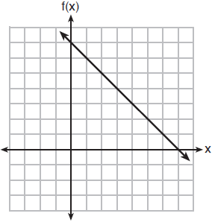

x | p(x)
2 | 5
3 | 4
4 | 3
5 | 4
6 | 5
When the input is 4, which functions have the same output value?
1) | and only | 3) | and , only
2) | and , only | 4) | and

11 Which graph does not represent a function that is always increasing over the entire interval ?
1) | 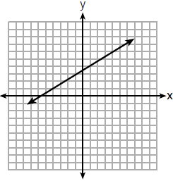 | 3) | 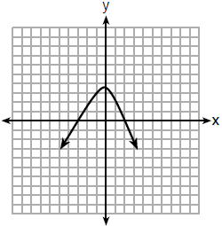
2) | 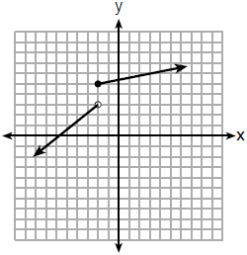 | 4) | 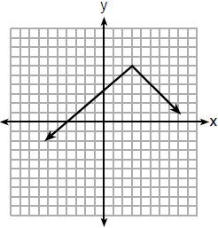

12 Nancy works for a company that offers two types of savings plans. Plan A is represented on the graph below.

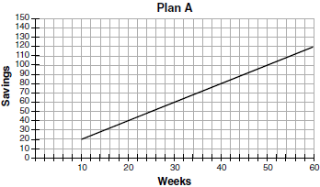

Plan B is represented by the function , where x is the number of weeks. Nancy wants to have the highest savings possible after a year. Nancy picks Plan B. Her decision is
1) | correct, because Plan B is an exponential function and will increase at a faster rate | 3) | incorrect, because Plan A will have a higher value after 1 year
2) | correct, because Plan B is a quadratic function and will increase at a faster rate | 4) | incorrect, because Plan B is a quadratic function and will increase at a slower rate

1 ANS: 4
1) ; 2) ; 3) ; 4)

REF: 081611ai

2 ANS: 3
1) -1; 2) 2; 3) 3; 4) 1

REF: 012411ai

3 ANS: 4

REF: 082314ai

4 ANS: 1
1) -6; 2) 1; 3) -2; 4) -2

REF: 062115ai

5 ANS: 2
1) 1; 2) -3; 3) -2; 4) -1

REF: 082214ai

6 ANS: 4
The y-intercept for is . The y-intercept for is . The y-intercept for is .

REF: 081811ai

7 ANS: 3 REF: 011622ai

8 ANS: 3
1) B’s zeros are and and C’s zeros are and ; 2) A’s y-intercept is 4 and B’s y-intercept is 12; 3) B in standard form, and C in standard form, ; d) A has no minimum

REF: 061914ai

9 ANS: 2
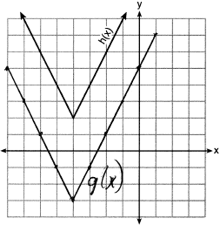

REF: 081718ai

10 ANS: 4

REF: 011921ai

11 ANS: 3 REF: 061820ai

12 ANS: 2 REF: 011723ai

