1 Which function represents exponential decay?
1) |  | 3) | 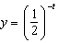
2) |  | 4)

2 Which function represents exponential decay?
1) | 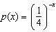 | 3)
2) |  | 4) | 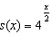

3 Which statement is true about the graph of 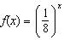?
1) | The graph is always increasing.
2) | The graph is always decreasing.
3) | The graph passes through .
4) | The graph has an asymptote, .

4 The population of bacteria, , in hundreds, after t hours can be modeled by the function . Determine whether the population is increasing or decreasing over time. Explain your reasoning.

5 The function represents the mass of radium over time, t, in years.

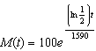

Determine if the function represents growth or decay. Explain your reasoning.
1 ANS: 4
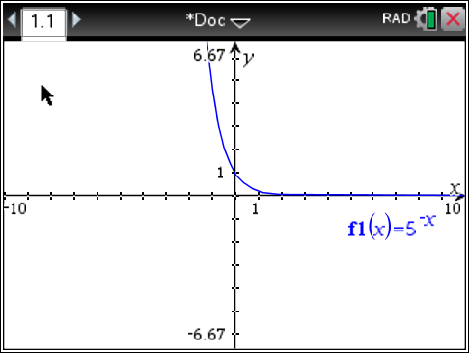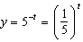

REF: 061615aii

2 ANS: 2
, 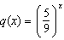, ,

REF: 012304aii

3 ANS: 2 REF: 061802aii

4 ANS:
, so is increasing.

REF: 062327aii

5 ANS:
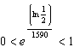, so represents decay.

REF: 011728aii

