1 Which graph represents a sound wave that follows a curve whose period is and that is in the form ?
1) | 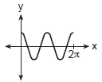
2) | 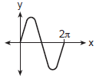
3) | 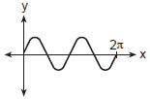
4) | 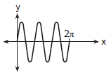

2 Which graph represents the function in the interval ?
1) | 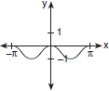
2) | 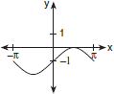
3) | 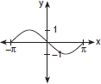
4) | 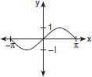

3 Which graph represents one complete cycle of the equation ?
1) | 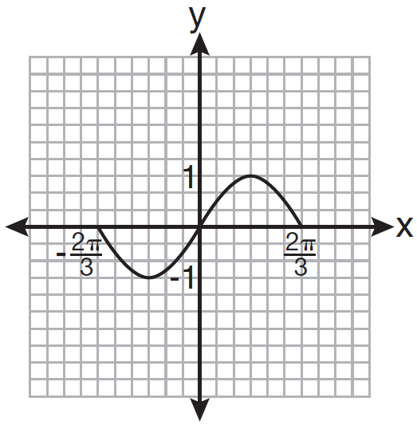
2) | 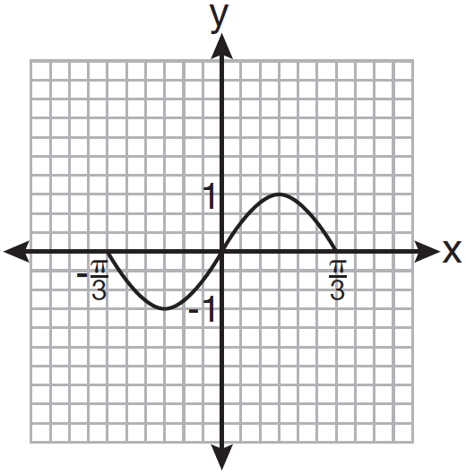
3) | 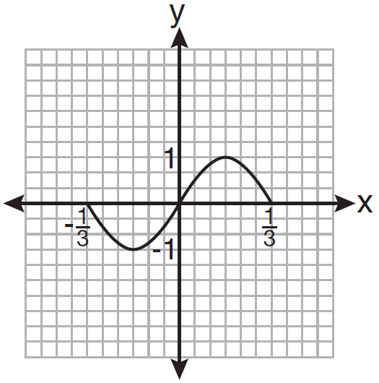
4) | 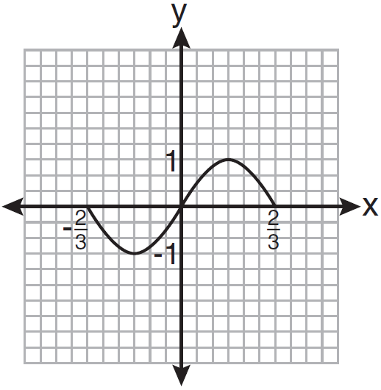

4 If , which graph represents under the composition ?
1) | 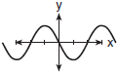
2) | 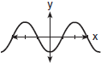
3) | 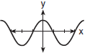
4) | 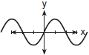

5 The graphs below show the average annual precipitation received at different latitudes on Earth. Which graph is a translated cosine curve?
1) | 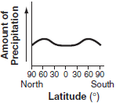
2) | 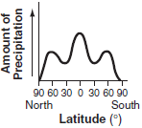
3) | 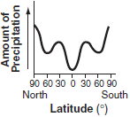
4) | 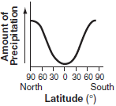

6 Which graph represents a cosine function with no horizontal shift, an amplitude of 2, and a period of ?
1) | 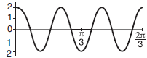
2) | 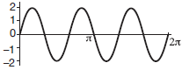
3) | 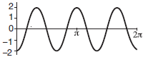
4) | 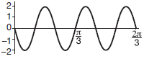

7 The graph below incorrectly represents the equation . Write a mathematical explanation of why this graph is incorrect.

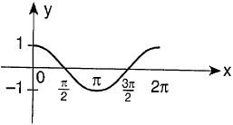

8 Which is a graph of ?
1) | 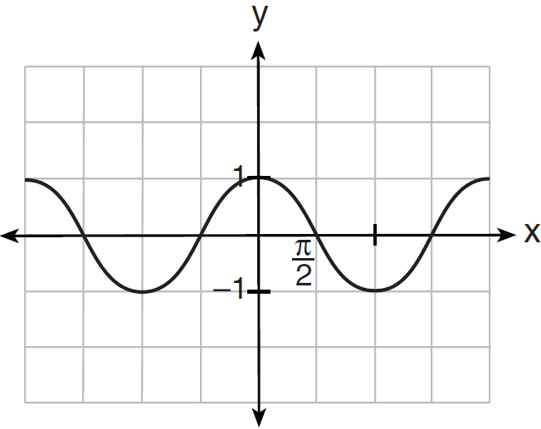
2) | 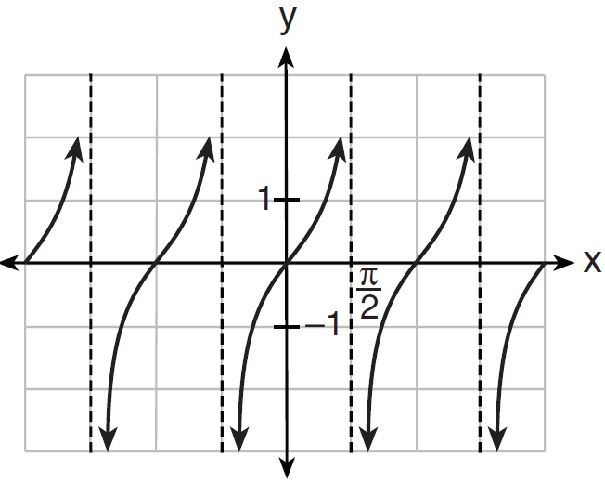
3) | 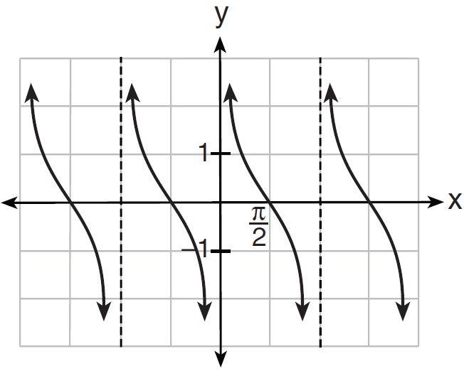
4) | 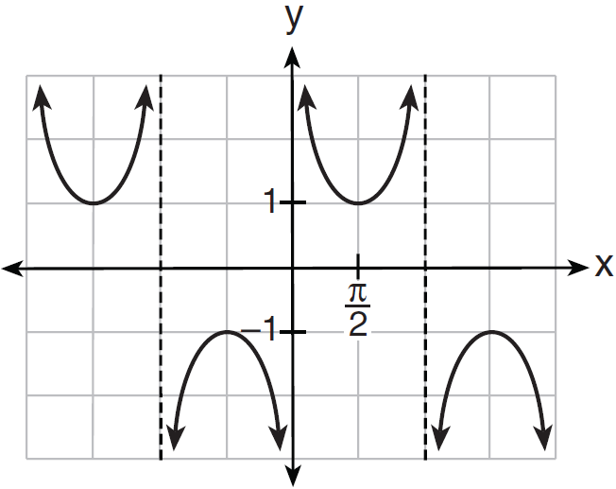

1 ANS: 3 REF: 080815b

2 ANS: 3 REF: 060228siii

3 ANS: 3
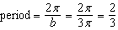

REF: 081026a2

4 ANS: 2
The reflection of f(x) in the x-axis is which is represented in answer (2). The graph of is symmetric with respect to the y-axis, so its reflection in the y-axis is represented by the same graph.

REF: 060309b

5 ANS: 4 REF: 080503b

6 ANS: 3
(3) repeats 3 times over .

REF: 011722aii

7 ANS:
Amplitude should be 2.

REF: 089736siii

8 ANS: 3
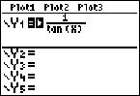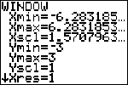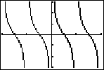

REF: 011207a2

