1 What are the amplitude and the period of the graph represented by the equation 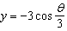?
1) | amplitude: ; period:
2) | amplitude: ; period:
3) | amplitude: 3; period:
4) | amplitude: 3; period:

2 Which statement is incorrect for the graph of the function 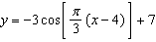?
1) | The period is 6.
2) | The amplitude is 3.
3) | The range is [4,10].
4) | The midline is .

3 Tides are a periodic rise and fall of ocean water. On a typical day at a seaport, to predict the time of the next high tide, the most important value to have would be the
1) | time between consecutive low tides
2) | time when the tide height is 20 feet
3) | average depth of water over a 24-hour period
4) | difference between the water heights at low and high tide

4 The average monthly temperature of a city can be modeled by a cosine graph. Melissa has been living in Phoenix, Arizona, where the average annual temperature is 75°F. She would like to move, and live in a location where the average annual temperature is 62°F. When examining the graphs of the average monthly temperatures for various locations, Melissa should focus on the
1) | amplitude
2) | horizontal shift
3) | period
4) | midline

5 A sine function is graphed below.

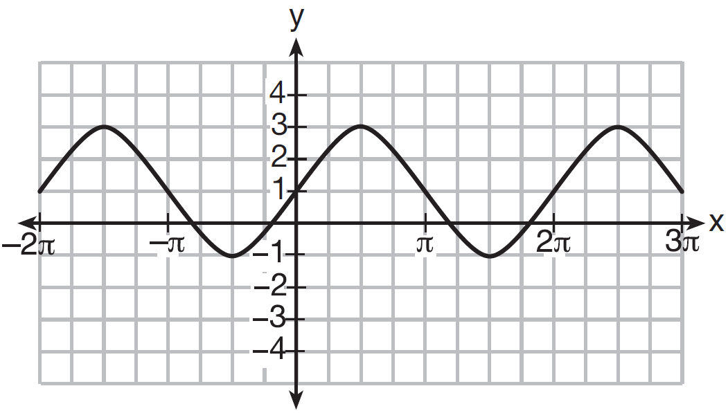

Determine and state the amplitude and period of this function.

6 The volume of air in a person’s lungs, as the person breathes in and out, can be modeled by a sine graph. A scientist is studying the differences in this volume for people at rest compared to people told to take a deep breath. When examining the graphs, should the scientist focus on the amplitude, period, or midline? Explain your choice.
1 ANS: 4 REF: 011627a2

2 ANS: 4
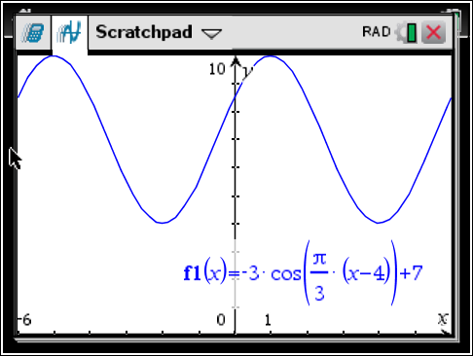 As the range is [4,10], the midline is 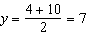.

REF: fall1506aii

3 ANS: 1
The time of the next high tide will be the midpoint of consecutive low tides.

REF: 011907aii

4 ANS: 4 REF: 081912aii

5 ANS:
2,

REF: 061633a2

6 ANS:
Amplitude, because the height of the graph shows the volume of the air.

REF: 081625aii

