1 How many full cycles of the function appear in p radians?
1) 1 2) 2 3) 3 4) 4

2 What is the period of the function ?
1) 5 2) 3) 3 4)

3 What is the period of the graph 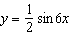?
1) 2) 3) 4)

4 What is the period of the function ?
1) 2) 3) 4)

5 What is the period of the graph of the equation 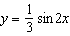?
1) 2) 2 3) 4)

6 What is the period of the graph of the equation 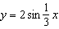?
1) 2) 3) 4)

7 What is the period of ?
1) 2) 2 3) 4) 4

8 What is the period of the function 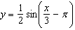?
1) 2) 3) 4)

9 A certain radio wave travels in a path represented by the equation . What is the period of this wave?
1) 5 2) 2 3) 4)

10 A sound wave is modeled by the curve . What is the period of this curve?
1) 2) 3) 3 4) 4

11 A wave displayed by an oscilloscope is represented by the equation . What is the period of this function?
1) 2) 2 3) 3 4)

12 A modulated laser heats a diamond. Its variable temperature, in degrees Celsius, is given by . What is the period of the curve?
1) 2) 3) 4)

13 An object that weighs 2 pounds is suspended in a liquid. When the object is depressed 3 feet from its equilibrium point, it will oscillate according to the formula , where t is the number of seconds after the object is released. How many seconds are in the period of oscillation?
1) 2) 3) 3 4)

14 The Sea Dragon, a pendulum ride at an amusement park, moves from its central position at rest according to the trigonometric function 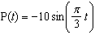, where t represents time, in seconds. How many seconds does it take the pendulum to complete one full cycle?
1) 5 2) 6 3) 3 4) 10

15 The height above ground for a person riding a Ferris wheel after t seconds is modeled by 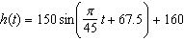 feet. How many seconds does it take to go from the bottom of the wheel to the top of the wheel?
1) 10 2) 45 3) 90 4) 150

16 The graph of which function has a period of 3?
1) 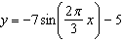 2) 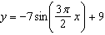 3) 4)

17 The height, above ground, of a Ferris wheel car can be modeled by the function 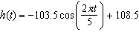 where h is measured in feet and t is measured in minutes. State the period of the function and describe what the period represents in this context.

18 The brightness of the star MIRA over time is given by the equation 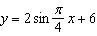, where x represents time and y represents brightness. What is the period of this function, in radian measure?

19 The graph below represents the height above the ground, h, in inches, of a point on a triathlete's bike wheel during a training ride in terms of time, t, in seconds.

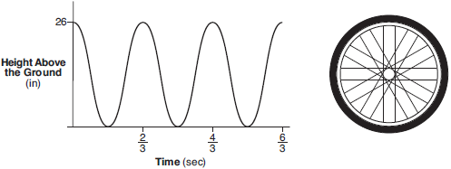

Identify the period of the graph and describe what the period represents in this context.

20 Visible light can be represented by sinusoidal waves. Three visible light waves are shown in the graph below. The midline of each wave is labeled .

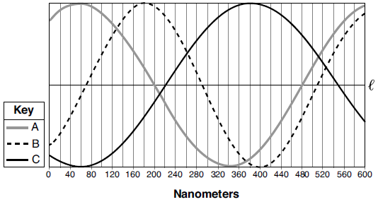

Based on the graph, which light wave has the longest period? Justify your answer.
1 ANS: 1
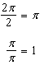

REF: 061519a2

2 ANS: 4
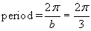

REF: 080113b

3 ANS: 2
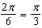

REF: 061413a2

4 ANS: 2
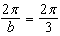

REF: 061111a2

5 ANS: 3
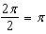

REF: 081519a2

6 ANS: 3
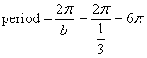

REF: 080615b

7 ANS: 3 REF: 069025siii

8 ANS: 4
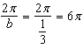

REF: 061027a2

9 ANS: 3
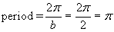

REF: 080514b

10 ANS: 2
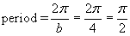

REF: 010606b

11 ANS: 1
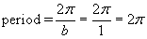

REF: 010810b

12 ANS: 2
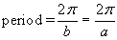

REF: 060105b

13 ANS: 1
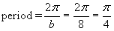

REF: 010204b

14 ANS: 2
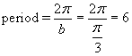

REF: 060920b

15 ANS: 2
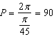

REF: 081822aii

16 ANS: 1
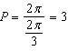

REF: 082413aii

17 ANS:
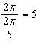 The wheel rotates every 5 minutes.

REF: 062429aii

18 ANS:
8. 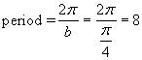.

REF: 010425b

19 ANS:
period is . The wheel rotates once every second.

REF: 061728aii

20 ANS:
Light wave C. The periods for A, B, and C are 280, 220 and 320.

REF: 012030aii

