1 Which sinusoid has the greatest amplitude?
1) | 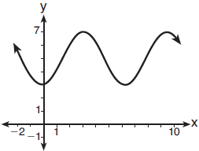
2)
3) | 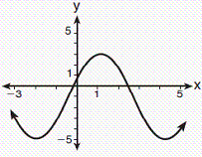
4)

2 What is the amplitude of the function shown in the accompanying graph?

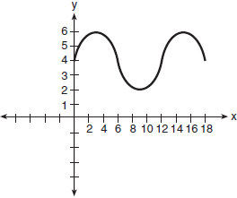
1) | 1.5
2) | 2
3) | 6
4) | 12

3 What is the amplitude of the function 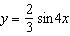?
1)
2)
3)
4) | 4

4 What is the amplitude of the graph of the equation 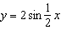?
1)
2) | 2
3)
4)

5 What is the amplitude of the graph of the equation ?
1)
2) | 2
3) | 3
4)

6 The equation below can be used to model the height of a tide in feet, , on a beach at t hours.
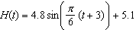
Using this function, the amplitude of the tide is
1)
2) | 4.8
3) | 3
4) | 5.1

7 A monitor displays the graph . What will be the amplitude after a dilation of 2?
1) | 5
2) | 6
3) | 7
4) | 10

8 What is the amplitude of the graph of ?

9 What is the amplitude of the graph of 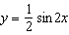?

10 What is the amplitude of the graph of the equation 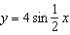?

11 What is the amplitude of the graph of the equation 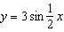?

12 What is the amplitude of the function ?

13 What will be the amplitude of the image of the curve after a dilation of scale factor 2?

14 On July 21, 2016, the water level in Puget Sound, WA reached a high of 10.1 ft at 6 a.m. and a low of ft at 12:30 p.m. Across the country in Long Island, NY, Shinnecock Bay’s water level reached a high of 2.5 ft at 10:42 p.m. and a low of ft at 5:31 a.m. The water levels of both locations are affected by the tides and can be modeled by sinusoidal functions. Determine the difference in amplitudes, in feet, for these two locations.
1 ANS: 4 REF: 081718aii

2 ANS: 2 REF: 010715b

3 ANS: 2 REF: 060403b

4 ANS: 2 REF: 018719siii

5 ANS: 2 REF: 068715siii

6 ANS: 2 REF: 082203aii

7 ANS: 2 REF: 010301b

8 ANS:
1

REF: 068007siii

9 ANS:

REF: 018604siii

10 ANS:
4

REF: 010401siii

11 ANS:
3

REF: 089001siii

12 ANS:
3

REF: 080002siii

13 ANS:
4

REF: 069707siii

14 ANS:
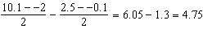

REF: 081930aii

