1 Which graph represents ?
1) | 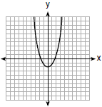
2) | 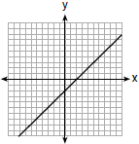
3) | 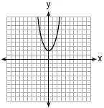
4) | 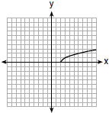

2 Draw the graph of on the set of axes below.

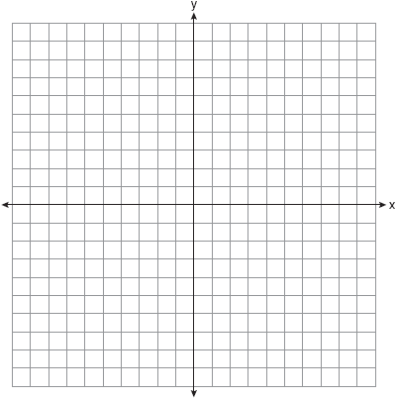

3 Graph over the domain .

4 Graph the function on the set of axes below.

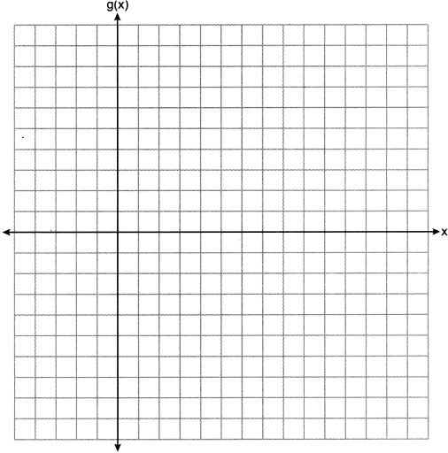

5 Graph the function on the set of axes below.

6 Graph on the set of axes below.

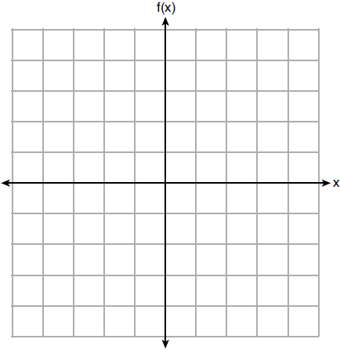
1 ANS: 4 REF: 061703ai

2 ANS:
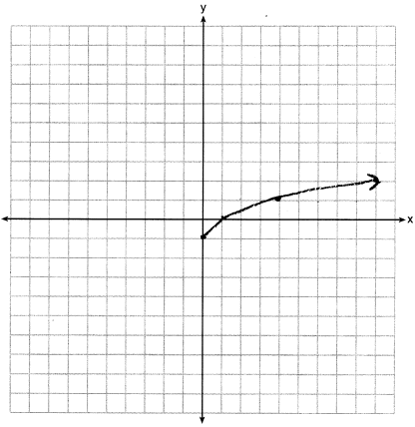

REF: 061425ai

3 ANS:
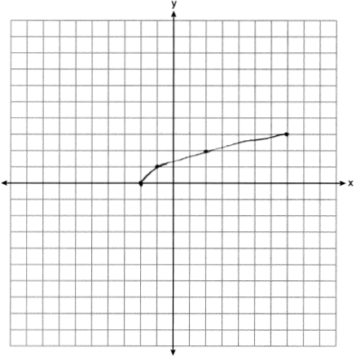

REF: 061825ai

4 ANS:
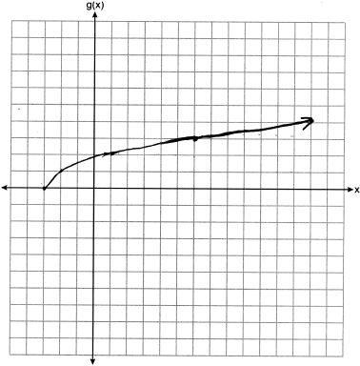

REF: 012325ai

5 ANS:
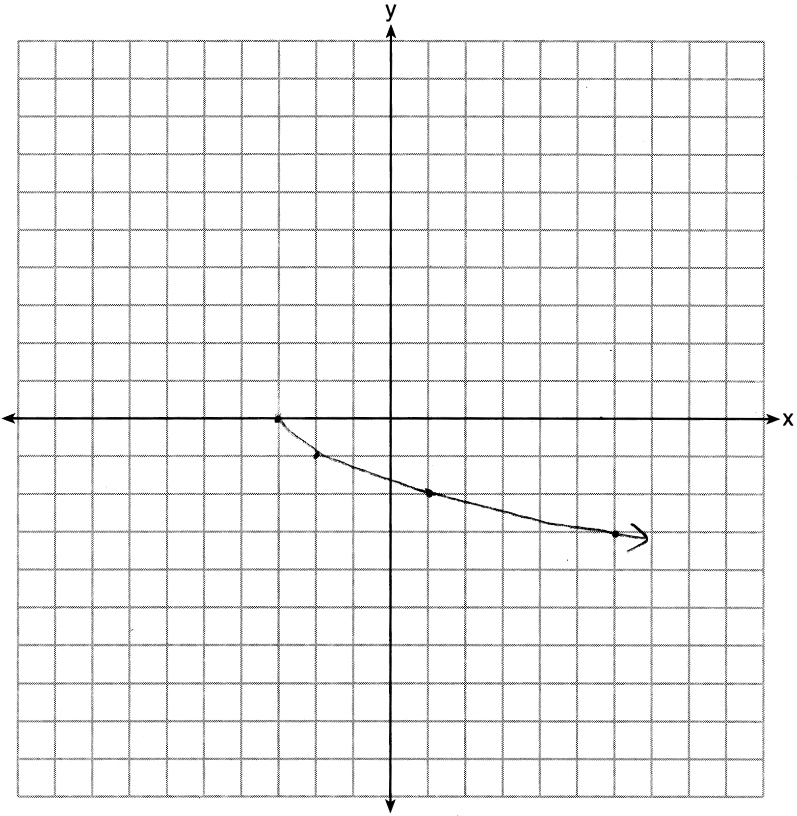

REF: 081625ai

6 ANS:
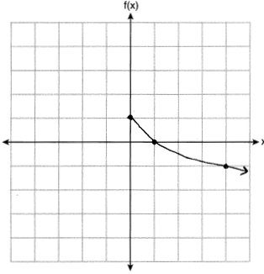

REF: 012025ai

