1 Which graph represents an inverse variation between stream velocity and the distance from the center of the stream?
1) 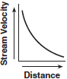 2) 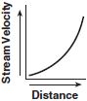 3) 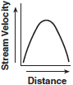 4) 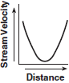

2 Which graph shows that soil permeability varies inversely to runoff?
1) 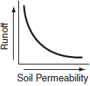 2) 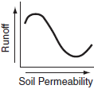 3) 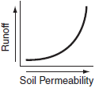 4) 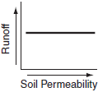

3 Jack is driving from New York to Florida. The number of hours that he drives and the speed at which he drives are inversely proportional. Which graph could be used to describe this situation if one axis represents speed and the other represents hours?
1) 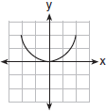 2) 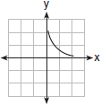 3) 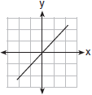 4) 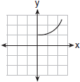

4 The graph of the equation is best described as
1) a circle 2) two lines 3) an ellipse 4) a hyperbola

5 Camisha is paying a band $330 to play at her graduation party. The amount each member earns, d, varies inversely as the number of members who play, n. The graph of the equation that represents the relationship between d and n is an example of
1) a hyperbola 2) a line 3) a parabola 4) an ellipse

6 Which equation represents a hyperbola?
1) 2) 3) 4) 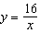

7 Which function is symmetrical with respect to the origin?
1) 2) 3) 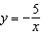 4)

8 The graph of which function is symmetric with respect to the graph of the line ?
1) 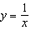 2) 3) 4)

9 The price of a certain stock has decreased over 5 years, as shown in the graph below. Which of the following equations best represents this graph?
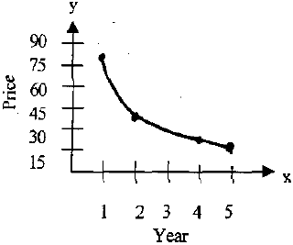
1) 2) 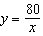 3) 4)

10 The accompanying graph shows the relationship between a person’s weight and the distance that the person must sit from the center of a seesaw to make it balanced.

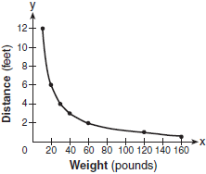

Which equation best represents this graph?
1) 2) 3) 4) 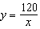

1 ANS: 1 REF: 060408b

2 ANS: 1 REF: 010603b

3 ANS: 2 REF: 080913b

4 ANS: 4 REF: 011009b

5 ANS: 1 REF: 060104b

6 ANS: 4 REF: 060616b

7 ANS: 3 REF: 060414b

8 ANS: 1 REF: 080714b

9 ANS: 2 REF: fall9913b

10 ANS: 4 REF: 080312b

