1 Which is an equation of the line of symmetry for the parabola in the accompanying diagram?

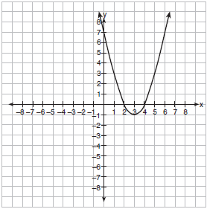
1)
2)
3)
4)

2 Which is the equation of the axis of symmetry of the graph of the equation ?
1)
2) | 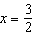
3)
4) | 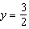

3 For which quadratic equation is the axis of symmetry ?
1)
2)
3)
4)

4 An equation of a parabola that has as its axis of symmetry is
1)
2)
3)
4)

5 What is the minimum point of the graph of the equation ?
1)
2)
3)
4)

6 What are the coordinates of the turning point of the parabola whose equation is ?
1)
2)
3)
4)

7 What is the turning point, or vertex, of the parabola whose equation is ?
1)
2)
3)
4)

8 If the equation of the axis of symmetry of a parabola is , at which pair of points could the parabola intersect the x-axis?
1) | (3,0) and (5,0)
2) | (3,0) and (2,0)
3) | (3,0) and (1,0)
4) | (-3,0) and (-1,0)

9 Point is a point on the graph of the equation . When point A is reflected across the axis of symmetry, what are the coordinates of its image, point ?
1)
2)
3)
4)

1 ANS: 3 REF: 010606a

2 ANS: 2
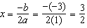

REF: 061012b

3 ANS: 2
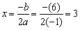

REF: 060514b

4 ANS: 3 REF: 011004b

5 ANS: 4
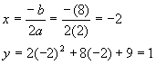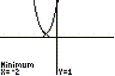

REF: 080603b

6 ANS: 3
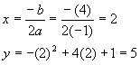

REF: 080902b

7 ANS: 2
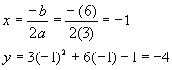. 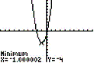
REF: 080501b

8 ANS: 3
The axis of symmetry of a parabola intersecting the x-axis at two points goes through the midpoint of the line segment connecting those two points. The midpoint of (3,0) and (1,0) is (2,0).
REF: 080912b

9 ANS: 4
The axis of symmetry of is: 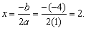 The reflection of point A(1,0) over the line is point A’(3,0).
REF: 060908b

