1 Which parabola has an axis of symmetry of ?
1) | 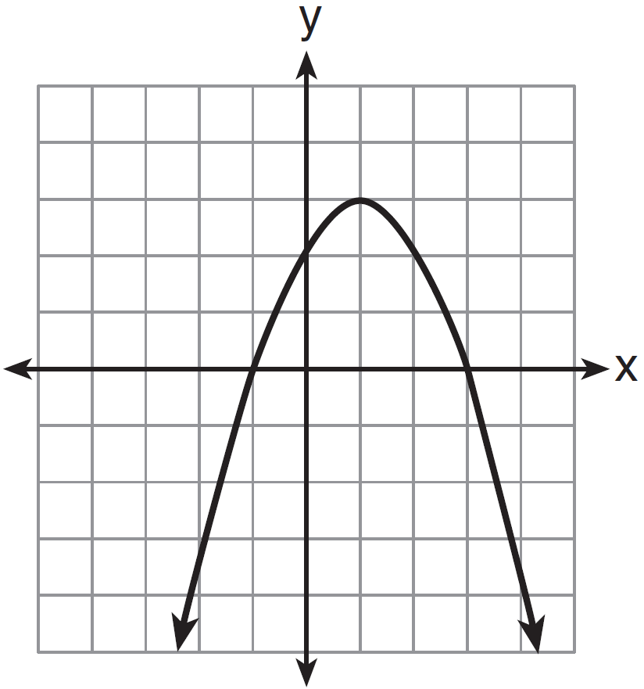
2) | 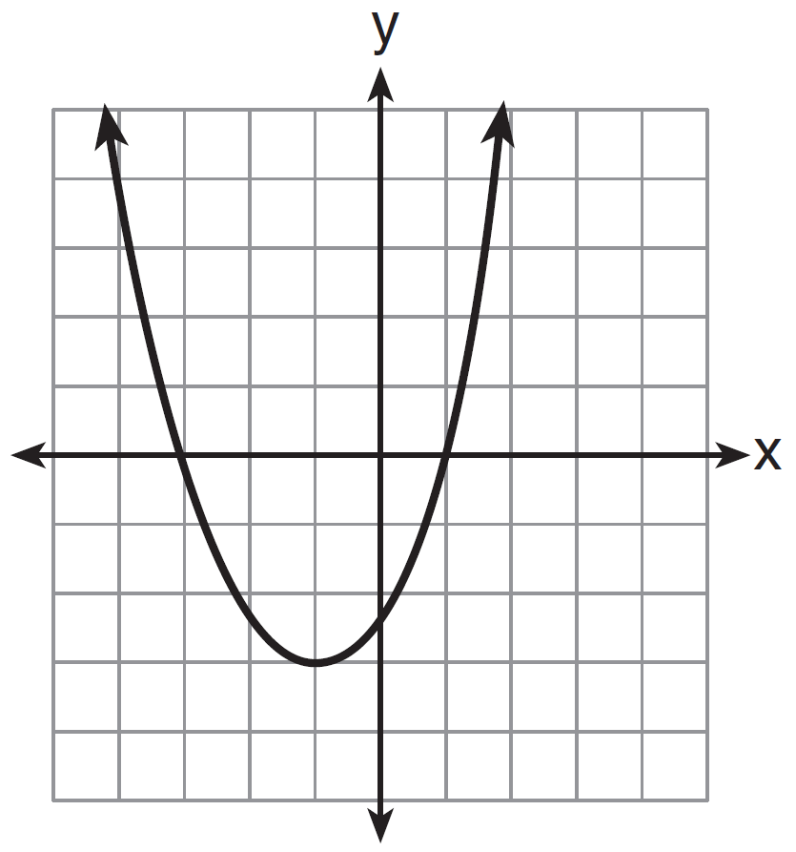
3) | 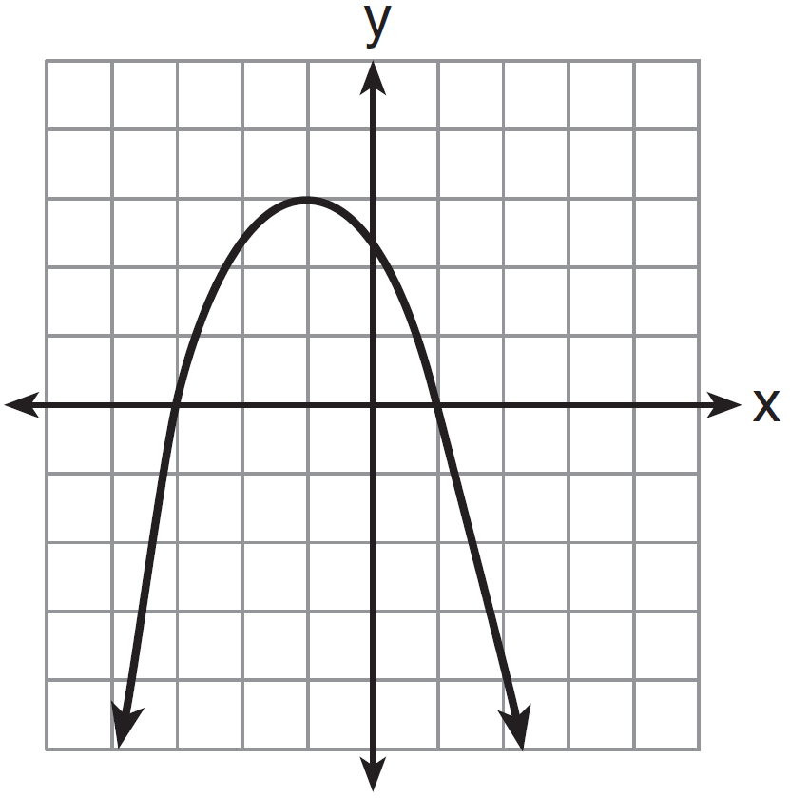
4) | 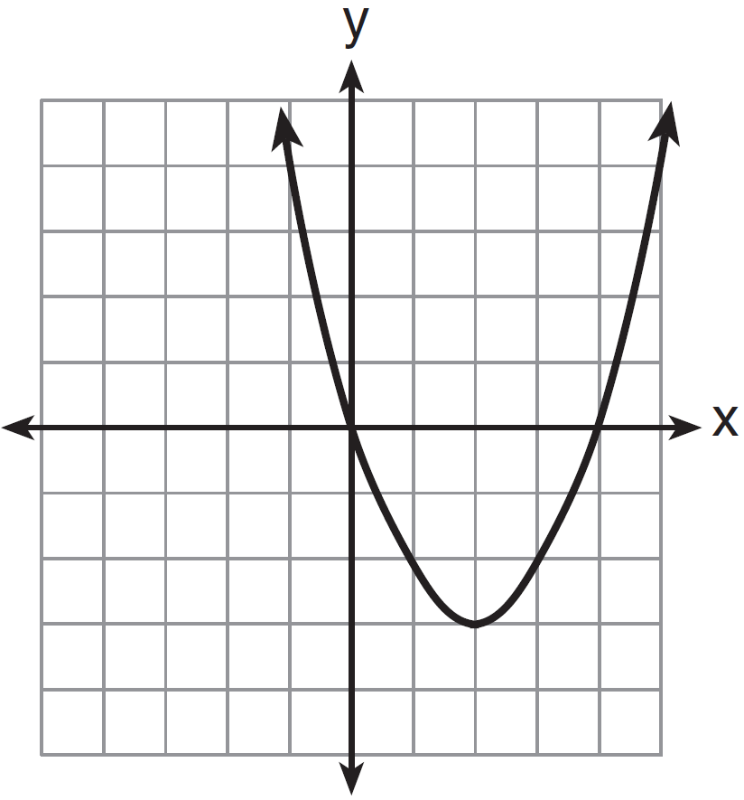

2 Which equation represents the axis of symmetry of the graph of the parabola below?

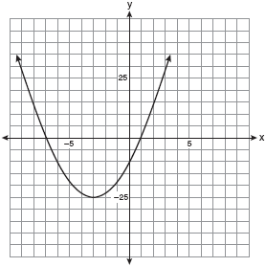
1)
2)
3)
4)

3 What is the equation of the axis of symmetry of the parabola shown in the diagram below?

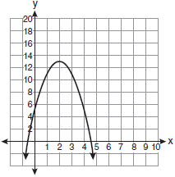
1)
2)
3)
4)

4 What are the vertex and the axis of symmetry of the parabola shown in the graph below?
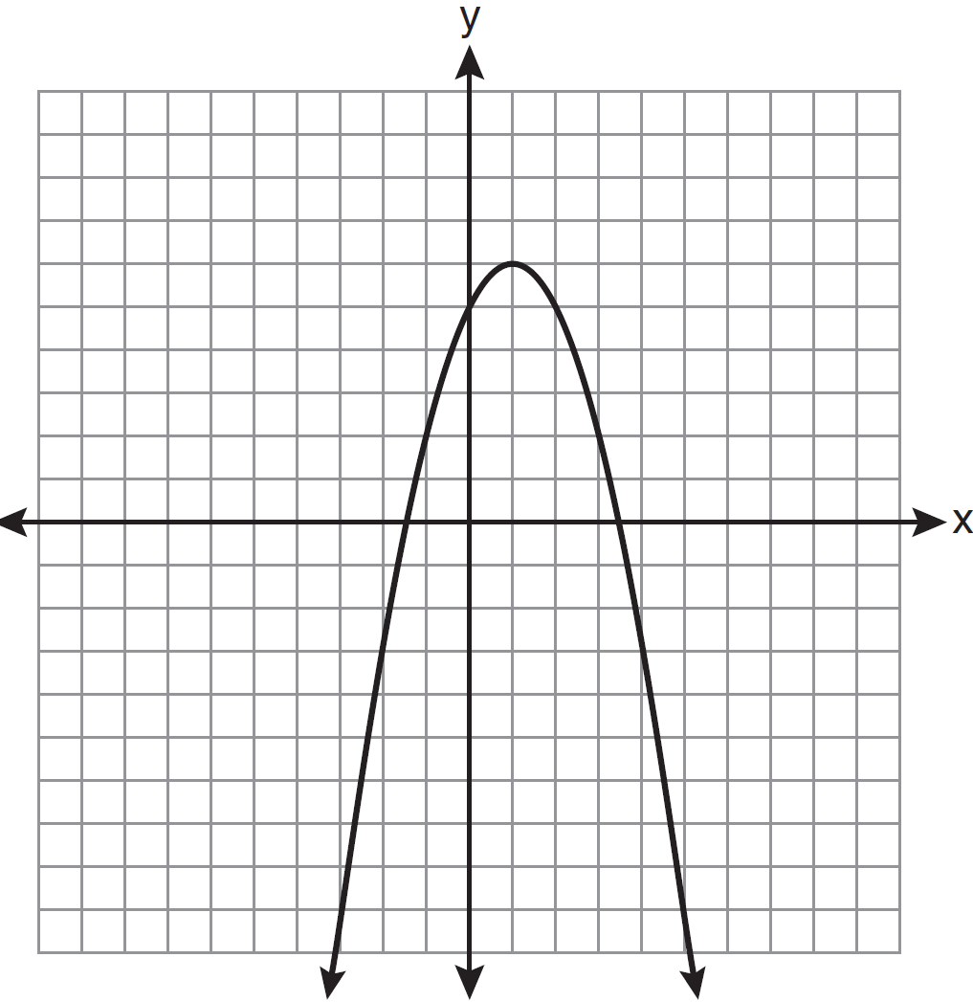
1) | vertex: ; axis of symmetry:
2) | vertex: ; axis of symmetry:
3) | vertex: ; axis of symmetry:
4) | vertex: ; axis of symmetry:

5 What are the vertex and the axis of symmetry of the parabola shown in the diagram below?
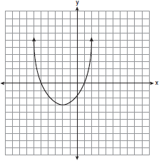
1) | The vertex is , and the axis of symmetry is .
2) | The vertex is , and the axis of symmetry is .
3) | The vertex is , and the axis of symmetry is .
4) | The vertex is , and the axis of symmetry is .

6 What are the coordinates of the vertex and the equation of the axis of symmetry of the parabola shown in the graph below?

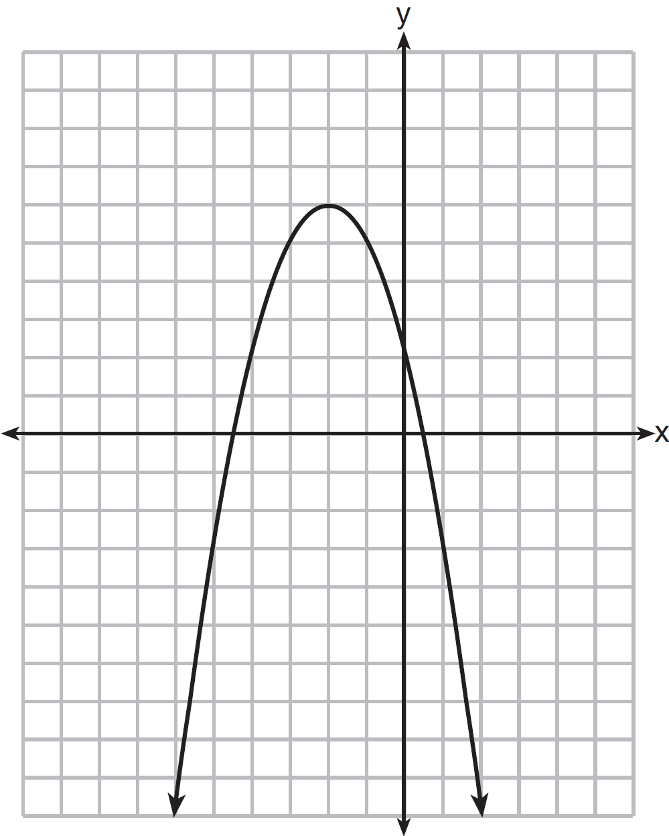
1) | and
2) | and
3) | and
4) | and

7 What are the vertex and axis of symmetry of the parabola shown in the diagram below?

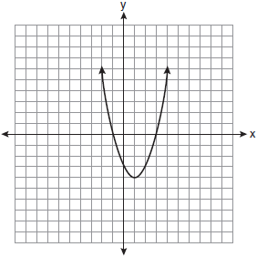
1) | vertex: ; axis of symmetry:
2) | vertex: ; axis of symmetry:
3) | vertex: ; axis of symmetry:
4) | vertex: ; axis of symmetry:

8 The equation is graphed on the set of axes below.

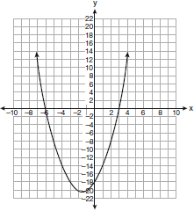

Based on this graph, what are the roots of the equation ?
1) | and 6
2) | 0 and
3) | 3 and
4) | 3 and

9 The equation is graphed on the set of axes below.

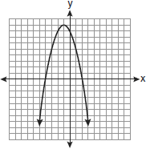

Based on this graph, what are the roots of the equation ?
1) | 8 and 0
2) | 2 and
3) | 9 and
4) | 4 and

10 The equation is graphed on the set of axes below.

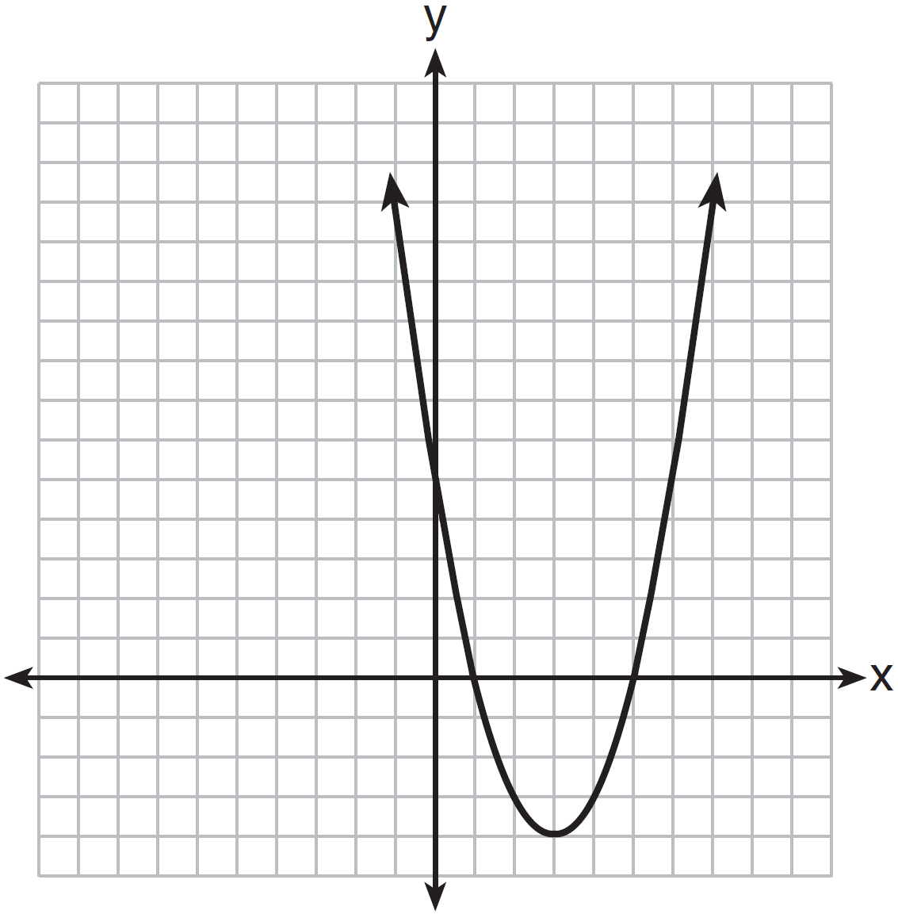

Based on the graph, what are the roots of the equation ?
1) | 0 and 5
2) | 1 and 0
3) | 1 and 5
4) | 3 and

11 The graph of is shown below.

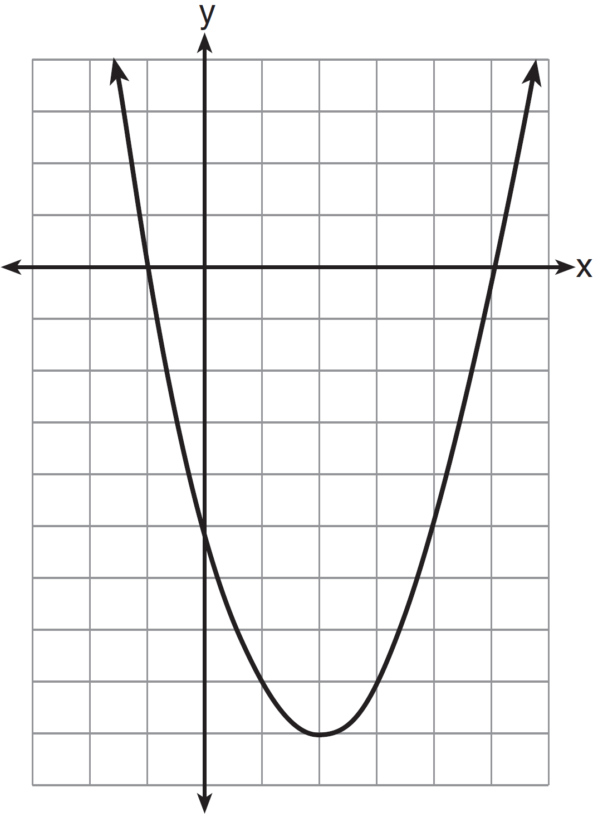

Based on this graph, what are the roots of the equation ?
1) | 1 and
2) | and 5
3) | 2 and
4) | and and 5

12 A student correctly graphed the parabola shown below to solve a given quadratic equation.

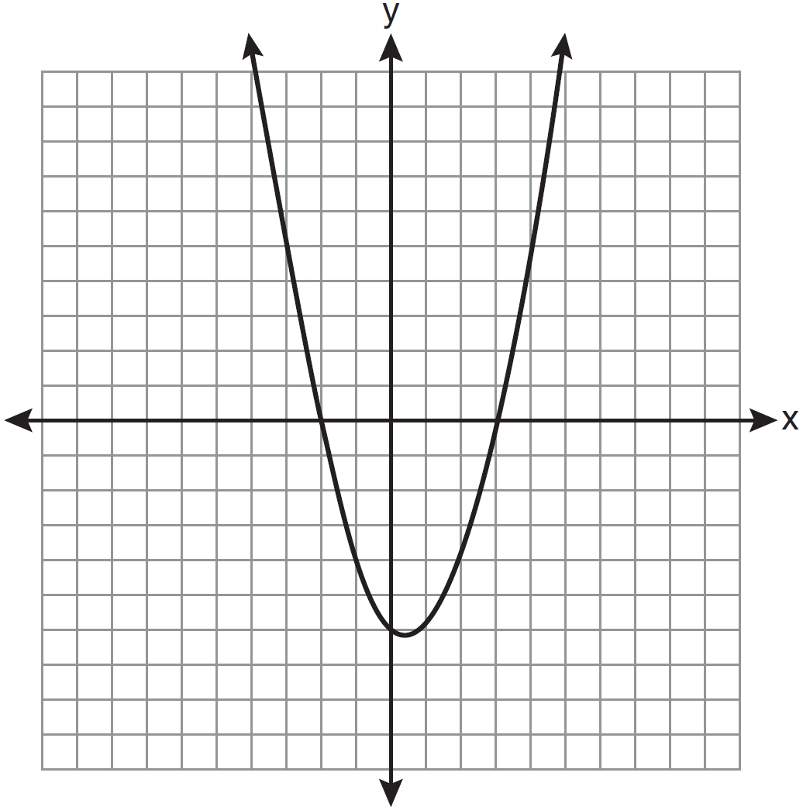

What are the roots of the quadratic equation associated with this graph?
1) | and 3
2) | and 0
3) | and 2
4) | and 3

13 The roots of a quadratic equation can be found using the graph below.

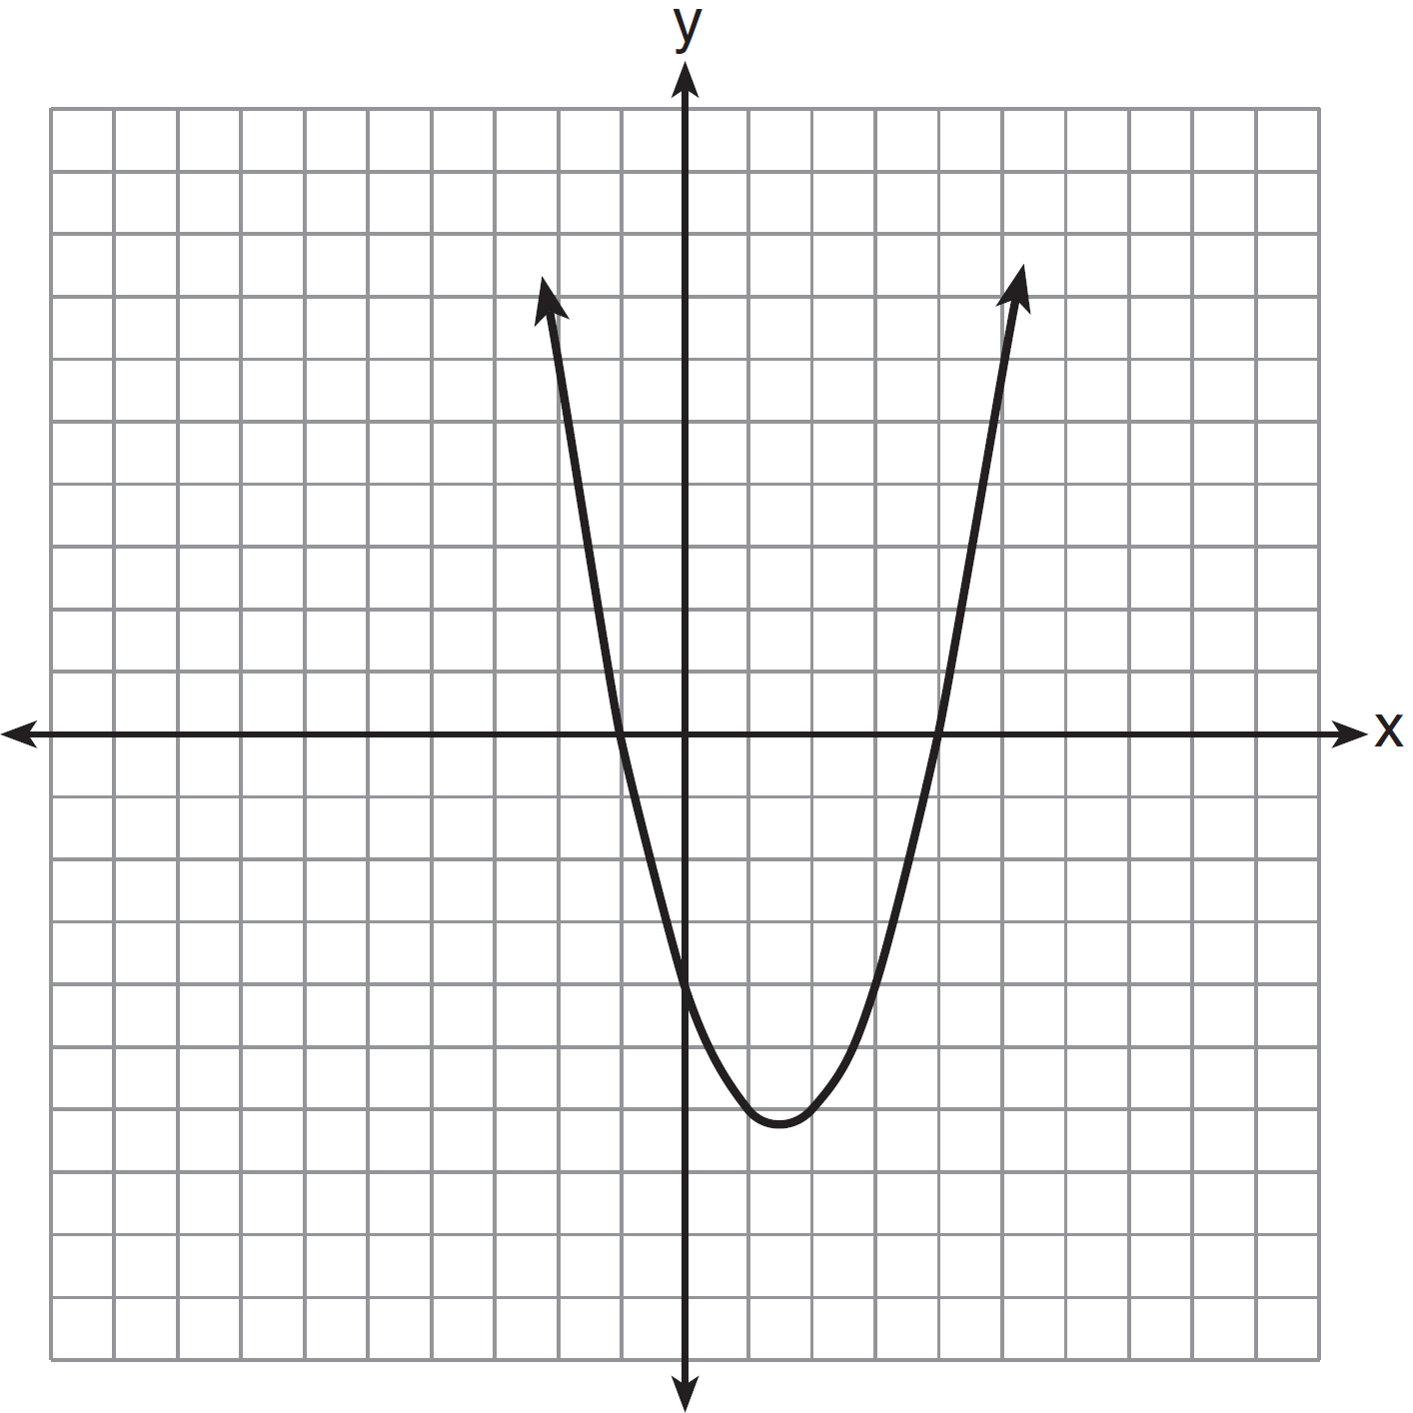

What are the roots of this equation?
1) | , only
2) | and
3) | and 4
4) | , and 4

14 What are the vertex and axis of symmetry of the parabola ?
1) | vertex: ; axis of symmetry:
2) | vertex: ; axis of symmetry:
3) | vertex: ; axis of symmetry:
4) | vertex: ; axis of symmetry:

15 What is an equation of the axis of symmetry of the parabola represented by ?
1)
2)
3)
4)

16 The equation of the axis of symmetry of the graph of is
1) | 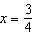
2) | 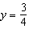
3) | 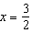
4) | 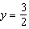

17 What is the vertex of the parabola represented by the equation ?
1)
2)
3)
4)

18 The vertex of the parabola lies in Quadrant
1) | I
2) | II
3) | III
4) | IV

19 What is the vertex of the graph of the equation ?
1)
2)
3)
4)

20 Which equation represents the axis of symmetry of the graph of the equation ?
1)
2)
3)
4)

21 The axis of symmetry and the vertex of are
1)
2)
3)
4)

22 State the equation of the axis of symmetry and the coordinates of the vertex of the parabola graphed below.

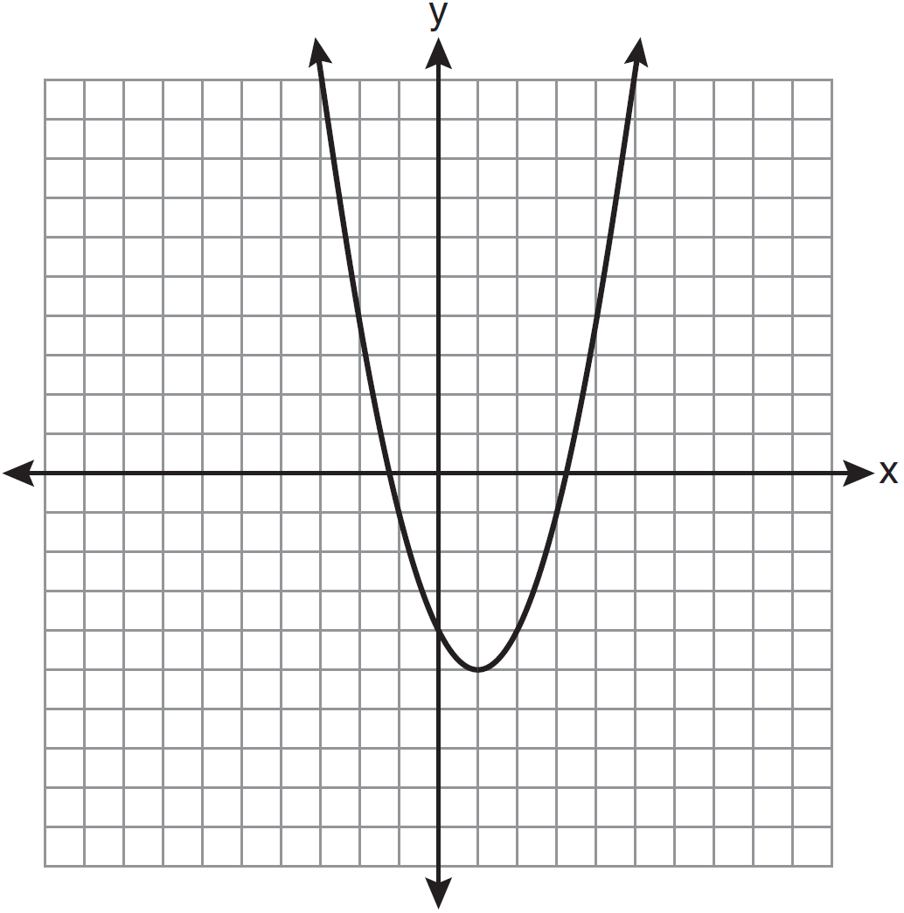

23 Find algebraically the equation of the axis of symmetry and the vertex of the parabola represented by the equation .

24 Find algebraically the equation of the axis of symmetry and the coordinates of the vertex of the parabola whose equation is .

25 Graph the equation on the accompanying set of axes. Using the graph, determine the roots of the equation .

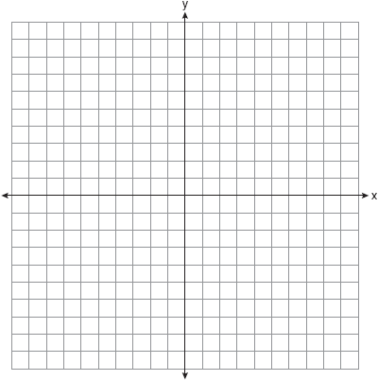

26 On the set of axes below, graph the equation . Using the graph, determine and state the roots of the equation .

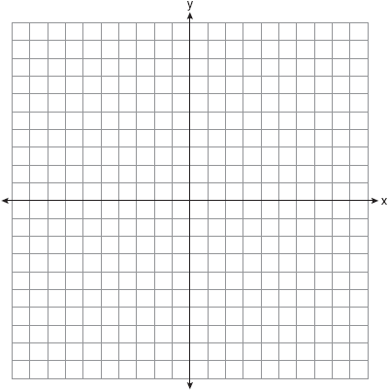

27 On the set of axes below, graph . State the roots of .

1 ANS: 1 REF: 061420ia

2 ANS: 2 REF: 010916ia

3 ANS: 2 REF: 011015ia

4 ANS: 2 REF: 081111ia

5 ANS: 1 REF: 060811ia

6 ANS: 4 REF: 081214ia

7 ANS: 1 REF: 061005ia

8 ANS: 3 REF: 060924ia

9 ANS: 2 REF: 080916ia

10 ANS: 3 REF: 061404ia

11 ANS: 2 REF: 011506ia

12 ANS: 4 REF: 011111ia

13 ANS: 3 REF: 061306ia

14 ANS: 1
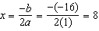.

REF: 060918ia

15 ANS: 1
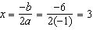.

REF: 011127ia

16 ANS: 1
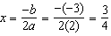.

REF: 011219ia

17 ANS: 3
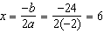.

REF: 061214ia

18 ANS: 3
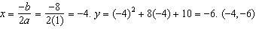

REF: 011314ia

19 ANS: 1
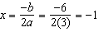.

REF: 011416ia

20 ANS: 1
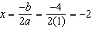

REF: 011520ia

21 ANS: 1
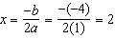

REF: 061614ia

22 ANS:

REF: 061133ia

23 ANS:
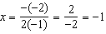

REF: 061534ia

24 ANS:
. 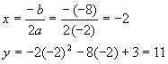

REF: 080934ia

25 ANS:
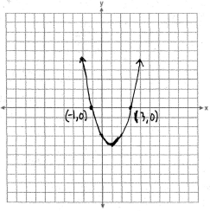
REF: 060836ia

26 ANS:
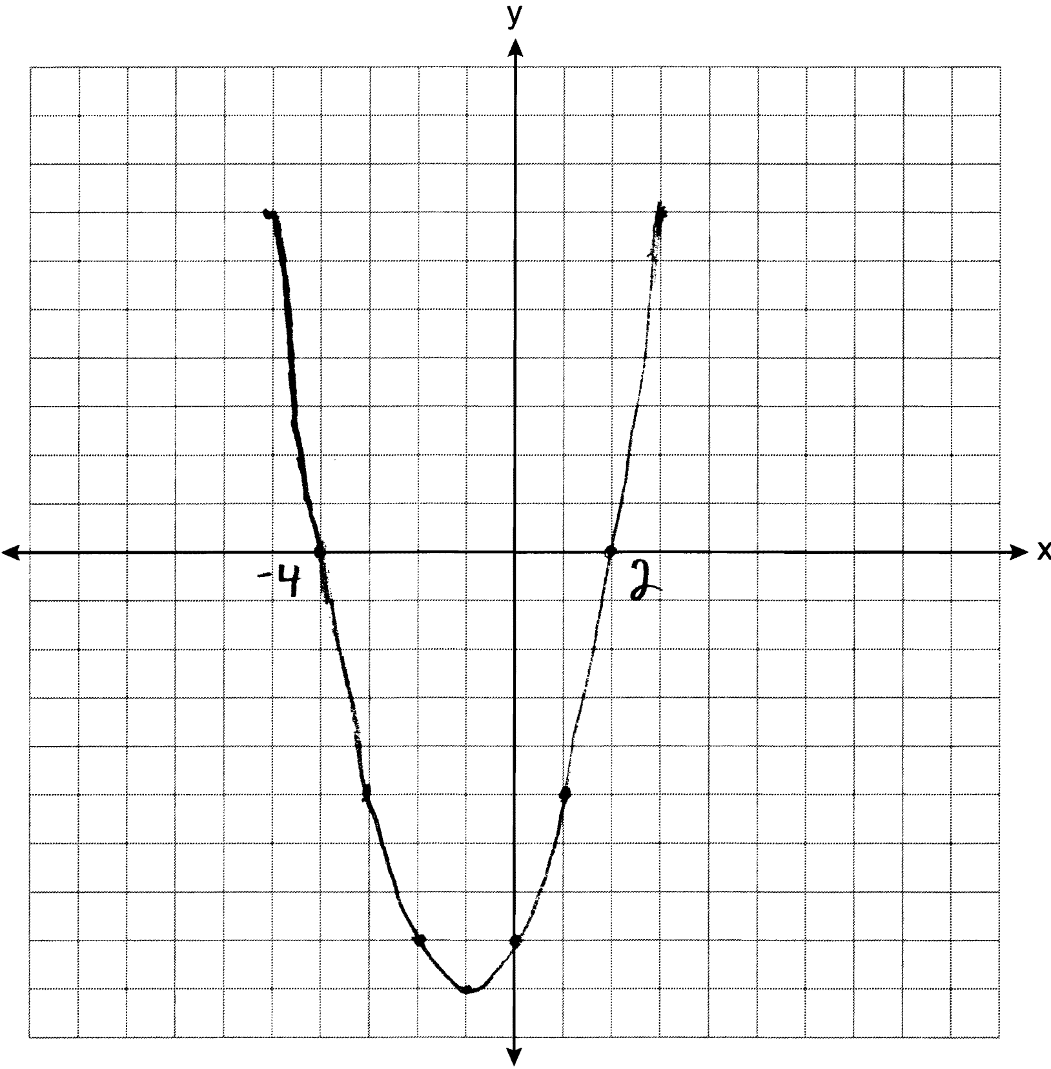
REF: 061234ia

27 ANS:
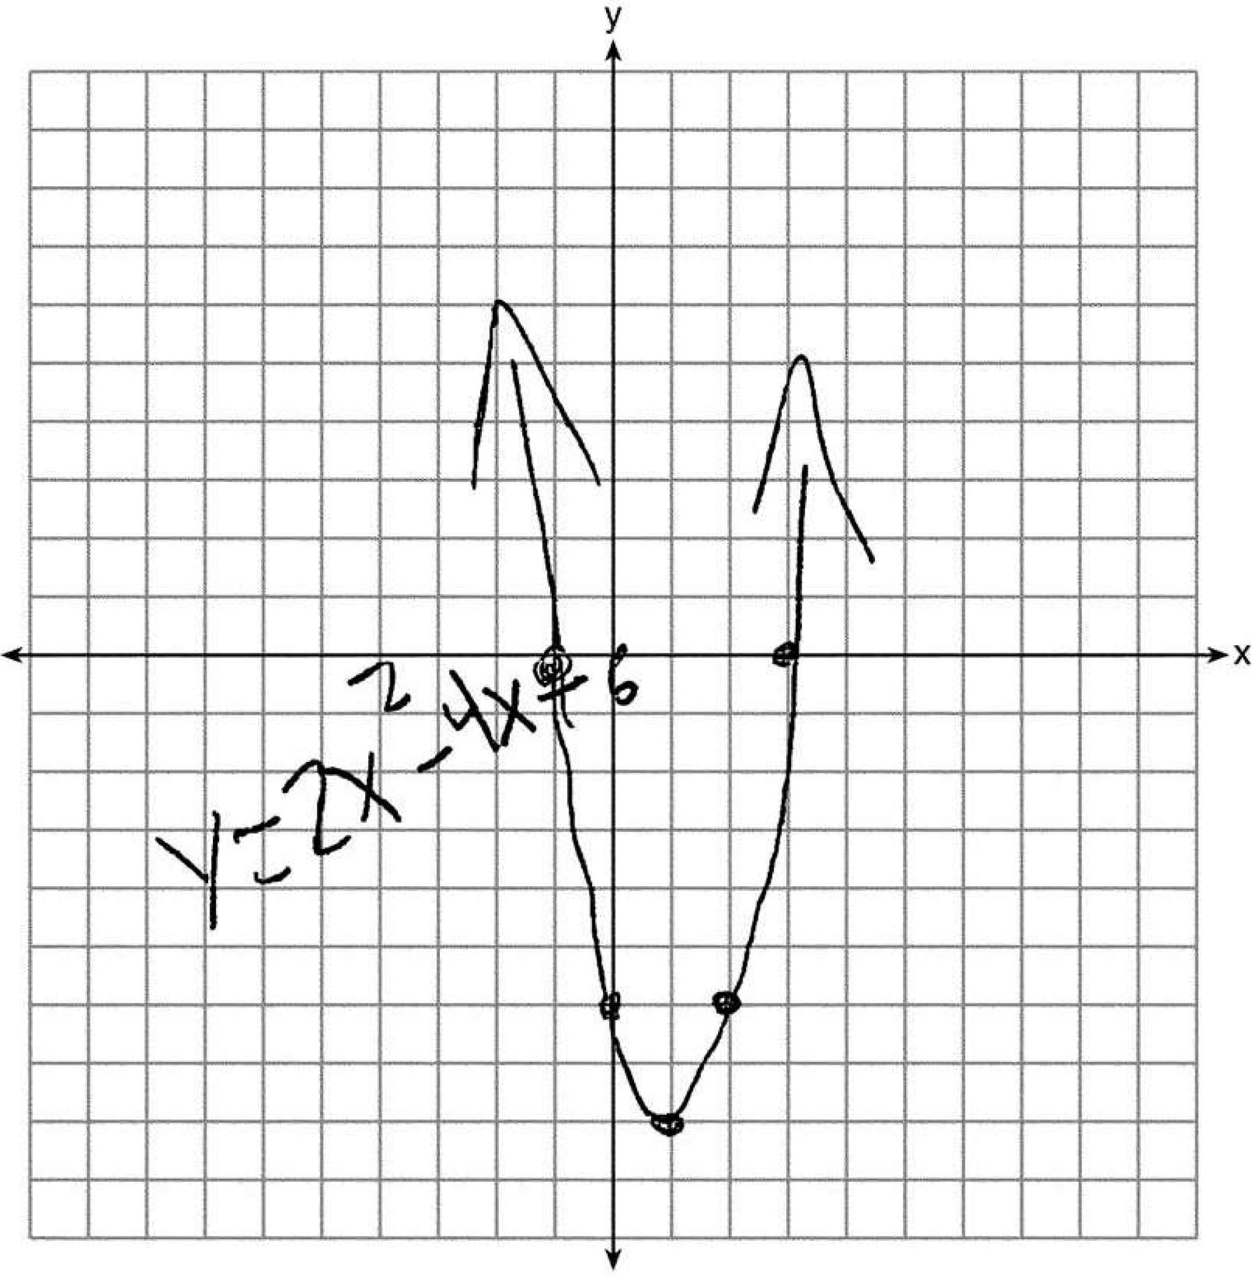 3 and .
REF: 061537ia

