1 What are the zeros of the polynomial function graphed below?
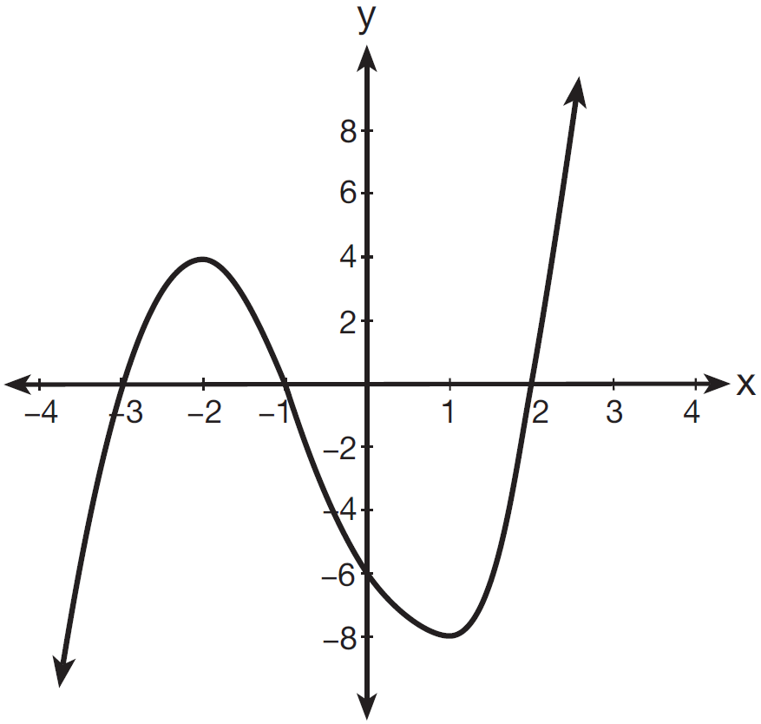
1)
2)
3)
4)

2 The function is graphed on the set of axes below.

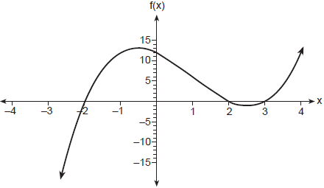

State the zeros of . Explain your reasoning.

3 A 4th degree polynomial has zeros , 3, , and . Which graph could represent the function defined by this polynomial?
1) | 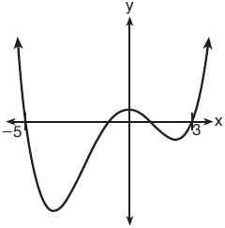
2) | 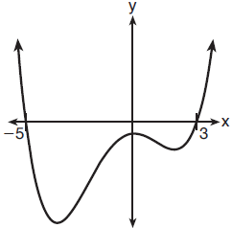
3) | 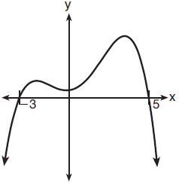
4) | 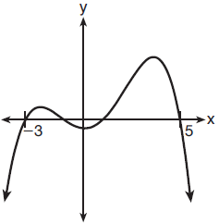

4 Which graph could represent a 4th degree polynomial function with a positive leading coefficient, 2 real zeros, and 2 imaginary zeros?
1) | 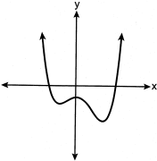
2) | 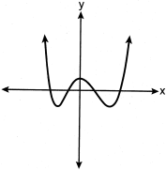
3) | 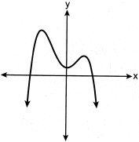
4) | 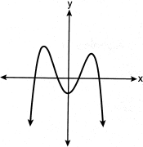

5 Which graph has the following characteristics?
• three real zeros
•
•
1) | 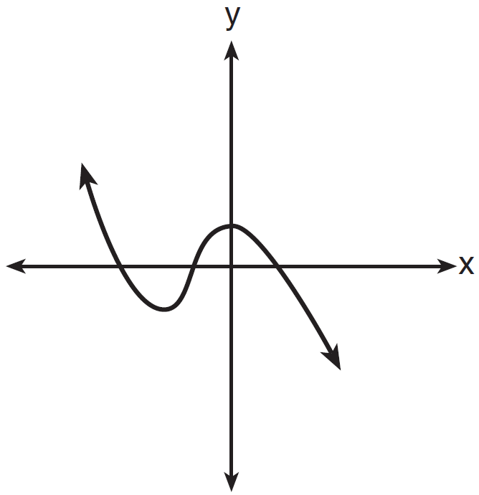
2) | 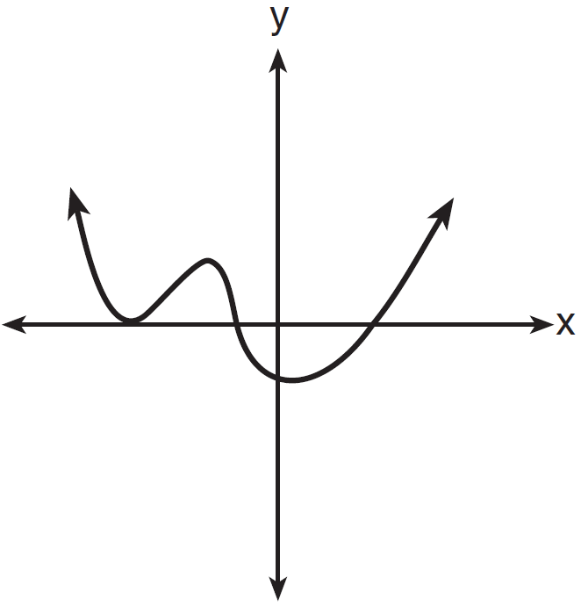
3) | 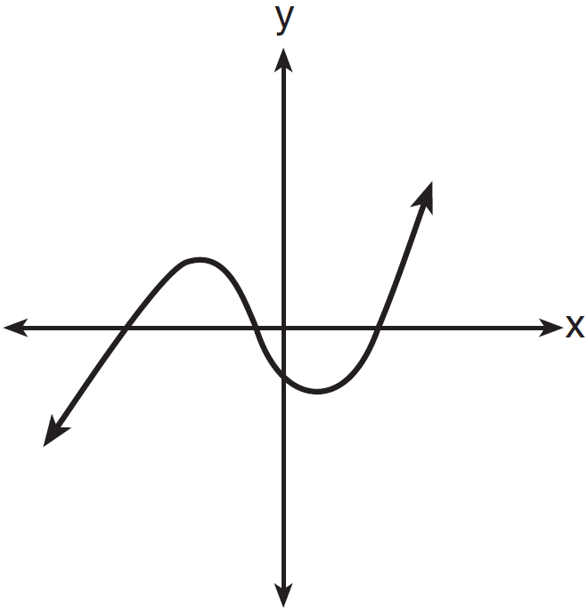
4) | 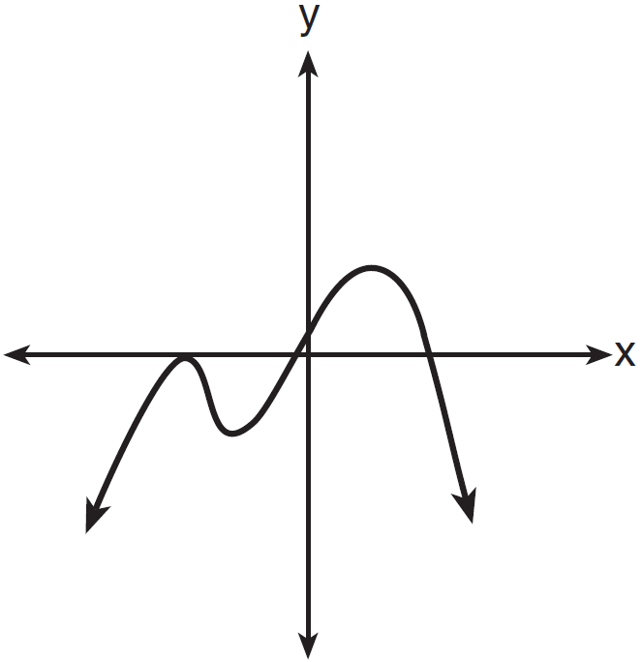

6 The zeros of a quartic polynomial function are 2, , 4, and . Use the zeros to construct a possible sketch of the function, on the set of axes below.

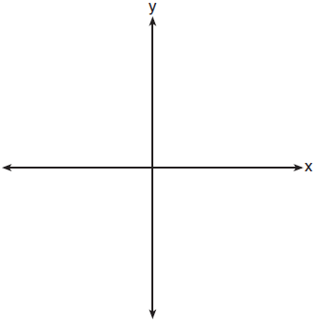

7 Sketch a graph of polynomial , given the criteria below:
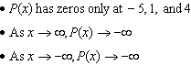

8 Patricia creates a cubic polynomial function, , with a leading coefficient of 1. The zeros of the function are 2, 3, and . Write an equation for . Sketch on the set of axes below.

9 On the grid below, sketch a cubic polynomial whose zeros are 1, 3, and -2.



10 The zeros of a quartic polynomial function h are , , and 3. Sketch a graph of on the grid below.



11 On the grid below, graph the function on the domain .

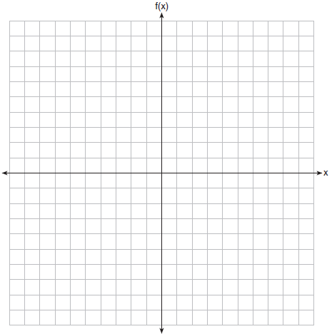

12 Graph on the set of axes below.

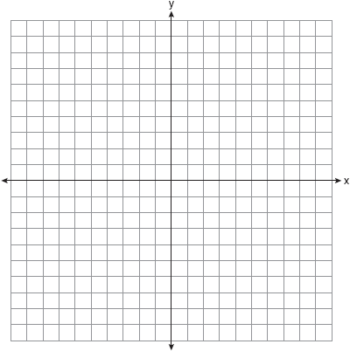

13 Find algebraically the zeros for . On the set of axes below, graph .

14 The function models the volume, in cubic inches, of a rectangular solid for . Graph over the domain .

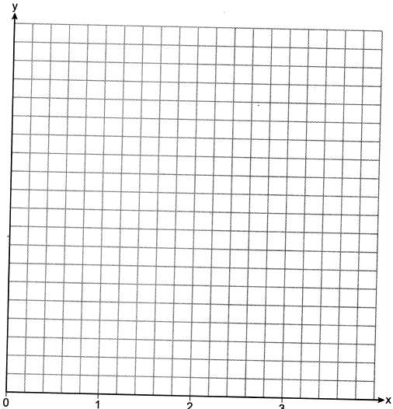

To the nearest tenth of a cubic inch, what is the maximum volume of the rectangular solid?

15 A manufacturer of sweatshirts finds that profits and costs fluctuate depending on the number of products created. Creating more products doesn't always increase profits because it requires additional costs, such as building a larger facility or hiring more workers. The manufacturer determines the profit, , in thousands of dollars, as a function of the number of sweatshirts sold, x, in thousands. This function, p, is given below.

Graph , over the interval , on the set of axes below.

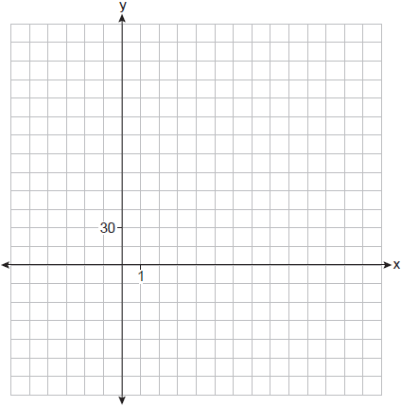

Over the given interval, state the coordinates of the maximum of p and round all values to the nearest integer. Explain what this point represents in terms of the number of sweatshirts sold and profit. Determine how many sweatshirts, to the nearest whole sweatshirt, the manufacturer would need to produce in order to first make a positive profit. Justify your answer.

16 A major car company analyzes its revenue, , and costs , in millions of dollars over a fifteen-year period. The company represents its revenue and costs as a function of time, in years, x, using the given functions.
The company's profits can be represented as the difference between its revenue and costs. Write the profit function, , as a polynomial in standard form. Graph on the set of axes below over the domain .

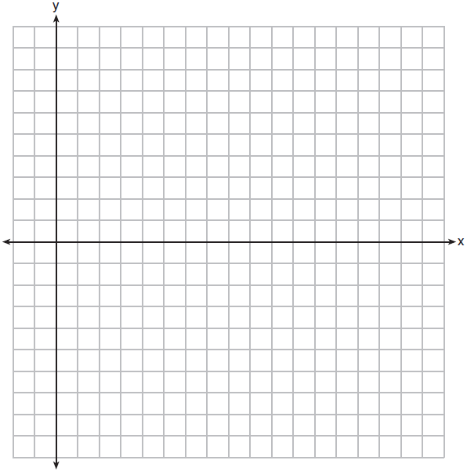

Over the given domain, state when the company was the least profitable and the most profitable, to the nearest year. Explain how you determined your answer.

1 ANS: 1 REF: 081501a2

2 ANS:
are the x-intercepts of f.

REF: 062326ai

3 ANS: 2 REF: 061816aii

4 ANS: 1 REF: 082414aii

5 ANS: 3
The graph shows three real zeros, and has end behavior matching the given end behavior.

REF: 061604aii

6 ANS:
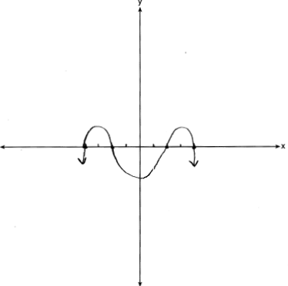

REF: 011926aii

7 ANS:
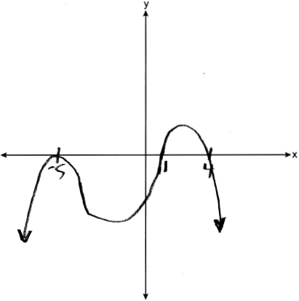

REF: 062428aii

8 ANS:
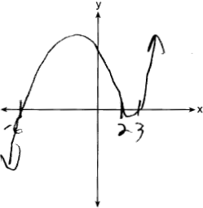

REF: 062333aii

9 ANS:
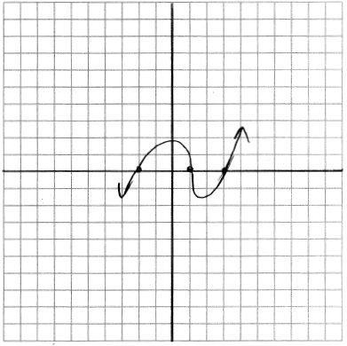

REF: 011729aii

10 ANS:
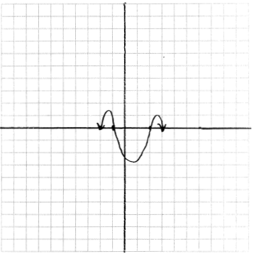

REF: 011831aii

11 ANS:
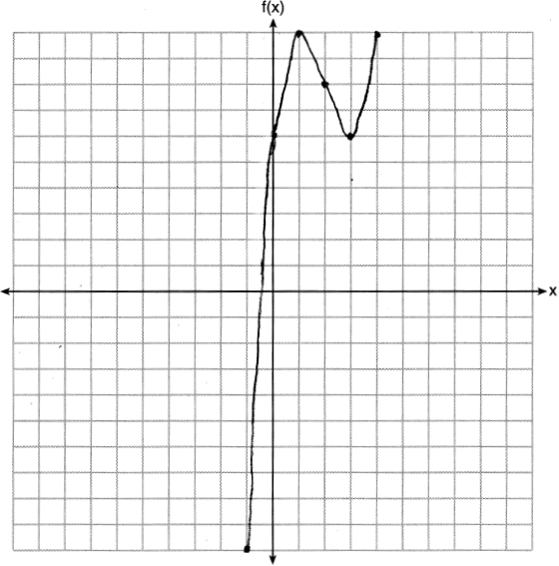

REF: 061826aii

12 ANS:
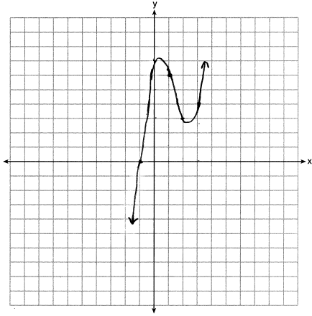

REF: 012032aii

13 ANS:
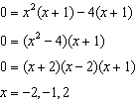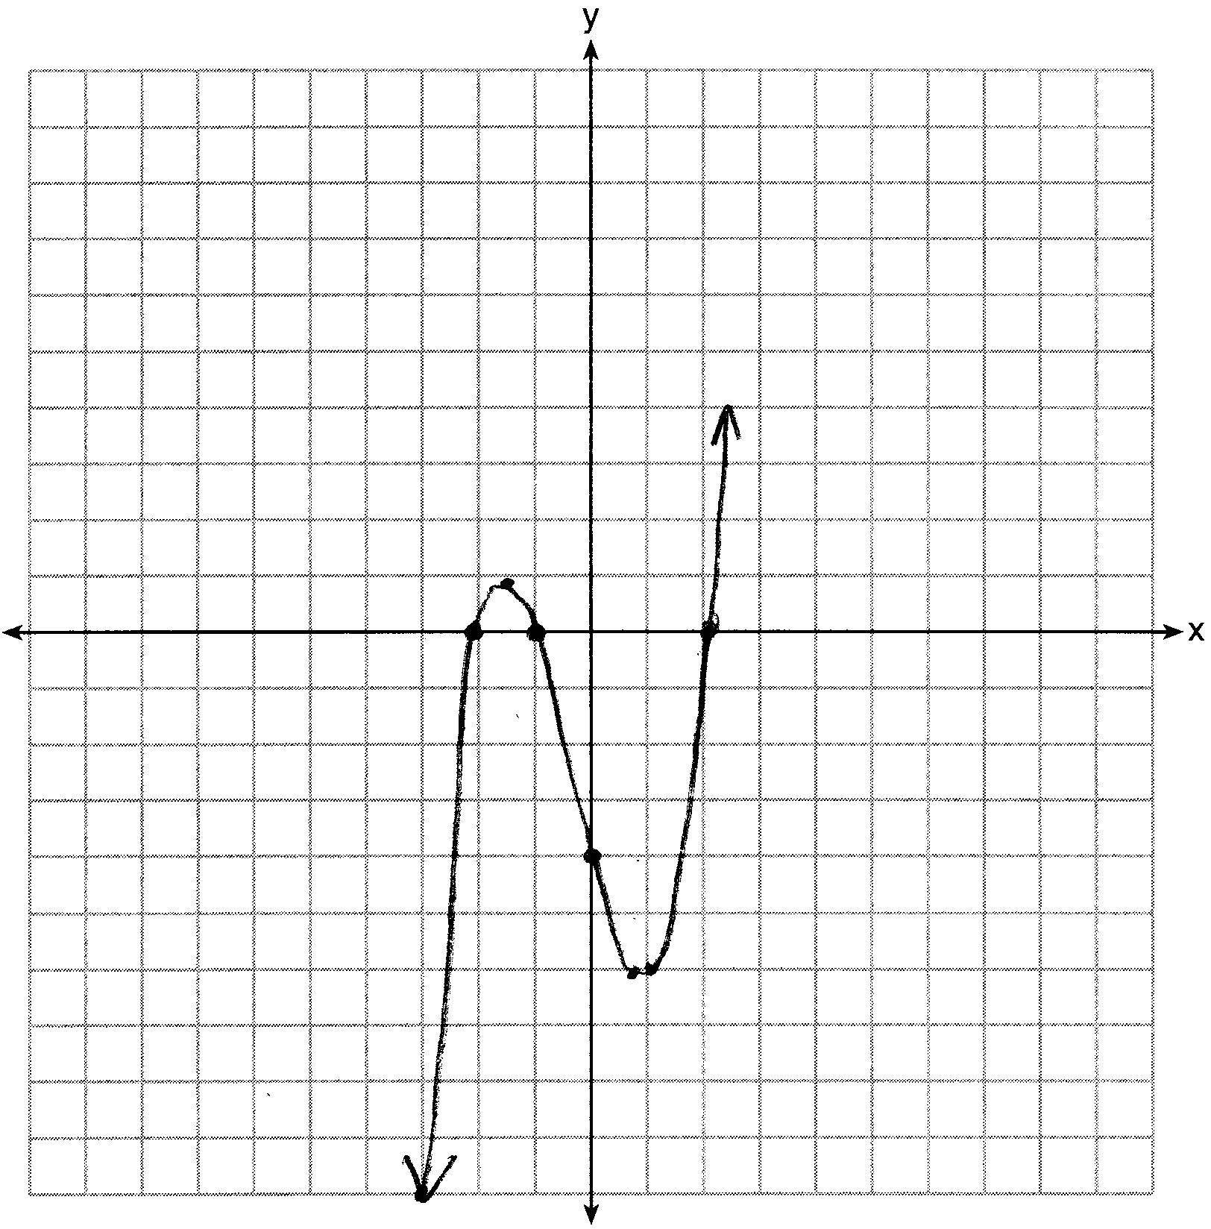

REF: 081633aii

14 ANS:
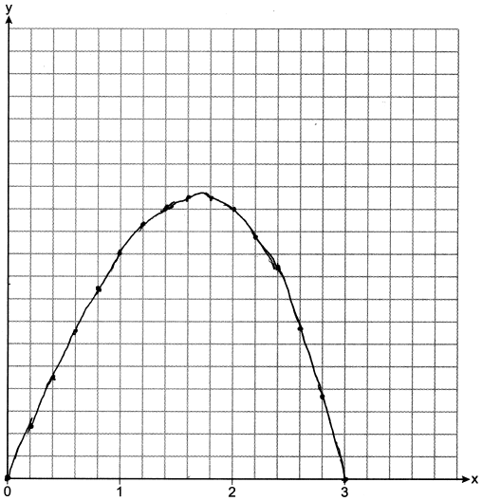 12.6

REF: 082234aii

15 ANS:
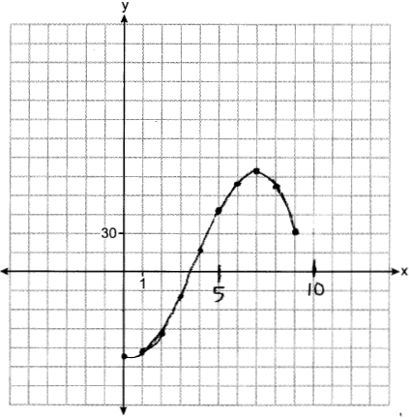 If 7000 sweatshirts are sold, the profit is $78,000. 3,549, because that is when is first greater than 0.

REF: 012437aii

16 ANS:
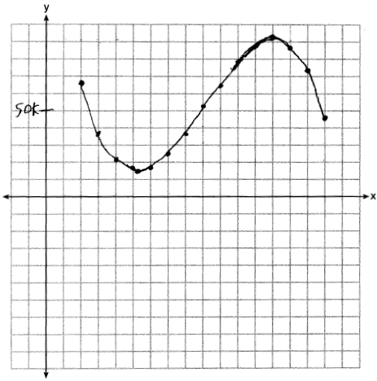 Least profitable at year 5 because there is a minimum in . Most profitable at year 13 because there is a maximum in .

REF: 081837aii

