1 For which value of x is undefined?
1) |  | 3)
2) |  | 4)

2 The asymptote of the graph of is
1) |  | 3)
2) |  | 4)

3 The graph of lies in Quadrant(s)
1) | I and II | 3) | III and IV
2) | II and III | 4) | I and IV

4 Which statement about the graph of is false?
1) | The asymptote has equation . | 3) | The domain is the set of positive reals.
2) | The graph has no y-intercept. | 4) | The range is the set of all real numbers.

5 Which statement below about the graph of is true?
1) | has a y-intercept at . | 3) | As
2) | has a y-intercept at . | 4)

6 If and is the image of after a translation five units to the left, which equation represents ?
1) |  | 3)
2) |  | 4)

7 The graph of is translated to the right 1 unit and down 1 unit. The coordinates of the x-intercept of the translated graph are
1) |  | 3)
2) |  | 4)

8 Which equation best represents the graph below?

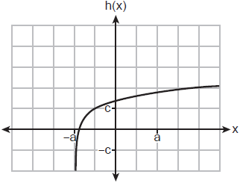
1) |  | 3)
2) |  | 4)

9 Which sketch shows the inverse of , where ?
1) | 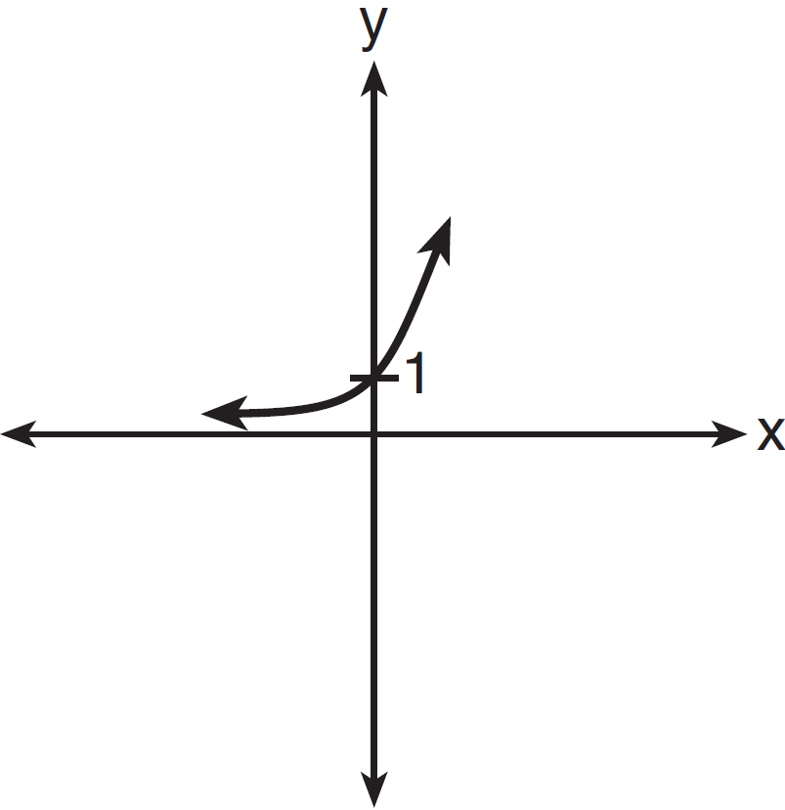 | 3) | 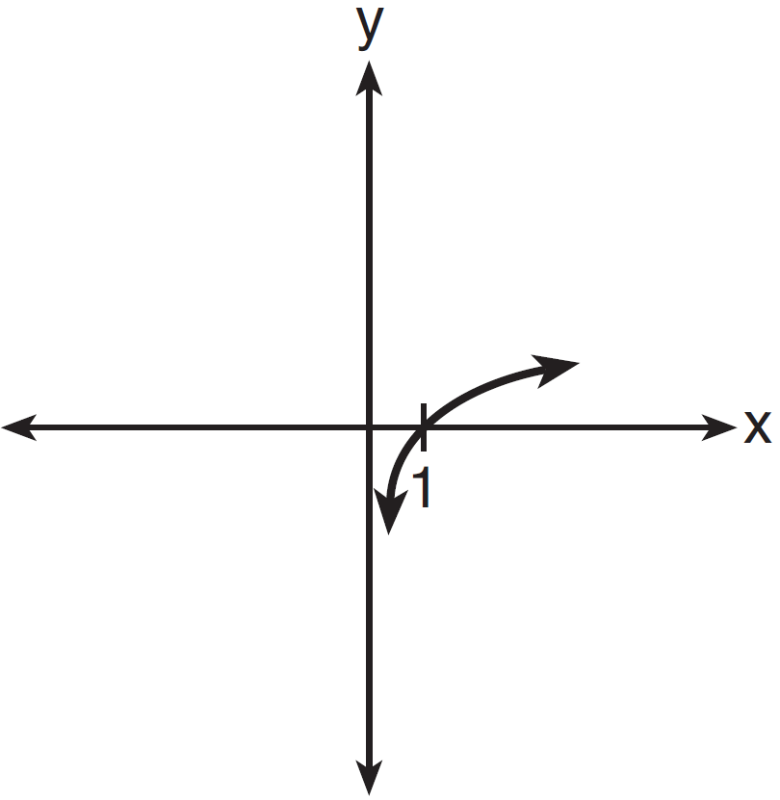
2) | 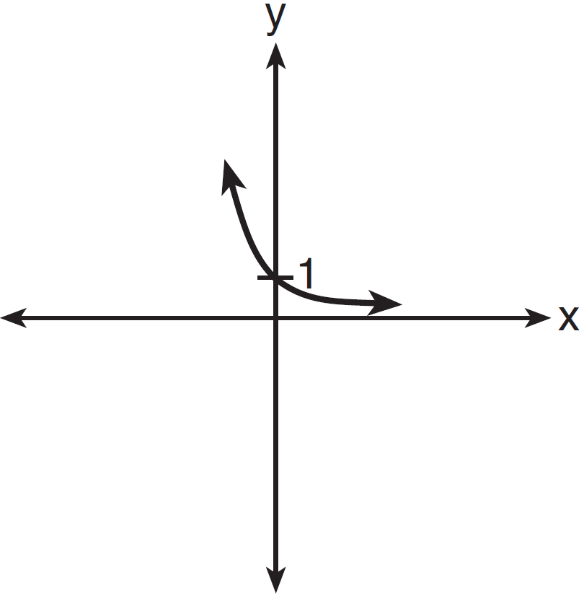 | 4) | 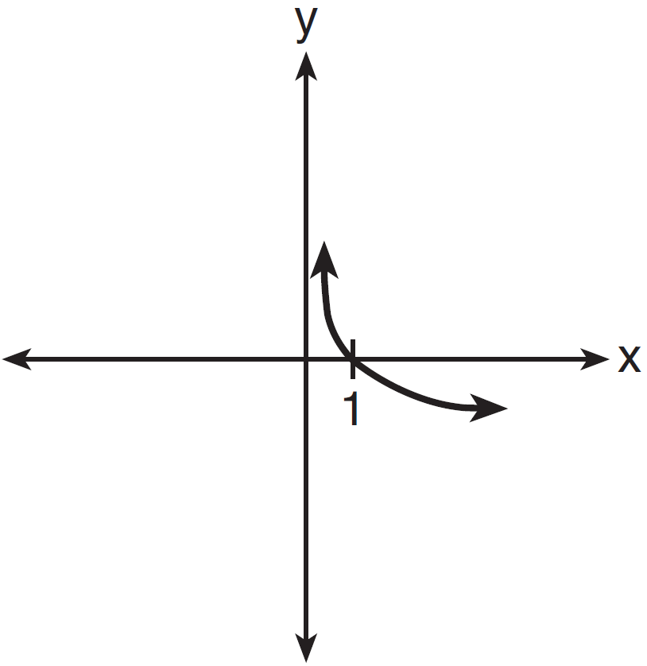

10 The cells of a particular organism increase logarithmically. If g represents cell growth and h represents time, in hours, which graph best represents the growth pattern of the cells of this organism?
1) | 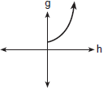 | 3) | 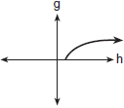
2) | 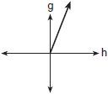 | 4) | 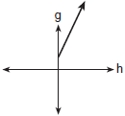

11 Which graph represents the function ?
1) | 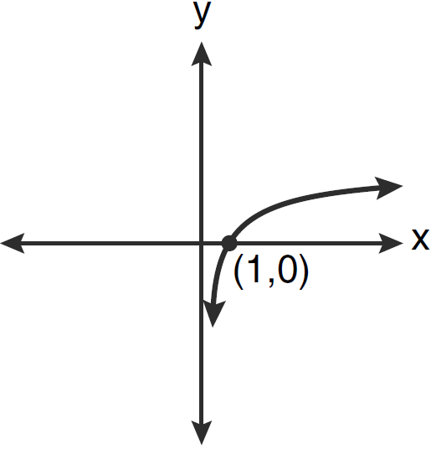 | 3) | 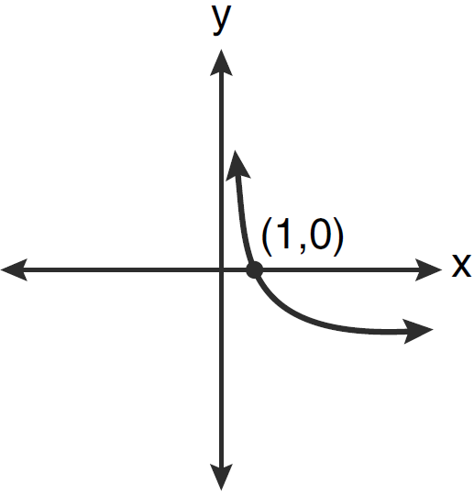
2) | 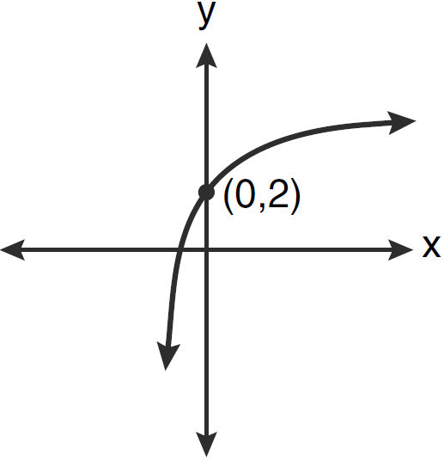 | 4) | 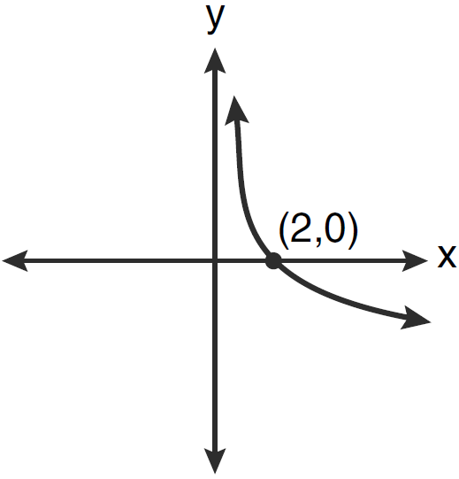

12 Which sketch best represents the graph of ?
1) | 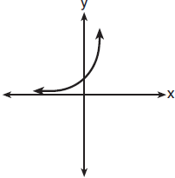 | 3) | 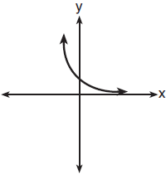
2) | 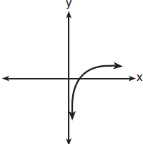 | 4) | 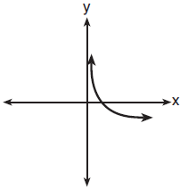

13 If a function is defined by the equation , which graph represents the inverse of this function?
1) | 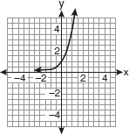 | 3) | 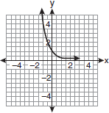
2) | 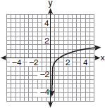 | 4) | 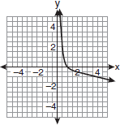

14 Which sketch could represent the function ?
1) | 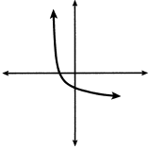 | 3) | 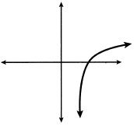
2) | 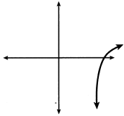 | 4) | 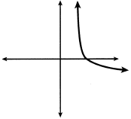

15 Sketch and label the graph of .

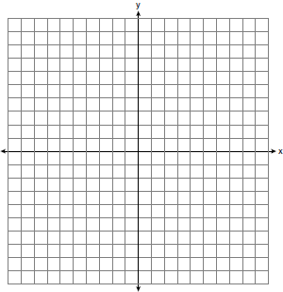

The graph of is subject to each of these transformations:
(1) reflection in the y-axis
(2) reflection in the line
(3) translation:
Next to the appropriate numeral below, write the letter of the equation, chosen from the list below, that best described the image of under each of the numbered transformations.
Equations
(a)
(b)
(c)
(d)

(1)
(2)
(3)

16 Sketch the graph of the functions and . Considering the graphs, describe the relationship between f(x) and g(x). Specify the domain and the range of g.

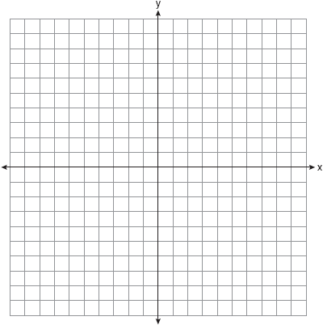

17 Sketch below the graph of . On the same set of axes, sketch the graph of .

18 Sketch and label the graph of the equation for all values of x in the interval . On the same set of axes, reflect the graph drawn in the line , and label it c. What is the equation of c?

19 Graph on the set of axes below.

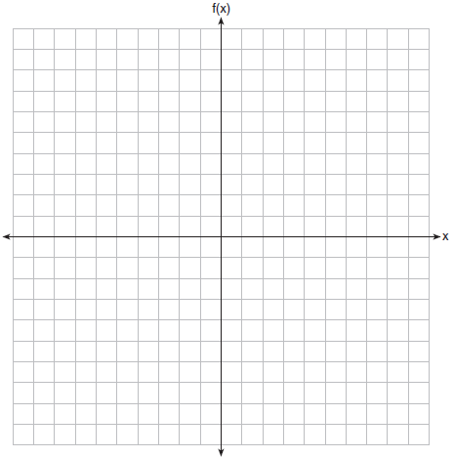

20 On the grid below, graph the function

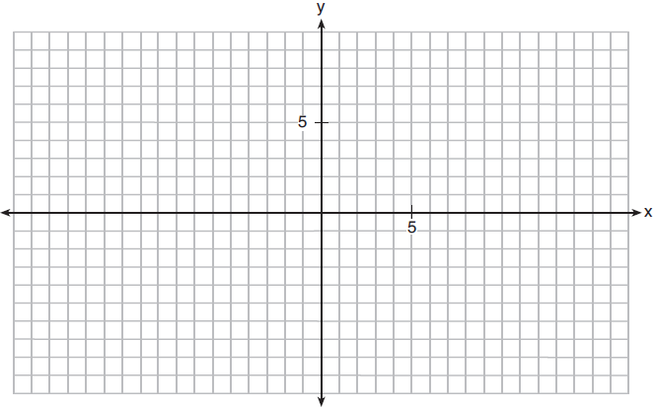

21 Sketch on the axes below.

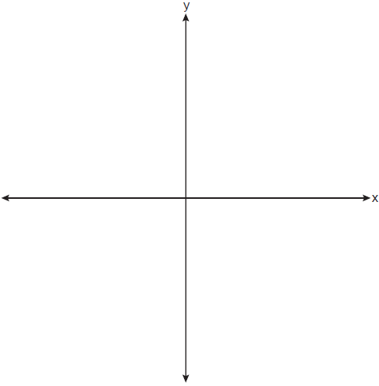

Describe the end behavior of as . Describe the end behavior of as

22 Graph on the set of axes below. Use an appropriate scale to include both intercepts.

Describe the behavior of the given function as x approaches and as x approaches positive infinity.

23 Graph , where on the set of axes below.

State the equation of the asymptote of . When is reflected over the line , a new function is formed: . State the equation of the asymptote of .

24 Graph the following function on the axes below.

State the domain of f. State the equation of the asymptote.

25 A hotel finds that its total annual revenue and the number of rooms occupied daily by guests can best be modeled by the function , where R is the total annual revenue, in millions of dollars, and n is the number of rooms occupied daily by guests. The hotel needs an annual revenue of $12 million to be profitable. Graph the function on the accompanying grid over the interval . Calculate the minimum number of rooms that must be occupied daily to be profitable.



1 ANS: 1 REF: 060301b

2 ANS: 2 REF: 082409aii

3 ANS: 4 REF: 018535siii

4 ANS: 1
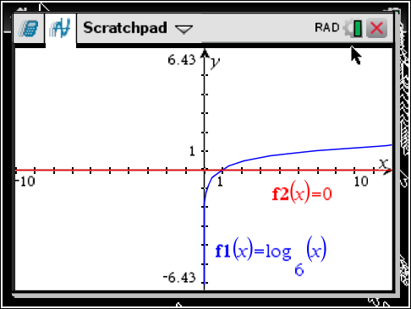

REF: 061618aii

5 ANS: 4 REF: 062215aii

6 ANS: 1 REF: 011902aii

7 ANS: 4
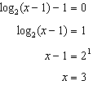

REF: 061819aii

8 ANS: 1 REF: 062308aii

9 ANS: 3 REF: 011422a2

10 ANS: 3 REF: 010420b

11 ANS: 1 REF: 061211a2

12 ANS: 2 REF: 081816aii

13 ANS: 2

REF: fall0916a2

14 ANS: 4
Translate the parent log function 2 to the right and reflect over the x-axis.

REF: 082207aii

15 ANS:
c, a, d

REF: 088539siii

16 ANS:
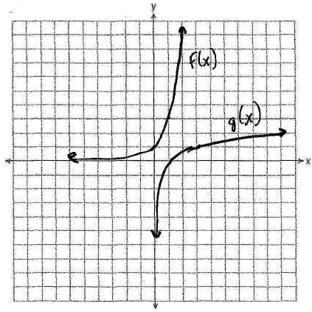 f(x) and g(x) are inverses of each other. The domain of g is the positive reals and the range of g is the reals.

REF: fall9927b

17 ANS:
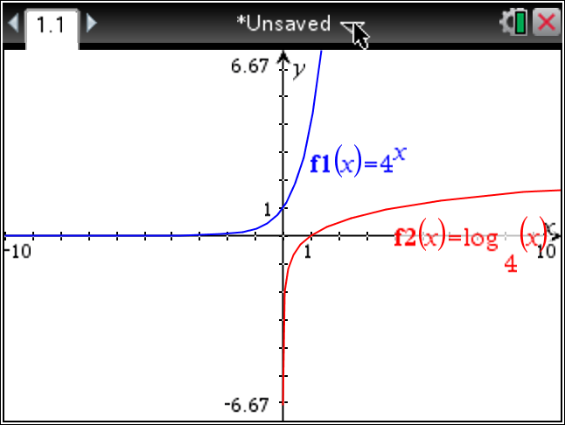

REF: 069039siii

18 ANS:
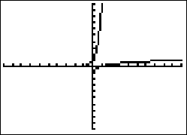,

REF: 019442siii

19 ANS:
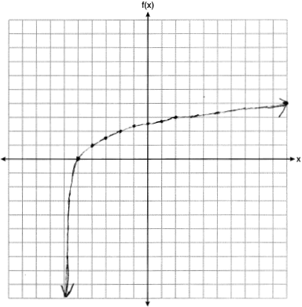

REF: 061927aii

20 ANS:
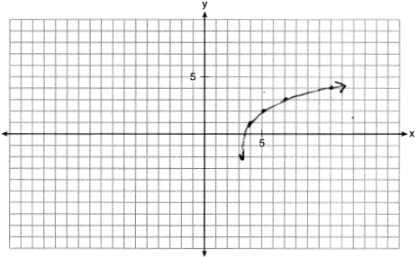

REF: 011932aii

21 ANS:
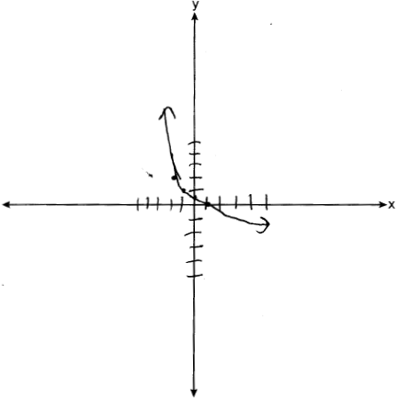 As . As .

REF: 082333aii

22 ANS:
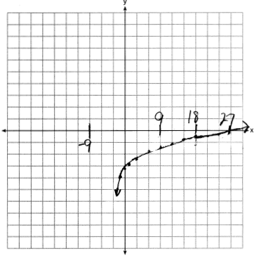 As . As .

REF: 061735aii

23 ANS:
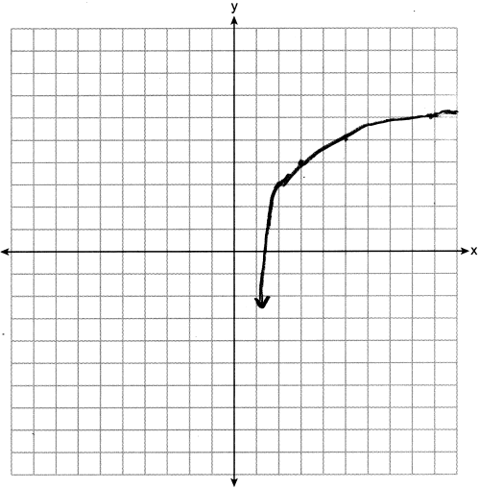

REF: 062436aii

24 ANS:
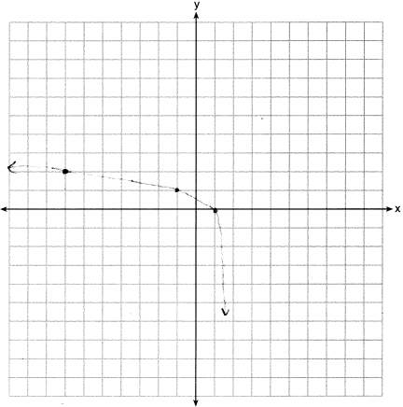Domain: , Asymptote

REF: 012034aii

25 ANS:
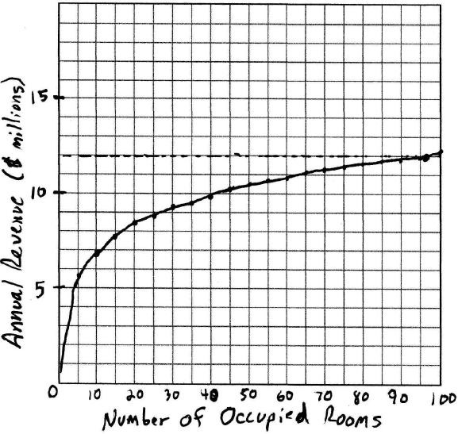 96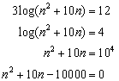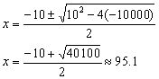. 96 rooms must be occupied. The other root is negative. 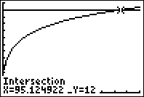

REF: 080530b

