1 The graph of the equation passes through the point
1)
2)
3)
4)

2 The graph of the equation intersects
1) | the x-axis, only
2) | the y-axis, only
3) | the x-axis and the y-axis
4) | neither the x-axis nor the y-axis

3 The graph of the function lies in which quadrant(s)?
1) | I, only
2) | I and II
3) | I and III
4) | I and IV

4 Which transformation of results in the function ?
1)
2)
3)
4)

5 Theresa is comparing the graphs of and . Which statement is true?
1) | The y-intercept of is , and the y-intercept of is .
2) | Both graphs have a y-intercept of , and is steeper for .
3) | Both graphs have a y-intercept of , and is steeper for .
4) | Neither graph has a y-intercept.

6 The graph of the function is shown on the accompanying set of axes. On the same set of axes, sketch the reflection of in the y-axis. State the coordinates of the point where the graphs intersect.

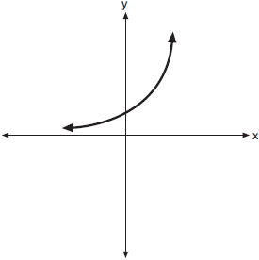

7 On the set of axes below, draw the graph of over the interval . Will this graph ever intersect the x-axis? Justify your answer.

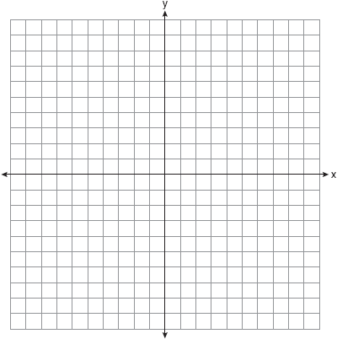

8 Graph the function on the set of axes below.

If , determine if when . Justify your answer.

9 On the set of axes below, graph over the interval .

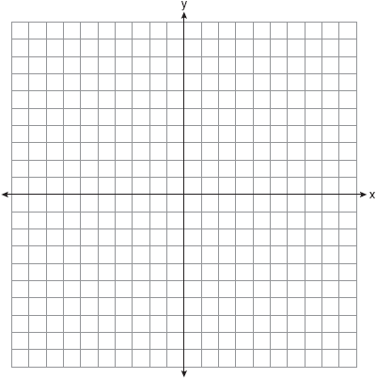
1 ANS: 1 REF: 011720a2

2 ANS: 2 REF: 068430siii

3 ANS: 2 REF: 088434siii

4 ANS: 2 REF: 080801b

5 ANS: 3
As originally written, alternatives (2) and (3) had no domain restriction, so that both were correct.

REF: 061405a2

6 ANS:
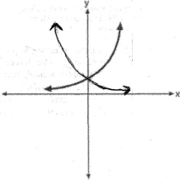

REF: 080721b

7 ANS:
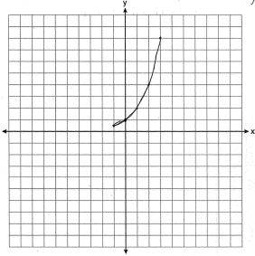. The graph will never intersect the x-axis as for all values of x.

REF: 080835ia

8 ANS:
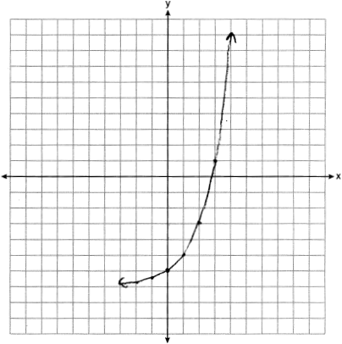 Yes, because .

REF: 011929ai

9 ANS:
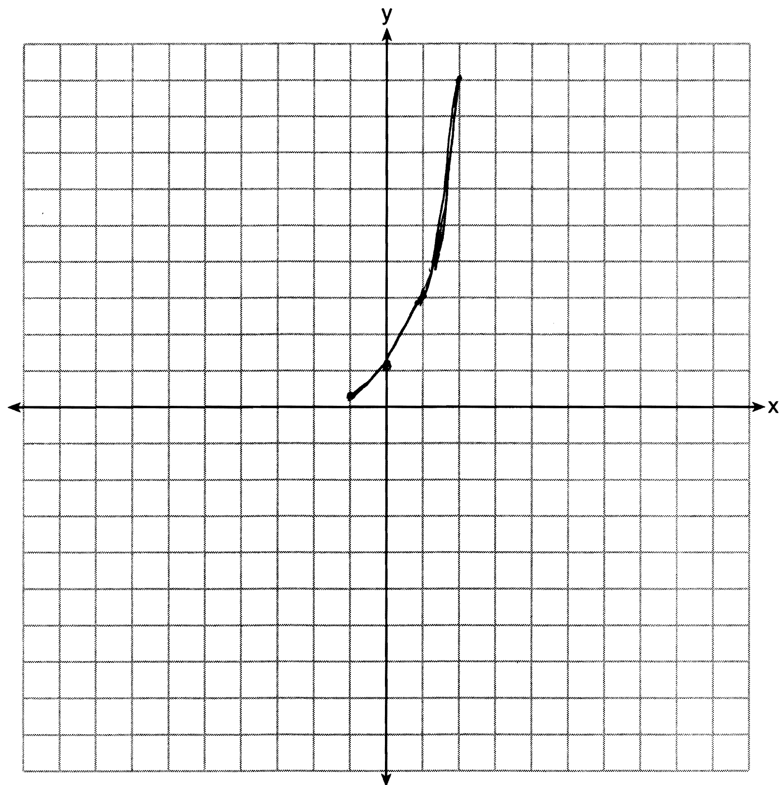

REF: 081233ia

