1 Joelle has a credit card that has a 19.2% annual interest rate compounded monthly. She owes a total balance of B dollars after m months. Assuming she makes no payments on her account, the table below illustrates the balance she owes after m months.

m | B
0 | 100.00
10 | 1172.00
19 | 1352.00
36 | 1770.80
60 | 2591.90
69 | 2990.00
72 | 3135.80
73 | 3186.00

Over which interval of time is her average rate of change for the balance on her credit card account the greatest?
1) | month 10 to month 60 | 3) | month 36 to month 72
2) | month 19 to month 69 | 4) | month 60 to month 73

2 The population of Austin, Texas from 1850 to 2010 is summarized in the table below.

Year | 1850 | 1870 | 1890 | 1910 | 1930 | 1950 | 1970 | 1990 | 2010
Population | 629 | 4428 | 14,575 | 29,860 | 53,120 | 132,459 | 251,808 | 494,290 | 790,390

Over which period of time was the average rate of change in population the greatest?
1) | 1850 to 1910 | 3) | 1950 to 1970
2) | 1990 to 2010 | 4) | 1890 to 1970

3 A cardboard box manufacturing company is building boxes with length represented by , width by , and height by . The volume of the box is modeled by the function below.

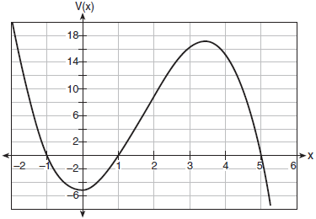

Over which interval is the volume of the box changing at the fastest average rate?
1) |  | 3) | [1,5]
2) | [1,3.5] | 4)

4 Irma initially ran one mile in over ten minutes. She then began a training program to reduce her one-mile time. She recorded her one-mile time once a week for twelve consecutive weeks, as modeled in the graph below.

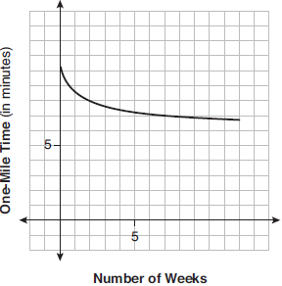

Which statement regarding Irma’s one-mile training program is correct?
1) | Her one-mile speed increased as the number of weeks increased. | 3) | If the trend continues, she will run under a six-minute mile by week thirteen.
2) | Her one-mile speed decreased as the number of weeks increased. | 4) | She reduced her one-mile time the most between weeks ten and twelve.

5 The function can be used to predict the temperature of a cup of hot chocolate in degrees Fahrenheit after x minutes. What is the approximate average rate of change of the temperature of the hot chocolate, in degrees per minute, over the interval ?
1) |  | 3) | 0.11
2) |  | 4) | 8.93

6 The function models the number of grams in a sample of cesium-137 that remain after t years. On which interval is the sample's average rate of decay the fastest?
1) |  | 3) | [15,25]
2) |  | 4)

7 The value of a new car depreciates over time. Greg purchased a new car in June 2011. The value, V, of his car after t years can be modeled by the equation 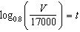. What is the average decreasing rate of change per year of the value of the car from June 2012 to June 2014, to the nearest ten dollars per year?
1) | 1960 | 3) | 2450
2) | 2180 | 4) | 2770

8 The function 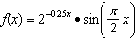 represents a damped sound wave function. What is the average rate of change for this function on the interval , to the nearest hundredth?
1) | -3.66 | 3) | -0.26
2) | -0.30 | 4) | 3.36

9 The equation 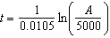 relates time, t, in years, to the amount of money, A, earned by a $5000 investment. Which statement accurately describes the relationship between the average rates of change of t on the intervals [6000, 8000] and [9000, 12,000]?
1) | A comparison cannot be made because the intervals are different sizes. | 3) | The average rate of change is larger for the interval [6000, 8000].
2) | The average rate of change is equal for both intervals. | 4) | The average rate of change is larger for the interval [9000, 12,000].

10 Consider the graph of g and the table representing t below.
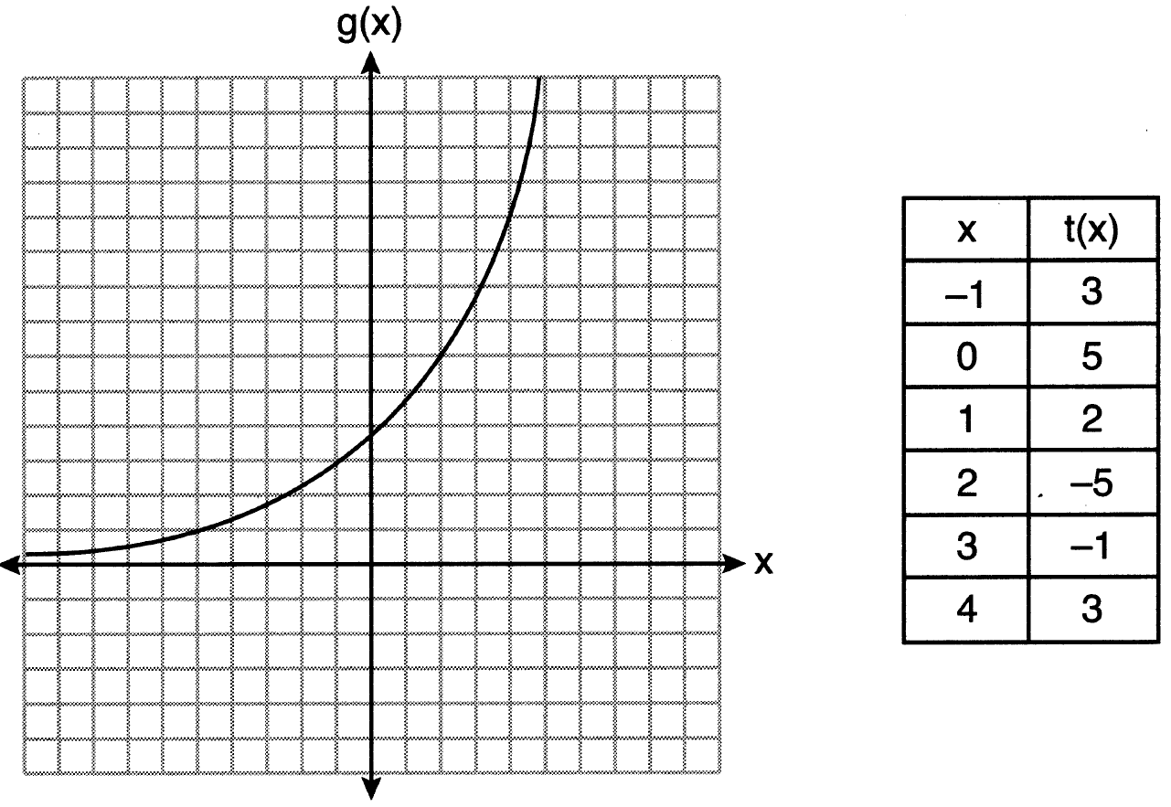
Over the interval , which statement regarding the average rate of change for g and t is true?
1) | g has a greater average rate of change. | 3) | The average rate of change for g is twice the average rate of change for t.
2) | The average rates of change are equal. | 4) | The average rate of change for g is half the average rate of change for t.

11 The table below shows the number of hours of daylight on the first day of each month in Rochester, NY.
Month | Hours of Daylight
Jan. | 9.4
Feb. | 10.6
March | 11.9
April | 13.9
May | 14.7
June | 15.4
July | 15.1
Aug. | 13.9
Sept. | 12.5
Oct. | 11.1
Nov. | 9.7
Dec. | 9.0
Given the data, what is the average rate of change in hours of daylight per month from January 1st to April 1st? Interpret what this means in the context of the problem.

12 The distance needed to stop a car after applying the brakes varies directly with the square of the car’s speed. The table below shows stopping distances for various speeds.

Speed (mph) | 10 | 20 | 30 | 40 | 50 | 60 | 70
Distance (ft) | 6.25 | 25 | 56.25 | 100 | 156.25 | 225 | 306.25

Determine the average rate of change in braking distance, in ft/mph, between one car traveling at 50 mph and one traveling at 70 mph. Explain what this rate of change means as it relates to braking distance.

13 Determine the average rate of change, in mph, from 2 to 4 hours on the graph shown below.

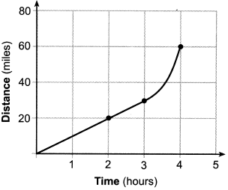

14 A fruit fly population can be modeled by the equation , where P represents the number of fruit flies after t days. What is the average rate of change of the population, rounded to the nearest hundredth, over the interval ? Include appropriate units in your answer.

15 An initial investment of $1000 reaches a value, , according to the model , where t is the time in years. Determine the average rate of change, to the nearest dollar per year, of this investment from year 2 to year 7.

16 In the town of Skaneateles, New York, house prices since 2008 have changed based on the function , where t is the number of years since 2008 and is the median house price. Determine the average rate of change for the median house price in Skaneateles, from 2010 to 2018 to the nearest dollar per year. Explain what this rate of change means as it relates to median house prices.

17 The world population was 2560 million people in 1950 and 3040 million in 1960 and can be modeled by the function , where t is time in years after 1950 and is the population in millions. Determine the average rate of change of in millions of people per year, from . Round your answer to the nearest hundredth.

18 The average monthly high temperature in Buffalo, in degrees Fahrenheit, can be modeled by the function , where t is the month number . State, to the nearest tenth, the average monthly rate of temperature change between August and November. Explain its meaning in the given context.

19 The monthly high temperature (ºF) in Buffalo, New York can be modeled by , where m is the number of the month and . Find the average rate of change in the monthly high temperature between June and October, to the nearest hundredth. Explain what this value represents in the given context.

20 Which function shown below has a greater average rate of change on the interval ? Justify your answer.

x | f(x)
 | 0.3125
 | 0.625
 | 1.25
 | 2.5
0 | 5
1 | 10
2 | 20
3 | 40
4 | 80
5 | 160
6 | 320

21 The population of China, in millions, can be modeled by the function , where x is the number of years since 1900. The population of India since 1900 is summarized in the table below:

Years since 1900 | Population (millions)
0 | 243
10 | 254
20 | 268
30 | 285
40 | 324
50 | 376.3
60 | 450.6
70 | 555.1
80 | 699
60 | 873.3
100 | 1056.6
110 | 1234.3
120 | 1380

Which country's population had a greater average rate of change between 1950 and 2020? Justify your answer.
1 ANS: 4
(1) 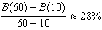 (2) 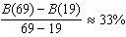 (3) 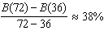 (4) 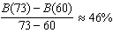

REF: 011721aii

2 ANS: 2
1) 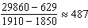; 2) 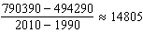; 3) 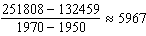; 4) 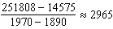

REF: 062301aii

3 ANS: 1
(1) 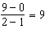 (2) 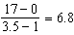 (3) 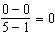 (4) 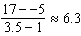

REF: 011724aii

4 ANS: 1 REF: 061904aii

5 ANS: 1
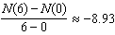

REF: 012012aii

6 ANS: 1
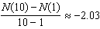, 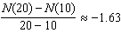, 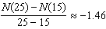, 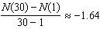

REF: 061807aii

7 ANS: 3
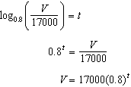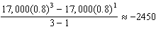

REF: 081709aii

8 ANS: 3
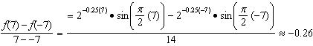

REF: 061721aii

9 ANS: 3
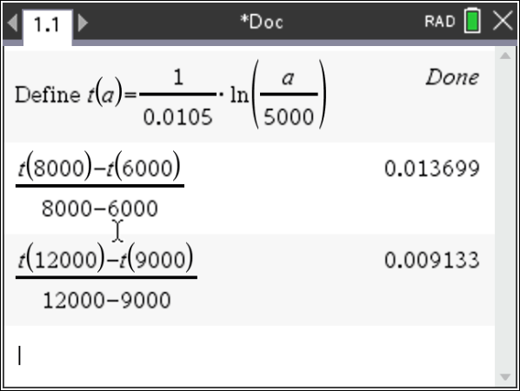

REF: 081922aii

10 ANS: 4
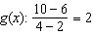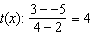

REF: 062212ai

11 ANS:
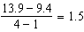 The average rate of change in the number of hours of daylight from January 1-April 1 is 1.5.

REF: 061925aii

12 ANS:
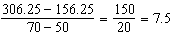 Between 50-70 mph, each additional mph in speed requires 7.5 more feet to stop.

REF: 081631aii

13 ANS:
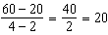

REF: 082225aii

14 ANS:
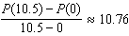 fruit flies per day

REF: 082332aii

15 ANS:
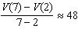

REF: 012427aii

16 ANS:
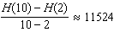 From 2014-2018, the median house price increased $11524 per year on average.

REF: 062434aii

17 ANS:
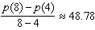

REF: 081827aii

18 ANS:
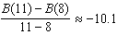 The average monthly high temperature decreases 10.1º each month from August to November.

REF: 011930aii

19 ANS:
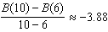. The average monthly high temperature decreases about 4º each month from June and October.

REF: 012336aii

20 ANS:
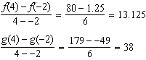 has a greater rate of change

REF: 061636aii

21 ANS:
China: 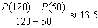 India: 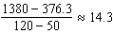 India

REF: 082433aii

