1 A café owner tracks the number of customers during business hours. The graph below models the data.

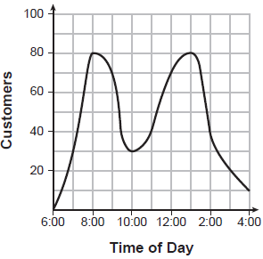

Based on the graph, the café owner saw a continual
1) | increase in customers from 6:00 to 11:00 | 3) | decrease in customers from 1:00 to 4:00
2) | increase in customers from 12:00 to 3:00 | 4) | decrease in customers from 11:00 to 2:00

2 The graph below represents a jogger's speed during her 20-minute jog around her neighborhood.

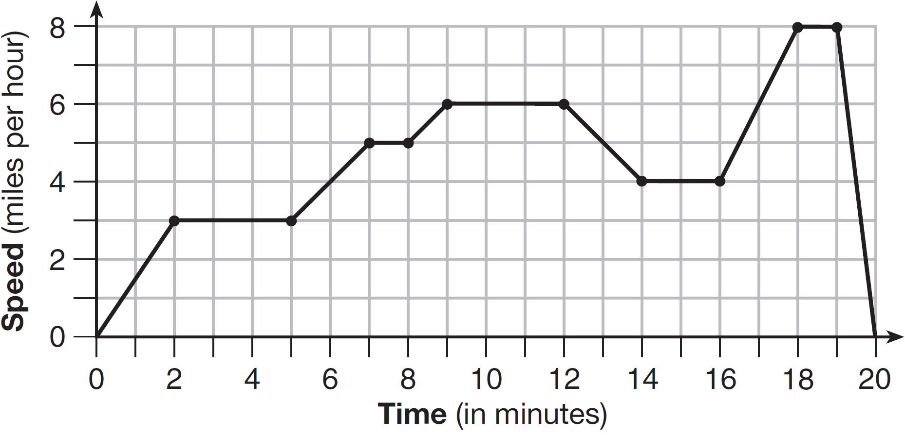

Which statement best describes what the jogger was doing during the minute interval of her jog?
1) | She was standing still. | 3) | She was decreasing her speed.
2) | She was increasing her speed. | 4) | She was jogging at a constant rate.

3 The graph below represents a dog walker's speed during his 30-minute walk around the neighborhood.

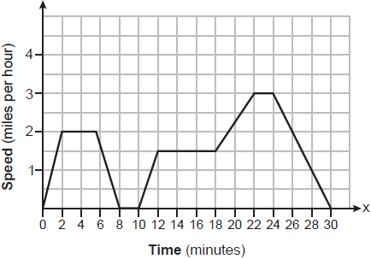

Which statement best describes what the dog walker was doing during the 12-18 minute interval of his walk?
1) | He was walking at a constant rate. | 3) | He was decreasing his speed.
2) | He was increasing his speed. | 4) | He was standing still.

4 John left his home and walked 3 blocks to his school, as shown in the accompanying graph.

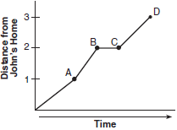

What is one possible interpretation of the section of the graph from point B to point C?
1) | John arrived at school and stayed throughout the day. | 3) | John returned home to get his mathematics homework.
2) | John waited before crossing a busy street. | 4) | John reached the top of a hill and began walking on level ground.

5 A child is playing outside. The graph below shows the child's distance, , in yards from home over a period of time, t, in seconds.

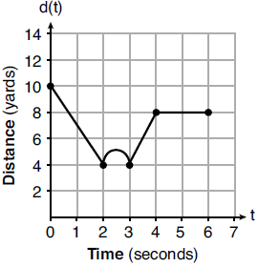

Which interval represents the child constantly moving closer to home?
1) |  | 3)
2) |  | 4)

6 The accompanying graph shows the amount of water left in Rover’s water dish over a period of time.

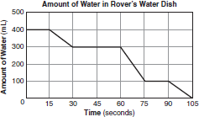

How long did Rover wait from the end of his first drink to the start of his second drink of water?
1) | 10 sec | 3) | 60 sec
2) | 30 sec | 4) | 75 sec

7 A bug travels up a tree, from the ground, over a 30-second interval. It travels fast at first and then slows down. It stops for 10 seconds, then proceeds slowly, speeding up as it goes. Which sketch best illustrates the bug’s distance (d) from the ground over the 30-second interval (t)?
1) | 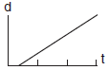 | 3) | 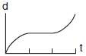
2) | 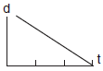 | 4) | 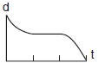

8 To keep track of his profits, the owner of a carnival booth decided to model his ticket sales on a graph. He found that his profits only declined when he sold between 10 and 40 tickets. Which graph could represent his profits?
1) | 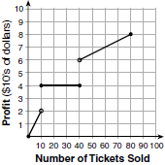 | 3) | 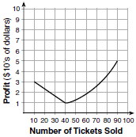
2) | 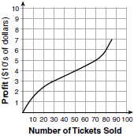 | 4) | 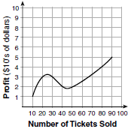

9 The accompanying graph shows Marie’s distance from home (A) to work (F) at various times during her drive.

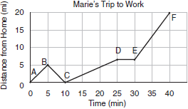

Marie left her briefcase at home and had to return to get it. State which point represents when she turned back around to go home and explain how you arrived at that conclusion. Marie also had to wait at the railroad tracks for a train to pass. How long did she wait?

10 The graph below models the height of Sam's kite over a period of time.

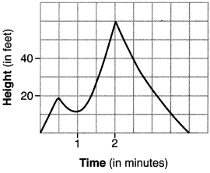

Explain what the zeros of the graph represent in the context of the situation. State the time intervals over which the height of the kite is increasing. State the maximum height, in feet, that the kite reaches.

11 The graph below models Craig's trip to visit his friend in another state. In the course of his travels, he encountered both highway and city driving.

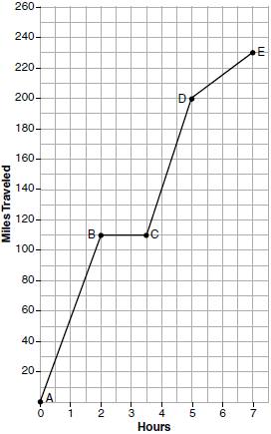

Based on the graph, during which interval did Craig most likely drive in the city? Explain your reasoning. Explain what might have happened in the interval between B and C. Determine Craig's average speed, to the nearest tenth of a mile per hour, for his entire trip.

12 Anessa is studying the changes in population in a town. The graph below shows the population over 50 years.

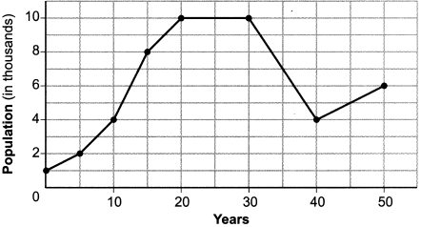

State the entire interval during which the population remained constant. State the maximum population of the town over the 50-year period. Determine the average rate of change from year 30 to year 40. Explain what your average rate of change means from year 30 to year 40 in the context of the problem.

13 Thomas took a 140-mile bus trip to visit his grandparents. His trip is outlined on the graph below.

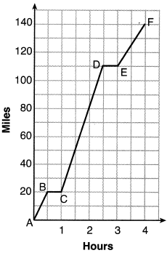

Explain what might have happened in the interval between D and E. State the interval in which the bus traveled the fastest. State how many miles per hour the bus was traveling during this interval. What was the average rate of speed, in miles per hour, for Thomas' entire bus trip?

14 During a snowstorm, a meteorologist tracks the amount of accumulating snow. For the first three hours of the storm, the snow fell at a constant rate of one inch per hour. The storm then stopped for two hours and then started again at a constant rate of one-half inch per hour for the next four hours.
a) On the grid below, draw and label a graph that models the accumulation of snow over time using the data the meteorologist collected.



b) If the snowstorm started at 6 p.m., how much snow had accumulated by midnight?

15 A driver leaves home for a business trip and drives at a constant speed of 60 miles per hour for 2 hours. Her car gets a flat tire, and she spends 30 minutes changing the tire. She resumes driving and drives at 30 miles per hour for the remaining one hour until she reaches her destination. On the set of axes below, draw a graph that models the driver’s distance from home.

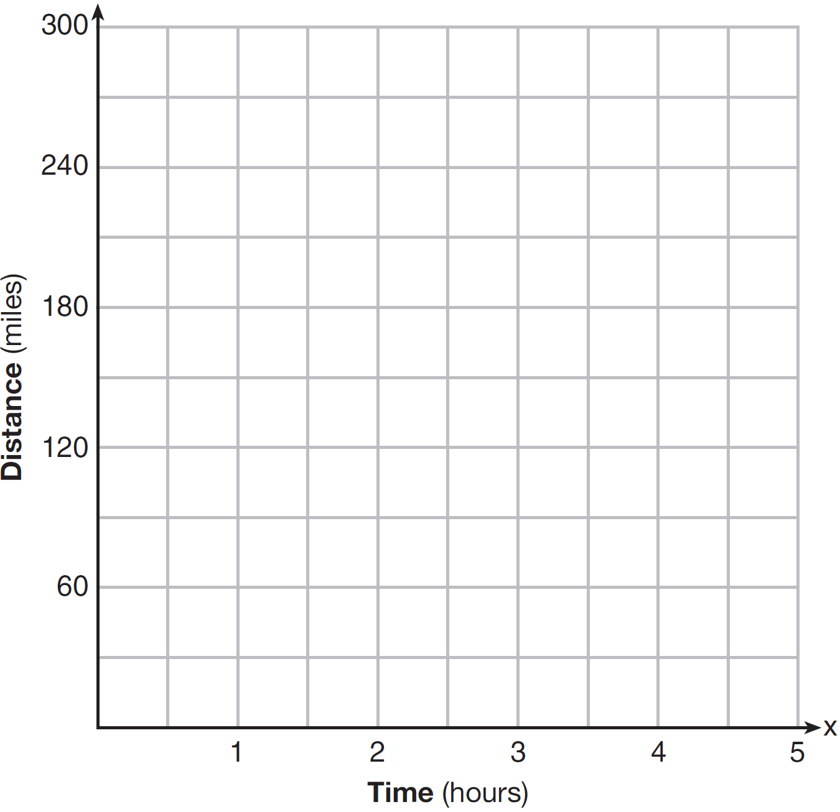

16 One spring day, Elroy noted the time of day and the temperature, in degrees Fahrenheit. His findings are stated below.
At 6 a.m., the temperature was 50°F. For the next 4 hours, the temperature rose 3° per hour. The next 6 hours, it rose 2° per hour. The temperature then stayed steady until 6 p.m. For the next 2 hours, the temperature dropped 1° per hour. The temperature then dropped steadily until the temperature was 56°F at midnight.
On the set of axes below, graph Elroy's data.

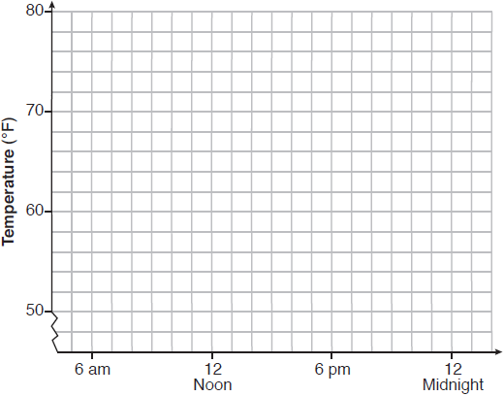

State the entire time interval for which the temperature was increasing. Determine the average rate of change, in degrees per hour, from 6:00 p.m. to midnight.

17 A snowstorm started at midnight. For the first 4 hours, it snowed at an average rate of one-half inch per hour. The snow then started to fall at an average rate of one inch per hour for the next 6 hours. Then it stopped snowing for 3 hours. Then it started snowing again at an average rate of one-half inch per hour for the next 4 hours until the storm was over. On the set of axes below, graph the amount of snow accumulated over the time interval of the storm.

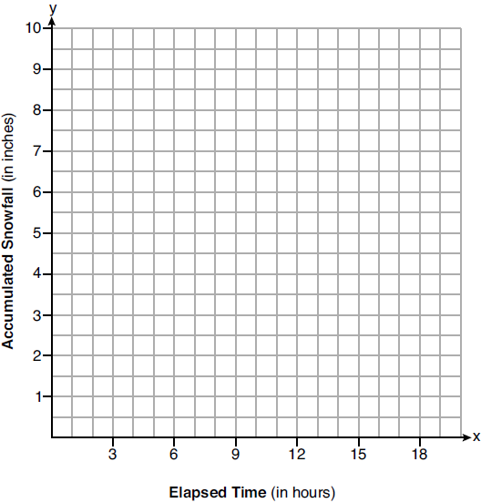

Determine the average rate of snowfall over the length of the storm. State the rate, to the nearest hundredth of an inch per hour.
1 ANS: 3 REF: 082301ai

2 ANS: 4 REF: 061502ai

3 ANS: 1 REF: 012401ai

4 ANS: 2
Between points B and C, John’s distance from home remains constant. (2) represents an interpretation in which John’s distance remains constant, waiting before crossing a busy street. (1) also represents an interpretation in which John’s distance remains constant, but at points B and C, John had not yet arrived at school. In both (3) and (4), John’s distance from school is changing.

REF: 010412a

5 ANS: 1 REF: 081918ai

6 ANS: 2
When Rover is drinking, the amount of water in his dish decreases over time. The first decrease ends at 30 seconds and the second decrease begins at 60 seconds. The difference between these points is 30 seconds.

REF: 080410a

7 ANS: 3
In this sketch, the bug’s speed is decreasing during the first third of time, equals 0 during the second third of time and is increasing the last third of time. In (4), the bug is traveling down the tree. In (1) and (2), the bug’s speed remains constant.

REF: 060114b

8 ANS: 3 REF: 061701ai

9 ANS:
B, 5 minutes. At point B, Mary’s distance from home begins to decrease, representing the point where she turned back around to go home. The interval between points D and E is the only portion of the graph where Mary’s distance from home remains constant. It lasts for 5 mins.

REF: 010121a

10 ANS:
The zeros represent when the height of the kite is 0. The height of the kite is increasing over 0-0.5 and 1-2 minutes. The maximum height of the kite is 60 feet.

REF: 062233ai

11 ANS:
D-E, because his speed was slower. Craig may have stayed at a rest stop during B-C. 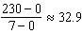

REF: 061734ai

12 ANS:
20-30; 10000; 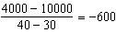. The population decreases by 600 each year.

REF: 012333ai

13 ANS:
The bus stopped in the interval between D and E. The bus traveled the fastest in the interval between C and D at 60 mph. The average rate of speed was 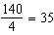 mph.

REF: 082233ai

14 ANS:
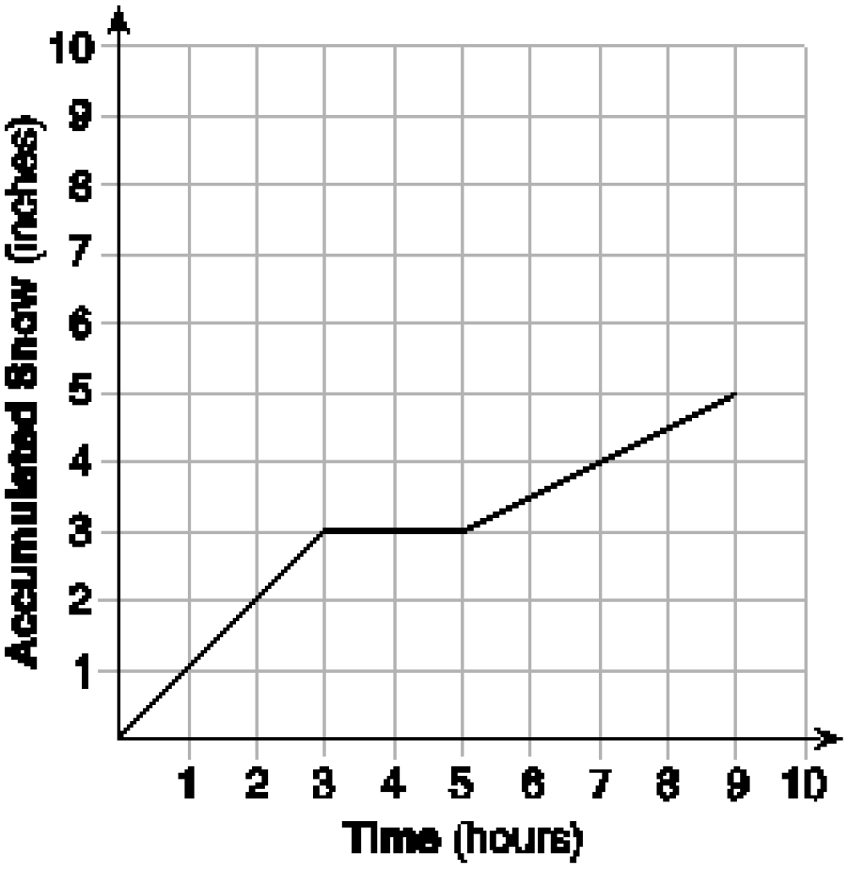 At 6 hours, inches of snow have fallen.

REF: spr1307ai

15 ANS:
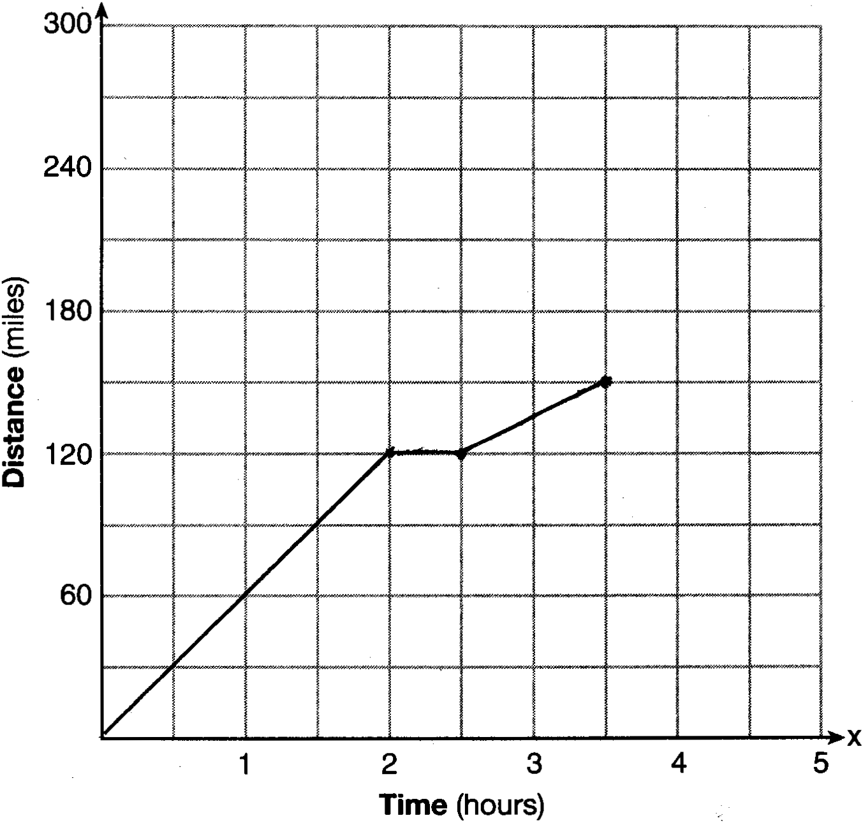

REF: 081528ai

16 ANS:
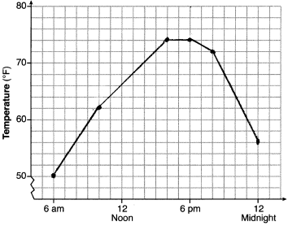, 6am-4pm, 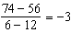

REF: 011936ai

17 ANS:
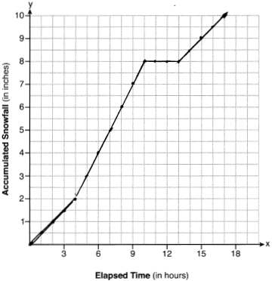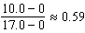

REF: 081936ai

