1 Relative to the graph of , what is the shift of the graph of 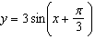?
1) | right
2) | left
3) | up
4) | down

2 Given the parent function , which phrase best describes the transformation used to obtain the graph of , if a and b are positive constants?
1) | right a units, up b units
2) | right a units, down b units
3) | left a units, up b units
4) | left a units, down b units

3 The temperature, in degrees Fahrenheit, in Times Square during a day in August can be predicted by the function , where x is the number of hours after midnight. According to this model, the predicted temperature, to the nearest degree Fahrenheit, at 7 P.M. is
1) | 68
2) | 74
3) | 77
4) | 81

4 The hours of daylight, y, in Utica in days, x, from January 1, 2013 can be modeled by the equation . How many hours of daylight, to the nearest tenth, does this model predict for February 14, 2013?
1) | 9.4
2) | 10.4
3) | 12.1
4) | 12.2

5 The Ferris wheel at the landmark Navy Pier in Chicago takes 7 minutes to make one full rotation. The height, H, in feet, above the ground of one of the six-person cars can be modeled by 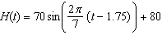, where t is time, in minutes. Using for one full rotation, this car's minimum height, in feet, is
1) | 150
2) | 70
3) | 10
4) | 0

6 The average monthly temperature, , in degrees Fahrenheit, over a 12 month period, can be modeled by 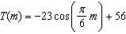, where m is in months. What is the range of temperatures, in degrees Fahrenheit, of this function?
1)
2)
3)
4)

7 As increases from to 0 radians, the value of will
1) | decrease from 1 to 0
2) | decrease from 0 to
3) | increase from to 0
4) | increase from 0 to 1

8 A sine function increasing through the origin can be used to model light waves. Violet light has a wavelength of 400 nanometers. Over which interval is the height of the wave decreasing, only?
1)
2)
3)
4)

9 Given 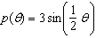 on the interval , the function p
1) | decreases, then increases
2) | increases, then decreases
3) | decreases throughout the interval
4) | increases throughout the interval

10 As x increases from 0 to , the graph of the equation will
1) | increase from 0 to 2
2) | decrease from 0 to
3) | increase without limit
4) | decrease without limit

11 The depth of the water, , in feet, on a given day at Thunder Bay, t hours after midnight is modeled by 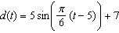. Which statement about the Thunder Bay tide is false?
1) | A low tide occurred at 2 a.m.
2) | The maximum depth of the water was 12 feet.
3) | The water depth at 9 a.m. was approximately 11 feet.
4) | The difference in water depth between high tide and low tide is 14 feet.

12 Based on climate data that have been collected in Bar Harbor, Maine, the average monthly temperature, in degrees F, can be modeled by the equation . The same governmental agency collected average monthly temperature data for Phoenix, Arizona, and found the temperatures could be modeled by the equation . Which statement can not be concluded based on the average monthly temperature models x months after starting data collection?
1) | The average monthly temperature variation is more in Bar Harbor than in Phoenix.
2) | The midline average monthly temperature for Bar Harbor is lower than the midline temperature for Phoenix.
3) | The maximum average monthly temperature for Bar Harbor is 79° F, to the nearest degree.
4) | The minimum average monthly temperature for Phoenix is 20° F, to the nearest degree.

13 The function 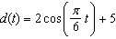 models the water depth, in feet, at a location in a bay, t hours since the last high tide. Determine the minimum water depth of the location, in feet, and justify your answer.

14 A person’s lung capacity can be modeled by the function 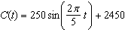, where represents the volume in mL present in the lungs after t seconds. State the maximum value of this function over one full cycle, and explain what this value represents.

15 The height, in cm, of a piston, is given by the equation 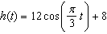, where t represents the number of seconds since the measurements began. Determine the average rate of change, in cm/sec, of the piston's height on the interval . At what value(s) of t, to the nearest tenth of a second, does in the interval ? Justify your answer.
1 ANS: 2 REF: 011701aii

2 ANS: 4 REF: 061706aii

3 ANS: 3

REF: 061922aii

4 ANS: 2 REF: 011804aii

5 ANS: 3
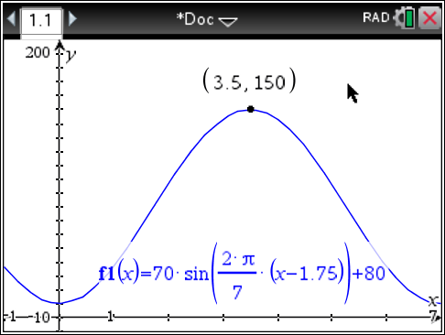 is at a minimum at

REF: 061613aii

6 ANS: 2
;

REF: 062305aii

7 ANS: 4 REF: 012016aii

8 ANS: 2 REF: 081610aii

9 ANS: 4 REF: 082220aii

10 ANS: 3 REF: 081705aii

11 ANS: 4
1) ; 2) ; 3) ; 4)

REF: 062220aii

12 ANS: 4
 | Bar Harbor | Phoenix
Minimum | 31.386 | 66.491
Midline | 55.3 | 86.729
Maximum | 79.214 | 106.967
Range | 47.828 | 40.476

REF: 061715aii

13 ANS:

REF: 082429aii

14 ANS:
The maximum lung capacity of a person is 2700 mL.

REF: 081928aii

15 ANS:
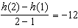, at , using a graphing calculator to find where .
REF: 061836aii

