1 An arch is built so that it is 6 feet wide at the base. Its shape can be represented by a parabola with the equation , where y is the height of the arch. Graph the parabola from to on the grid below. Determine the maximum height, y, of the arch.

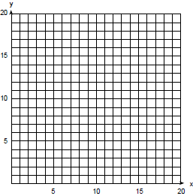

2 Greg is in a car at the top of a roller-coaster ride. The distance, d, of the car from the ground as the car descends is determined by the equation , where t is the number of seconds it takes the car to travel down to each point on the ride. How many seconds will it take Greg to reach the ground? Solve algebraically or graphically.

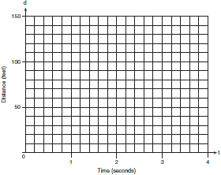

3 Amy tossed a ball in the air in such a way that the path of the ball was modeled by the equation . In the equation, y represents the height of the ball in feet and x is the time in seconds.
a Graph for on the grid provided below.

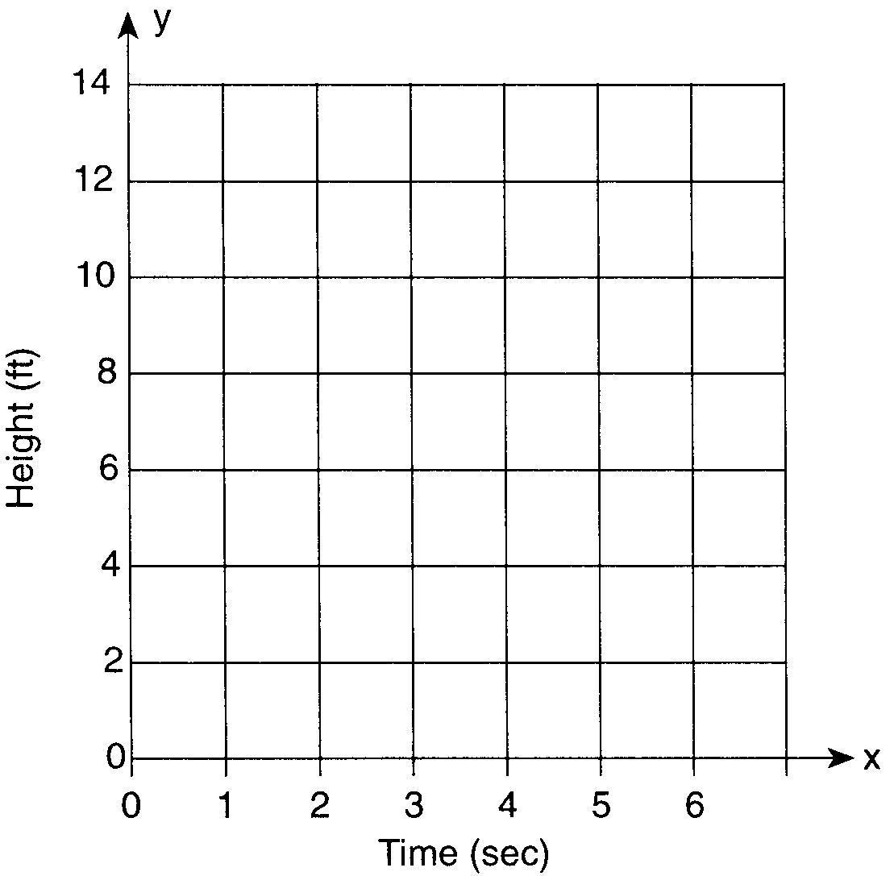

b At what time, x, is the ball at its highest point?

4 Tom throws a ball into the air. The ball travels on a parabolic path represented by the equation , where h is the height, in feet, and t is the time, in seconds.
a On the accompanying set of axes, graph the equation from to seconds, including all integral values of t from 0 to 5.
b What is the value of t at which h has its greatest value?
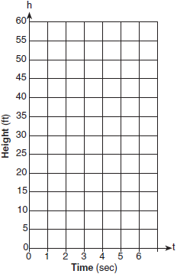

5 An architect is designing a museum entranceway in the shape of a parabolic arch represented by the equation , where and all dimensions are expressed in feet. On the accompanying set of axes, sketch a graph of the arch and determine its maximum height, in feet.
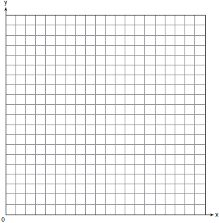

6 An acorn falls from the branch of a tree to the ground 25 feet below. The distance, S, the acorn is from the ground as it falls is represented by the equation , where t represents time, in seconds. Sketch a graph of this situation on the accompanying grid. Calculate, to the nearest hundredth of a second, the time the acorn will take to reach the ground.



7 The path of a rocket fired during a fireworks display is given by the equation , where t is the time, in seconds, and s is the height, in feet. What is the maximum height, in feet, the rocket will reach? In how many seconds will the rocket hit the ground? [The use of the grid is optional.].

8 A laundry owner's estimate of her weekly profits, p, in dollars, is given by the equation , where w represents the number of workers she hires. What is the number of workers she should hire in order to earn the greatest profit? [The use of the accompanying grid is optional.]

9 Each year, the student council at Briarwood High School sponsors a community talent show to raise money. In previous years, the council has discovered that profit from ticket sales, , is a function of the amount charged per ticket, x, in dollars, as modeled by the equation . What amount should the council charge for a ticket to make the greatest profit? [The use of the grid is optional.]

10 A baseball player throws a ball from the outfield toward home plate. The ball’s height above the ground is modeled by the equation , where y represents height, in feet, and x represents time, in seconds. The ball is initially thrown from a height of 6 feet. How many seconds after the ball is thrown will it again be 6 feet above the ground? What is the maximum height, in feet, that the ball reaches? [The use of the accompanying grid is optional.]

11 A rock is thrown vertically from the ground with a velocity of 24 meters per second, and it reaches a height of after t seconds. How many seconds after the rock is thrown will it reach maximum height, and what is the maximum height the rock will reach, in meters? How many seconds after the rock is thrown will it hit the ground? Round your answers to the nearest hundredth. [Only an algebraic or graphic solution will be accepted.]

12 The members of the Lincoln High School Prom Committee are trying to raise money for their senior prom. They plan to sell teddy bears. The senior advisor told them that the profit equation for their project is , where x is the price at which the teddy bears will be sold and y is the profit, in dollars. On the grid below, graph this relationship so that and . How much profit can the committee expect to make if they sell the teddy bears for $20 each? What price should they charge for the teddy bears to make the maximum profit possible?


1 ANS:
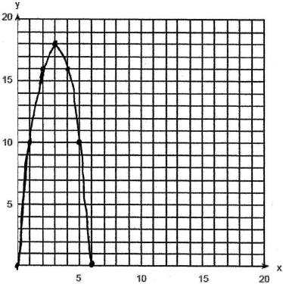. 18. 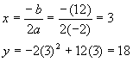. 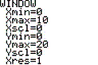. 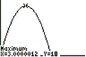

REF: 089933a

2 ANS:
3. 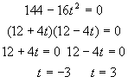. 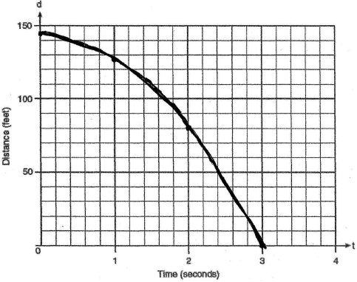. 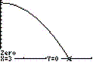

REF: 080234a

3 ANS:
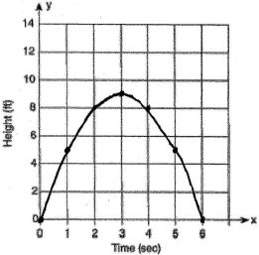. 3. 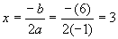. 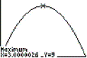.

REF: 010031a

4 ANS:
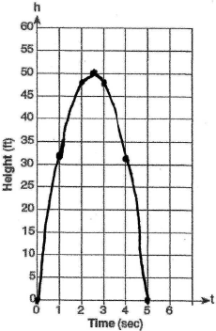 2.5. 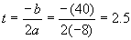. 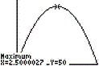

REF: 010439a

5 ANS:
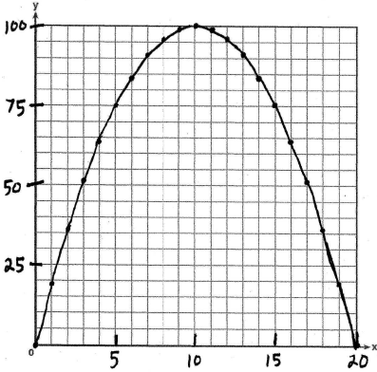. 100. 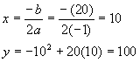. 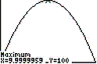

REF: 060333a

6 ANS:
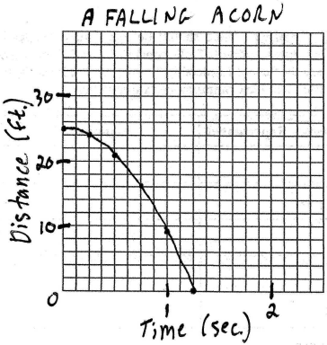 1.25. 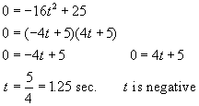

REF: 010431b

7 ANS:
64, 4. 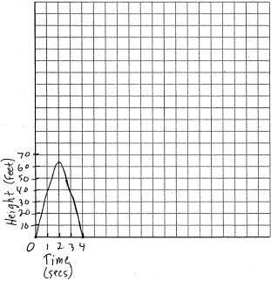. 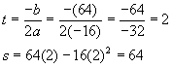. 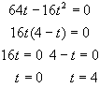.

REF: 060732b

8 ANS:
20. 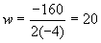. 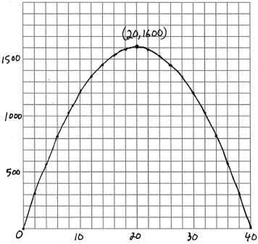

REF: 060822b

9 ANS:
5. 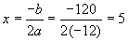. 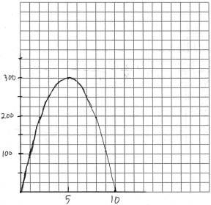

REF: 080825b

10 ANS:
3, 42. 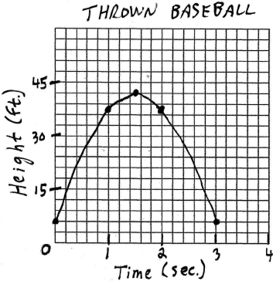. 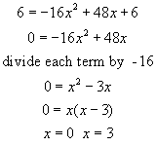. The ball will again be 6 feet above the ground 3 seconds after the ball is thrown. 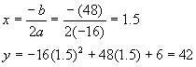. The maximum height the ball reaches is 42 feet. 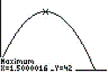.

REF: 060430b

11 ANS:
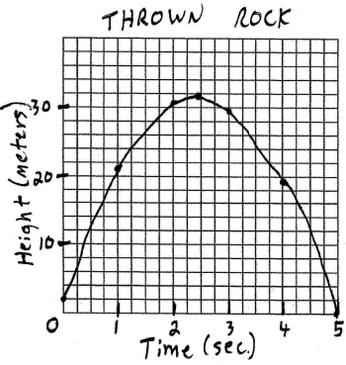. t=2.45, h=31.39. 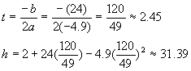. 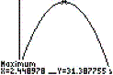. When the rock hits the ground, the height is zero. 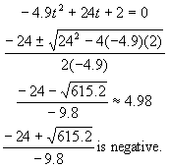. 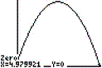

REF: 080229b

12 ANS:
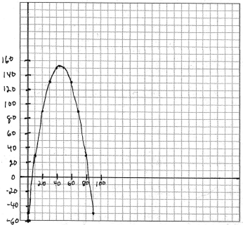 90, 45. . 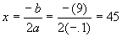

REF: 010834b

