1 A swim team member performs a dive from a 14-foot-high springboard. The parabola below shows the path of her dive.

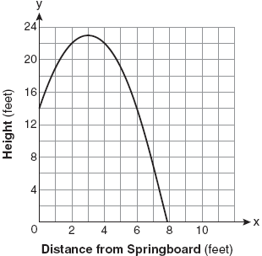

Which equation represents the axis of symmetry?
1)
2)
3)
4)

2 The graph below represents the parabolic path of a ball kicked by a young child. What are the vertex and the axis of symmetry for the parabola?

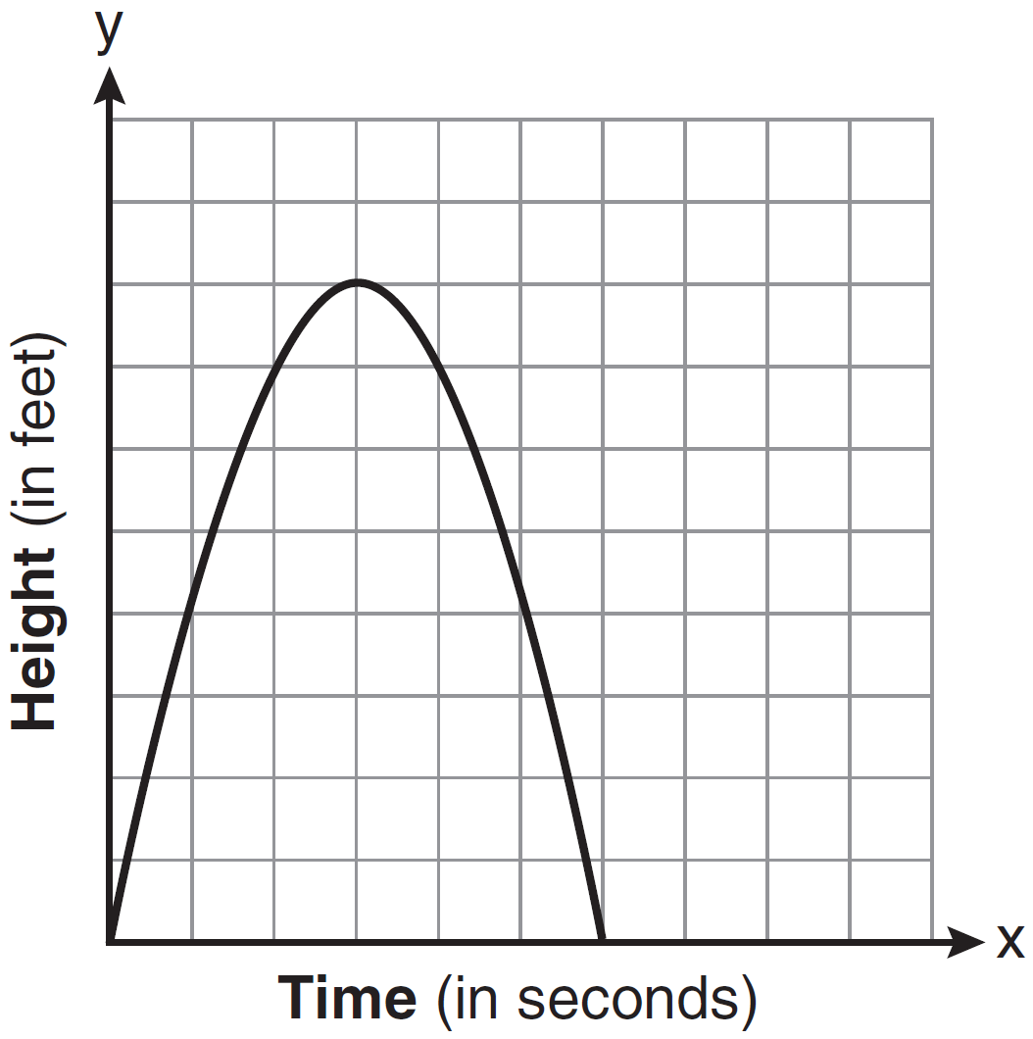
1) | vertex: ; axis of symmetry:
2) | vertex: ; axis of symmetry:
3) | vertex: ; axis of symmetry:
4) | vertex: ; axis of symmetry:

3 The height, y, of a ball tossed into the air can be represented by the equation , where x is the elapsed time. What is the equation of the axis of symmetry of this parabola?
1)
2)
3)
4)

4 A ball is thrown straight up at an initial velocity of 54 feet per second. The height of the ball t seconds after it is thrown is given by the formula . How many seconds after the ball is thrown will it return to the ground?
1) | 9.2
2) | 6
3) | 4.5
4) | 4

5 A model rocket is launched from ground level. Its height, h meters above the ground, is a function of time t seconds after launch and is given by the equation . What would be the maximum height, to the nearest meter, attained by the model?
1) | 243
2) | 242
3) | 241
4) | 240

6 An archer shoots an arrow into the air such that its height at any time, t, is given by the function . If the maximum height of the arrow occurs at time , what is the value of k?
1) | 128
2) | 64
3) | 8
4) | 4

7 The height of a swimmer’s dive off a 10-foot platform into a diving pool is modeled by the equation , where x represents the number of seconds since the swimmer left the diving board and y represents the number of feet above or below the water’s surface. What is the farthest depth below the water’s surface that the swimmer will reach?
1) | 6 feet
2) | 8 feet
3) | 10 feet
4) | 12 feet

8 The height of an object, , is determined by the formula , where t is time, in seconds. Will the object reach a maximum or a minimum? Explain or show your reasoning.

9 Vanessa throws a tennis ball in the air. The function represents the distance, in feet, that the ball is from the ground at any time t. At what time, to the nearest tenth of a second, is the ball at its maximum height?

10 The height, h, in feet, a ball will reach when thrown in the air is a function of time, t, in seconds, given by the equation . Find, to the nearest tenth, the maximum height, in feet, the ball will reach.

11 When a current, I, flows through a given electrical circuit, the power, W, of the circuit can be determined by the formula . What amount of current, I, supplies the maximum power, W?

12 The equation represents the power (W), in watts, of a 120-volt circuit having a resistance of 12 ohms when a current (I) is flowing through the circuit. What is the maximum power, in watts, that can be delivered in this circuit?
1 ANS: 1 REF: 080813ia

2 ANS: 1 REF: 081405ia

3 ANS: 3
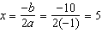.

REF: 081018ia

4 ANS: 3
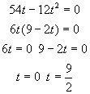

REF: 080112b

5 ANS: 4
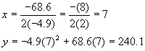

REF: fall9915b

6 ANS: 1
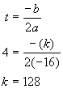

REF: 060101b

7 ANS: 2
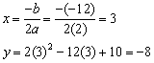

REF: 010907b

8 ANS:
Maximum, because the parabola representing the relationship between the object’s height and time is cupped downward and therefore has a maximum.

REF: 010322b

9 ANS:
1.4. 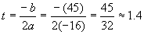

REF: 060321b

10 ANS:
20.1. 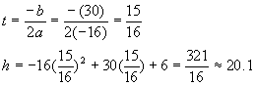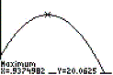

REF: 080321b

11 ANS:
5. 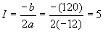

REF: 010424b

12 ANS:
300. 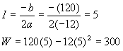

REF: 060225b

