1 A ball is thrown into the air from the edge of a 48-foot-high cliff so that it eventually lands on the ground. The graph below shows the height, y, of the ball from the ground after x seconds.

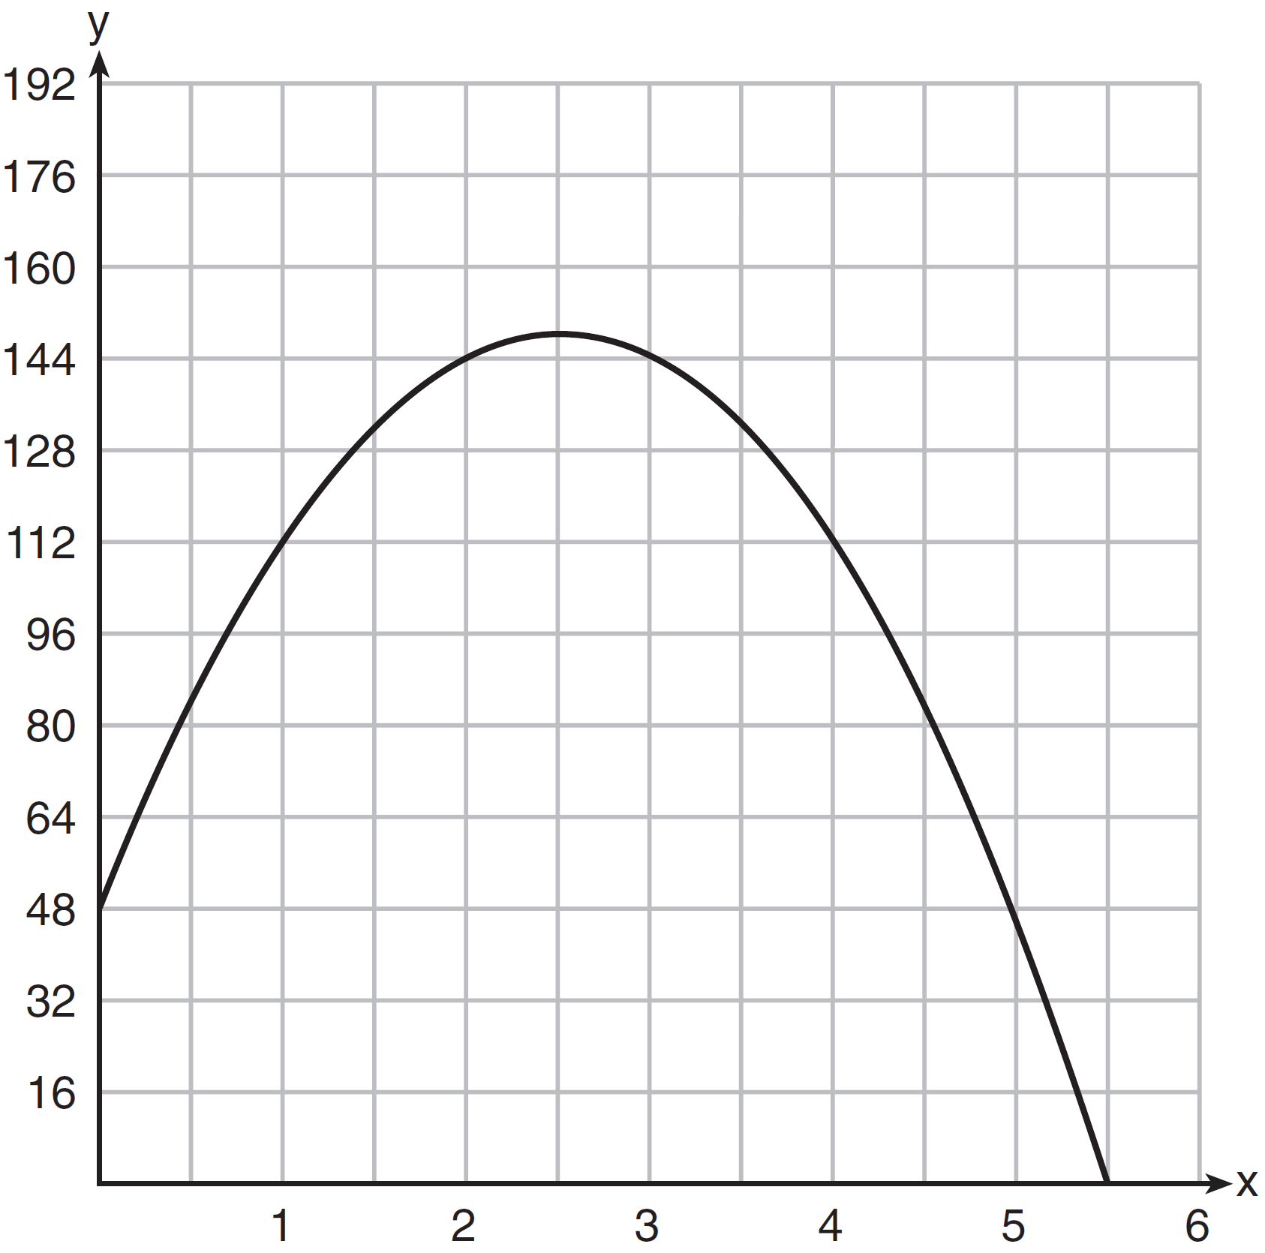

For which interval is the ball's height always decreasing?
1) |  | 3)
2) |  | 4)

2 The expression represents the height, in meters, of a toy rocket t seconds after launch. The initial height of the rocket, in meters, is
1) | 0 | 3) | 4.9
2) | 2 | 4) | 50

3 The height of a ball Doreen tossed into the air can be modeled by the function , where x is the time elapsed in seconds, and is the height in meters. The number 5 in the function represents
1) | the initial height of the ball | 3) | the time at which the ball was at its highest point
2) | the time at which the ball reaches the ground | 4) | the maximum height the ball attained when thrown in the air

4 A ball is thrown into the air from the top of a building. The height, , of the ball above the ground t seconds after it is thrown can be modeled by . How many seconds after being thrown will the ball hit the ground?
1) | 5 | 3) | 80
2) | 2 | 4) | 144

5 Morgan throws a ball up into the air. The height of the ball above the ground, in feet, is modeled by the function , where t represents the time, in seconds, since the ball was thrown. What is the appropriate domain for this situation?
1) |  | 3)
2) |  | 4)

6 A ball was launched into the air, and its height above the ground was recorded each second, as shown in the table below.

Time (sec) | 0 | 1 | 2 | 3 | 4
Height (ft) | 11 | 59 | 75 | 59 | 11

Based on these data, which statement is a valid conclusion?
1) | The ball lands on the ground at 4 seconds. | 3) | The ball was launched from a height of 0 feet.
2) | The ball reaches a maximum height of 11 feet. | 4) | The ball reaches its maximum height at 2 seconds.

7 The height of a rocket, at selected times, is shown in the table below.

Time (sec) | 0 | 1 | 2 | 3 | 4 | 5 | 6 | 7
Height (ft) | 180 | 260 | 308 | 324 | 308 | 260 | 180 | 68

Based on these data, which statement is not a valid conclusion?
1) | The rocket was launched from a height of 180 feet. | 3) | The rocket was in the air approximately 6 seconds before hitting the ground.
2) | The maximum height of the rocket occurred 3 seconds after launch. | 4) | The rocket was above 300 feet for approximately 2 seconds.

8 Ian throws a ball up in the air and lets it fall to the ground. The height of the ball, , is modeled by the equation , with measured in feet, and time, t, measured in seconds. The number 3 in represents
1) | the maximum height of the ball | 3) | the number of seconds it takes for the ball to reach the ground
2) | the height from which the ball is thrown | 4) | the number of seconds it takes for the ball to reach its maximum height

9 When an apple is dropped from a tower 256 feet high, the function models the height of the apple, in feet, after t seconds. Determine, algebraically, the number of seconds it takes the apple to hit the ground.

10 The height, H, in feet, of an object dropped from the top of a building after t seconds is given by . How many feet did the object fall between one and two seconds after it was dropped? Determine, algebraically, how many seconds it will take for the object to reach the ground.

11 An object is launched upward at 64 feet per second from a platform 80 feet above the ground. The function models the height of the object t seconds after launch. If , state the vertex of , and explain in detail what each coordinate means in the context of the problem. After the object is launched, how many seconds does it take for the object to hit the ground? Justify your answer.

12 A toy rocket is launched from the ground straight upward. The height of the rocket above the ground, in feet, is given by the equation , where t is the time in seconds. Determine the domain for this function in the given context. Explain your reasoning.

13 Let represent the height of an object above the ground after t seconds. Determine the number of seconds it takes to achieve its maximum height. Justify your answer. State the time interval, in seconds, during which the height of the object decreases. Explain your reasoning.

14 A ball is projected up into the air from the surface of a platform to the ground below. The height of the ball above the ground, in feet, is modeled by the function , where t is the time, in seconds, after the ball is projected. State the height of the platform, in feet. State the coordinates of the vertex. Explain what it means in the context of the problem. State the entire interval over which the ball's height is decreasing.

15 An Air Force pilot is flying at a cruising altitude of 9000 feet and is forced to eject from her aircraft. The function models the height, in feet, of the pilot above the ground, where t is the time, in seconds, after she is ejected from the aircraft. Determine and state the vertex of . Explain what the second coordinate of the vertex represents in the context of the problem. After the pilot was ejected, what is the maximum number of feet she was above the aircraft's cruising altitude? Justify your answer.

16 Paul plans to have a rectangular garden adjacent to his garage. He will use 36 feet of fence to enclose three sides of the garden. The area of the garden, in square feet, can be modeled by , where w is the width in feet. On the set of axes below, sketch the graph of .

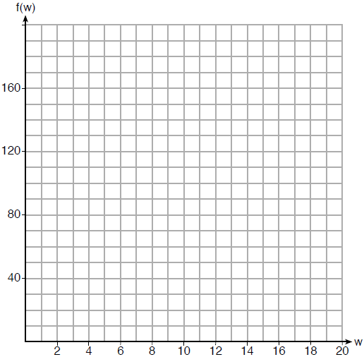

Explain the meaning of the vertex in the context of the problem.

17 While playing golf, Laura hit her ball from the ground. The height, in feet, of her golf ball can be modeled by , where t is the time in seconds. Graph on the set of axes below.

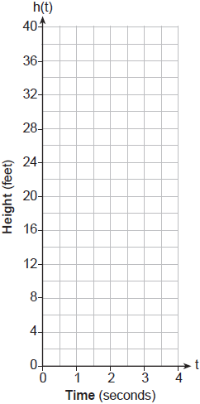

What is the maximum height, in feet, that the golf ball reaches on this hit? How many seconds does it take the golf ball to hit the ground?

18 The path of a rocket is modeled by the function , where h is the height, in meters, above the ground and t is the time, in seconds, after the rocket is launched. Sketch the graph on the set of axes below.

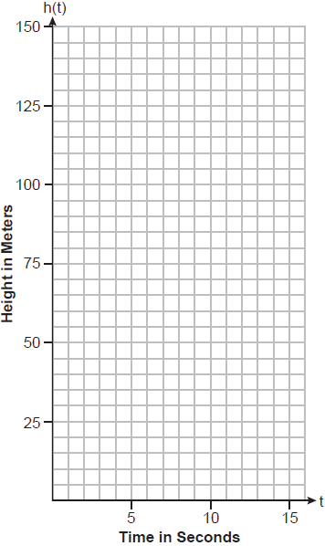

State the vertex of this function. Explain what the vertex means in the context of this situation.

19 Alex launched a ball into the air. The height of the ball can be represented by the equation , where h is the height, in units, and t is the time, in seconds, after the ball was launched. Graph the equation from to seconds.

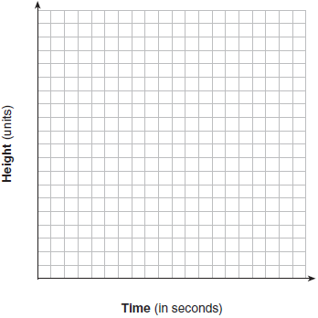

State the coordinates of the vertex and explain its meaning in the context of the problem.

20 Michael threw a ball into the air from the top of a building. The height of the ball, in feet, is modeled by the equation , where t is the elapsed time, in seconds. Graph this equation on the set of axes below.

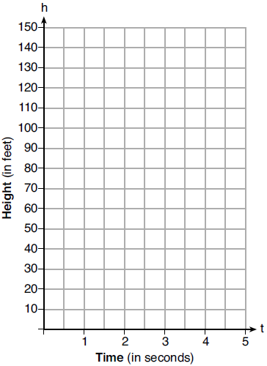

Determine the average rate of change, in feet per second, from when Michael released the ball to when the ball reached its maximum height.

21 A football player attempts to kick a football over a goal post. The path of the football can be modeled by the function 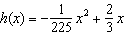, where x is the horizontal distance from the kick, and is the height of the football above the ground, when both are measured in feet. On the set of axes below, graph the function over the interval .

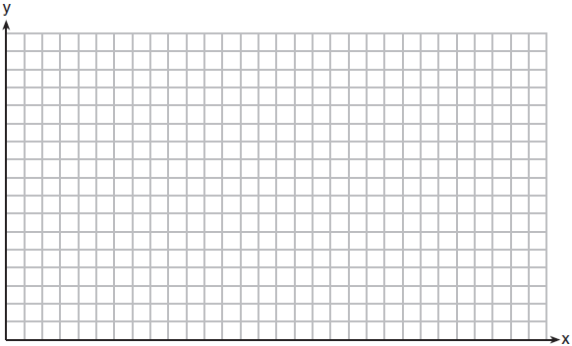

Determine the vertex of . Interpret the meaning of this vertex in the context of the problem. The goal post is 10 feet high and 45 yards away from the kick. Will the ball be high enough to pass over the goal post? Justify your answer.
1 ANS: 3 REF: 061409ai

2 ANS: 2

REF: 011811ai

3 ANS: 1

REF: 011913ai

4 ANS: 1
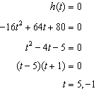

REF: 081910ai

5 ANS: 1
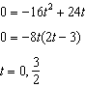

REF: 061724ai

6 ANS: 4 REF: 062401ai

7 ANS: 3
The rocket was in the air more than 7 seconds before hitting the ground.

REF: 081613ai

8 ANS: 2 REF: 012315ai

9 ANS:
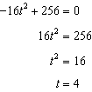

REF: 061829ai

10 ANS:
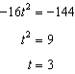

REF: 061633ai

11 ANS:
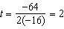 . At 2 seconds, the object is 144 feet above the ground. 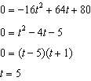

REF: 082433ai

12 ANS:
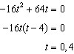 The rocket launches at and lands at .

REF: 081531ai

13 ANS:
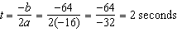. The height decreases after reaching its maximum at until it lands at 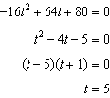

REF: 011633ai

14 ANS:
112; (3,256); At , the ball is 256 ft high; 3-7 seconds

REF: 062136ai

15 ANS:
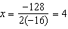 . The y coordinate represents the pilot’s height above the ground after ejection.

REF: 081736ai

16 ANS:
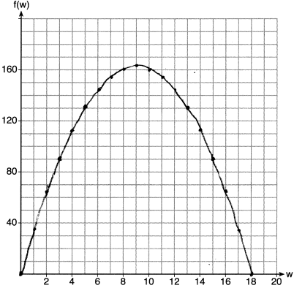 If the garden’s width is 9 ft, its area is 162 ft².

REF: 081836ai

17 ANS:
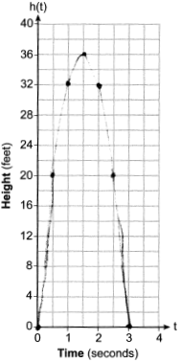 36, 3

REF: 012433ai

18 ANS:
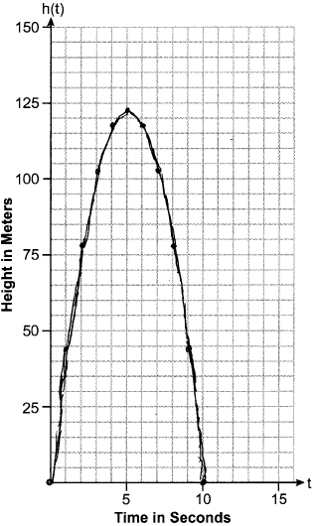 The rocket is at 122.5m at 5 sec.

REF: 082334ai

19 ANS:
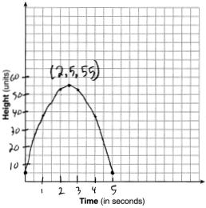 The ball reaches a maximum height of 55 units at 2.5 seconds.

REF: 011736ai

20 ANS:
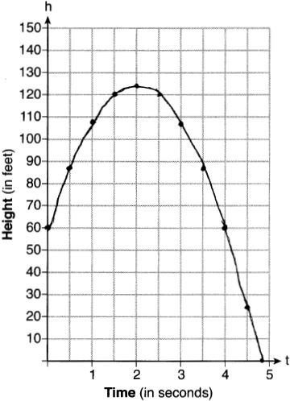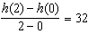

REF: 012033ai

21 ANS:
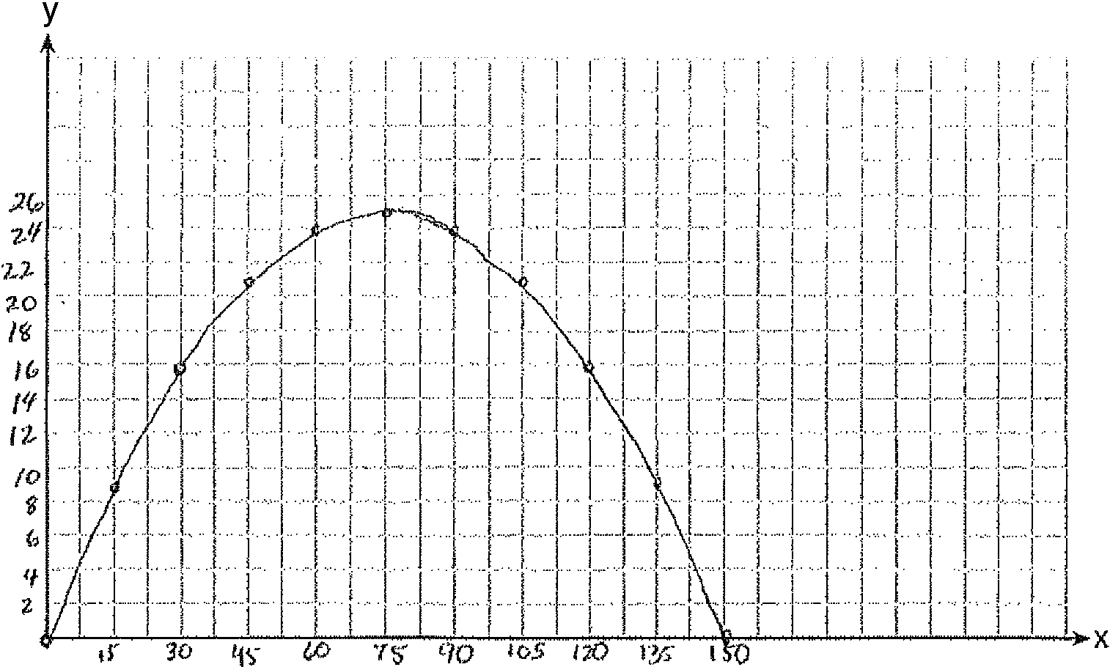 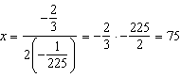 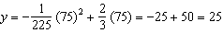 (75,25) represents the horizontal distance (75) where the football is at its greatest height (25). No, because the ball is less than 10 feet high 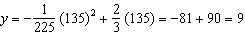

REF: 061537ai

