1 What is the y-intercept of the graph of the line whose equation is 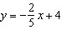?
1)
2)
3) | 0
4) | 4

2 The graph of the equation intersects the y-axis at the point whose coordinates are
1)
2)
3)
4)

3 The value of the x-intercept for the graph of is
1) | 10
2)
3)
4)

4 What is the y-intercept of the line that passes through the points and ?
1)
2)
3) | 3
4) | 5

5 Which function has the same y-intercept as the graph below?
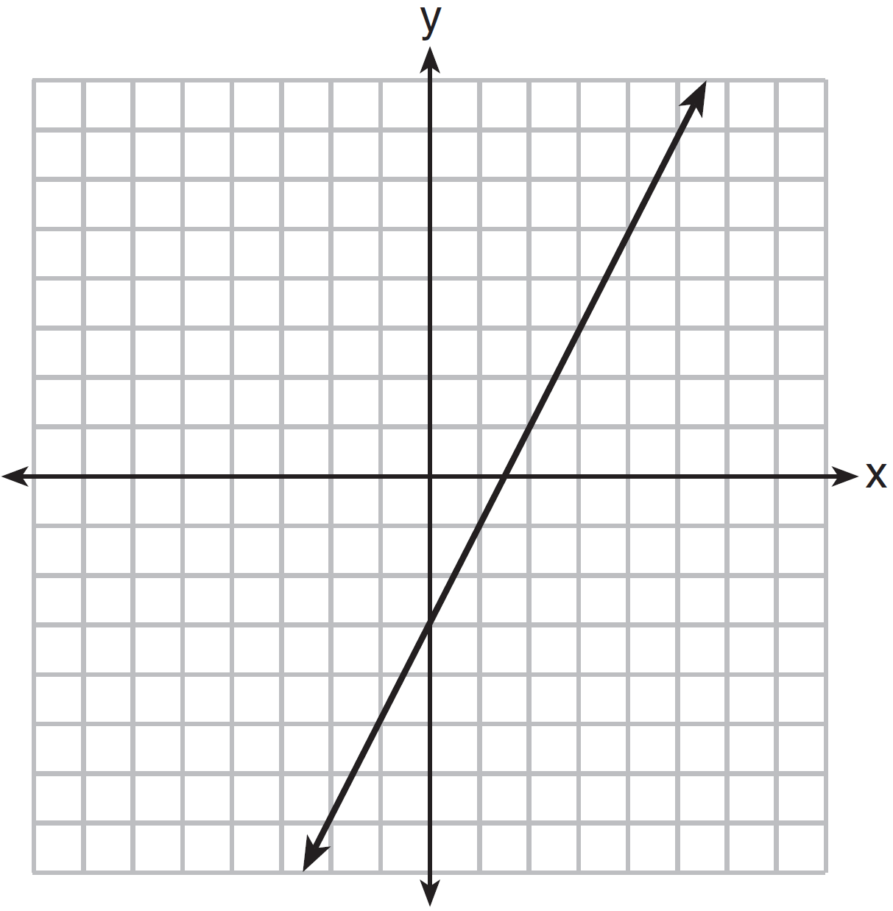
1) | 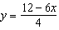
2)
3)
4)

6 Samantha purchases a package of sugar cookies. The nutrition label states that each serving size of 3 cookies contains 160 Calories. Samantha creates the graph below showing the number of cookies eaten and the number of Calories consumed.

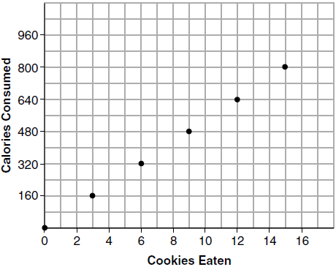

Explain why it is appropriate for Samantha to draw a line through the points on the graph.

7 On the set of axes below, draw the graph of the equation 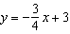.

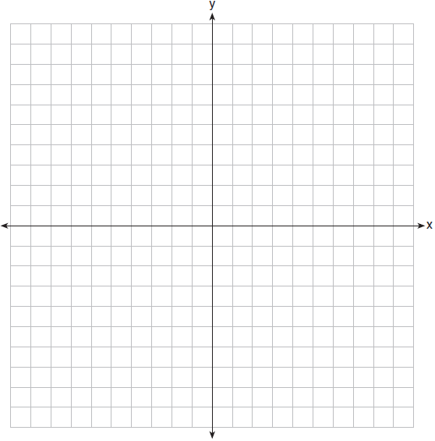

Is the point a solution to the equation? Explain your answer based on the graph drawn.

8 On the set of axes below, graph the line whose equation is .

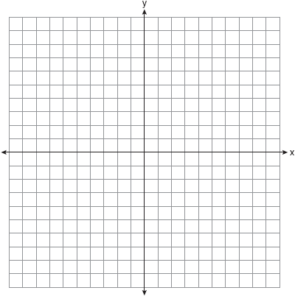

This linear equation contains the point . State the value of k.

9 On the set of axes below, graph the equation .

Explain why is a solution to the equation.
1 ANS: 4 REF: 010605a

2 ANS: 1
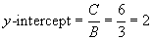

REF: 080619a

3 ANS: 1
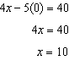

REF: 081408ai

4 ANS: 3
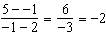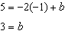

REF: 062410ai

5 ANS: 4
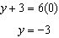

REF: 011509ai

6 ANS:
The data is continuous, i.e. a fraction of a cookie may be eaten.

REF: 081729ai

7 ANS:
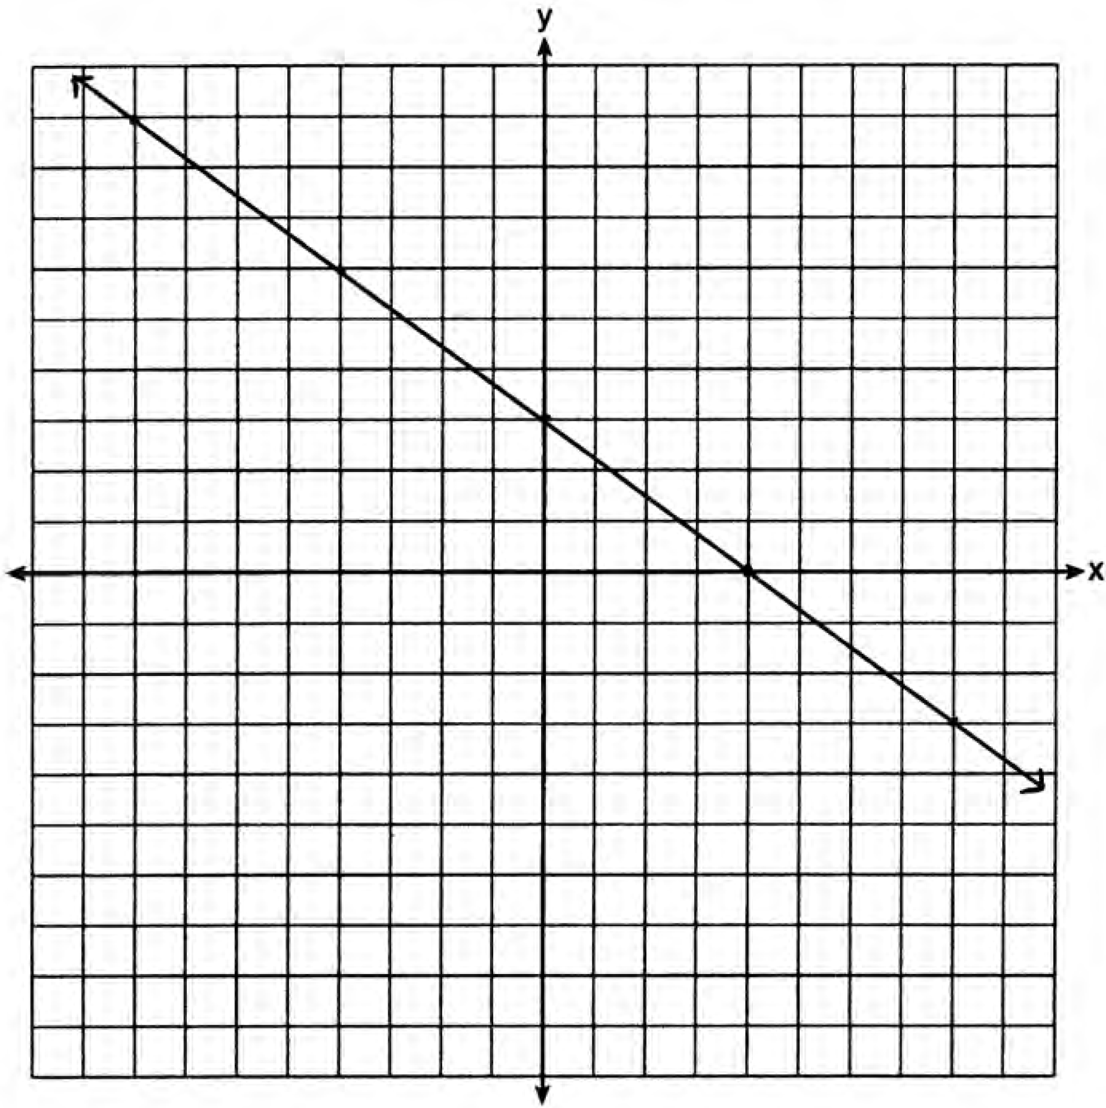No, because is not on the graph.

REF: 061429ai

8 ANS:
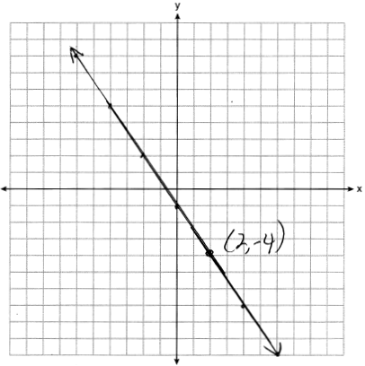

REF: 081927ai

9 ANS:
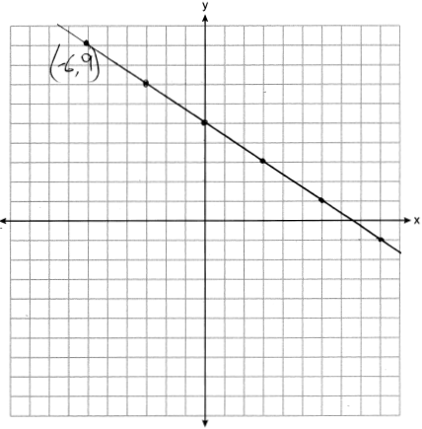 is a solution to the equation because it falls on the line.

REF: 012428ai

