1 Five thousand dollars is invested at an interest rate of 3.5% compounded quarterly. No money is deposited or withdrawn from the account. Using the formula below, determine, to the nearest cent, how much this investment will be worth in 18 years.
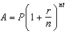
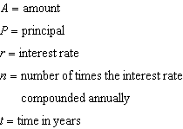

2 Robert is buying a car that costs $22,000. After a down payment of $4000, he borrows the remainder from a bank, a six year loan at 6.24% annual interest rate. The following formula can be used to calculate his monthly loan payment.
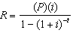
R = monthly payment
P = loan amount
i = monthly interest rate
t = time, in months
Robert's monthly payment will be
1) | $298.31
2) | $300.36
3) | $307.35
4) | $367.10

3 The George family would like to borrow $45,000 to purchase a new boat. They qualified for a loan with an annual interest rate of 6.75%. The monthly loan payment can be found using the formula below.
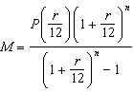
monthly payment
amount borrowed
annual interest rate
number of monthly payments
What is the monthly payment if they would like to pay off the loan in five years?
1) | $262.99
2) | $252.13
3) | $915.24
4) | $885.76

4 Monthly mortgage payments can be found using the formula below, where M is the monthly payment, P is the amount borrowed, r is the annual interest rate, and n is the total number of monthly payments.
If Adam takes out a 15-year mortgage, borrowing $240,000 at an annual interest rate of 4.5%, his monthly payment will be
1) | $1379.09
2) | $1604.80
3) | $1835.98
4) | $9011.94

5 The Wells family is looking to purchase a home in a suburb of Rochester with a 30-year mortgage that has an annual interest rate of 3.6%. The house the family wants to purchase is $152,500 and they will make a $15,250 down payment and borrow the remainder. Use the formula below to determine their monthly payment, to the nearest dollar.
monthly payment
amount borrowed
annual interest rate
total number of monthly payments

6 Using the formula below, determine the monthly payment on a 5-year car loan with a monthly percentage rate of 0.625% for a car with an original cost of $21,000 and a $1000 down payment, to the nearest cent.
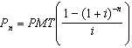
present amount borrowed
number of monthly pay periods
monthly payment
interest rate per month
The affordable monthly payment is $300 for the same time period. Determine an appropriate down payment, to the nearest dollar.

7 Jim is looking to buy a vacation home for $172,600 near his favorite southern beach. The formula to compute a mortgage payment, M, is 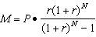 where P is the principal amount of the loan, r is the monthly interest rate, and N is the number of monthly payments. Jim's bank offers a monthly interest rate of 0.305% for a 15-year mortgage. With no down payment, determine Jim's mortgage payment, rounded to the nearest dollar. Algebraically determine and state the down payment, rounded to the nearest dollar, that Jim needs to make in order for his mortgage payment to be $1100.

8 The temperature, F, in degrees Fahrenheit, after t hours of a roast put into an oven is given by the equation . What was the temperature of the roast when it was put into the oven?
1) | 325
2) | 200
3) | 185
4) | 140

9 The formula to determine continuously compounded interest is , where A is the amount of money in the account, P is the initial investment, r is the interest rate, and t is the time, in years. Which equation could be used to determine the value of an account with an $18,000 initial investment, at an interest rate of 1.25% for 24 months?
1)
2)
3)
4)

10 The amount of money in an account can be determined by the formula , where P is the initial investment, r is the annual interest rate, and t is the number of years the money was invested. What is the value of a $5000 investment after 18 years, if it was invested at 4% interest compounded continuously?
1) | $9367.30
2) | $9869.39
3) | $10,129.08
4) | $10,272.17

11 The formula for continuously compounded interest is , where A is the amount of money in the account, P is the initial investment, r is the interest rate, and t is the time in years. Using the formula, determine, to the nearest dollar, the amount in the account after 8 years if $750 is invested at an annual rate of 3%.

12 Matt places $1,200 in an investment account earning an annual rate of 6.5%, compounded continuously. Using the formula , where V is the value of the account in t years, P is the principal initially invested, e is the base of a natural logarithm, and r is the rate of interest, determine the amount of money, to the nearest cent, that Matt will have in the account after 10 years.

13 Emma’s parents deposited $5000 into a bank account during her freshman year. The account pays 5% interest compounded continuously using the formula , where A is the total amount accrued, P is the principal, r is the annual interest rate, and t is time, in years. Determine, to the nearest dollar, the amount in the account 4 years later.

14 The number of bacteria that grow in a petri dish is approximated by the function , where t is time, in minutes. Use this model to approximate, to the nearest integer, the number of bacteria present after one half-hour.
1 ANS:
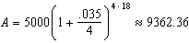

REF: 061629a2

2 ANS: 2
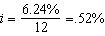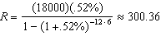

REF: 012420aii

3 ANS: 4
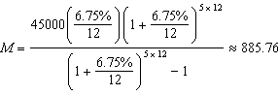

REF: 082316aii

4 ANS: 3
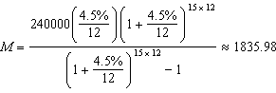

REF: 062209aii

5 ANS:
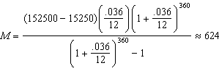

REF: 061831aii

6 ANS:
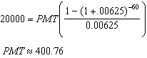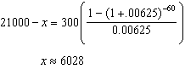

REF: 011736aii

7 ANS:
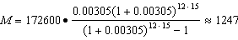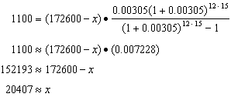

REF: 061734aii

8 ANS: 4

REF: 012415aii

9 ANS: 3 REF: 061416a2

10 ANS: 4

REF: 011607a2

11 ANS:

REF: 061229a2

12 ANS:
2,298.65

REF: fall0932a2

13 ANS:

REF: 081629a2

14 ANS:

REF: 011728a2

