1 If a sequence is defined recursively by and for , then is equal to
1) | 1
2)
3) | 5
4) | 17

2 If and , then
1)
2) | 11
3) | 21
4) | 43

3 Given the function defined by the following:
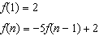
Which set could represent the range of the function?
1)
2)
3)
4)

4 Which recursively defined function represents the sequence ?
1)
2)
3)
4)

1 ANS: 3
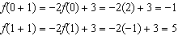

REF: 011520ai

2 ANS: 4

REF: 081424ai

3 ANS: 2
; ; ;

REF: 061718ai

4 ANS: 3 REF: 011618ai

