1 The first four terms of the sequence defined by 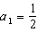 and are
1) | 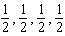 | 3) | 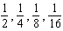
2) | 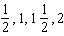 | 4) | 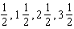

2 A recursively defined sequence is shown below.
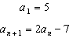
The value of is
1) |  | 3) | 8
2) |  | 4) | 15

3 A sequence is defined recursively by
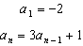
What is the value of ?
1) |  | 3) | 22
2) |  | 4) | 67

4 If a sequence is defined recursively as and , then is
1) |  | 3) | 55
2) |  | 4) | 67

5 If and , then equals
1) | 75 | 3) | 180
2) | 147 | 4) | 900

6 A sequence of blocks is shown in the diagram below.

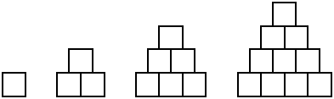

This sequence can be defined by the recursive function and . Assuming the pattern continues, how many blocks will there be when ?
1) | 13 | 3) | 28
2) | 21 | 4) | 36

7 If and , what is the value of ?
1) | 5 | 3) | 120
2) | 20 | 4) | 720

8 What is the third term of the recursive sequence below?
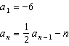
1) |  | 3)
2) |  | 4)

9 A function is defined as , where . What is the value of ?
1) | 8 | 3) | 9.2
2) | 8.5 | 4) | 10

10 A father makes a deal with his son regarding his weekly allowance. The first year, he agrees to pay his son a weekly allowance of $10. Every subsequent year, the allowance is recalculated by doubling the previous year's weekly allowance and then subtracting 8. Which recursive formula could be used to calculate the son's weekly allowance in future years?
1) |  | 3) | 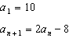
2) |  | 4) | 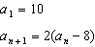

11 Jack started a new fitness program. The first day he did 10 push-ups. The program required him to increase the number of push-ups each day by doing 9 less than twice the number from the previous day. Which recursive formula correctly models Jack’s new program, where n is the number of days and is the number of push-ups on the nth day?
1) | 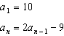 | 3) | 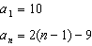
2) | 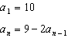 | 4) | 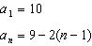

12 The Rickerts decided to set up an account for their daughter to pay for her college education. The day their daughter was born, they deposited $1000 in an account that pays 1.8% compounded annually. Beginning with her first birthday, they deposit an additional $750 into the account on each of her birthdays. Which expression correctly represents the amount of money in the account n years after their daughter was born?
1) |  | 3) | 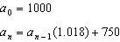
2) |  | 4) | 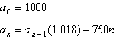

13 Find the third term in the recursive sequence , where .

14 Given the recursive formula:

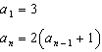

State the values of , , and for the given recursive formula.

15 The recursive formula to describe a sequence is shown below.
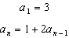
State the first four terms of this sequence. Can this sequence be represented using an explicit geometric formula? Justify your answer.

16 Write the first five terms of the recursive sequence defined below.
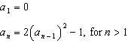

17 Use the recursive sequence defined below to express the next three terms as fractions reduced to lowest terms.
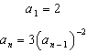

18 Find the first four terms of the recursive sequence defined below.
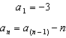

19 Write an explicit formula for , the nth term of the recursively defined sequence below.
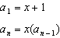
For what values of x would when ?

20 While experimenting with her calculator, Candy creates the sequence 4, 9, 19, 39, 79, .... Write a recursive formula for Candy's sequence. Determine the eighth term in Candy's sequence.

21 Elaina has decided to run the Buffalo half-marathon in May. She researched training plans on the Internet and is looking at two possible plans: Jillian’s 12-week plan and Josh’s 14-week plan. The number of miles run per week for each plan is plotted below.

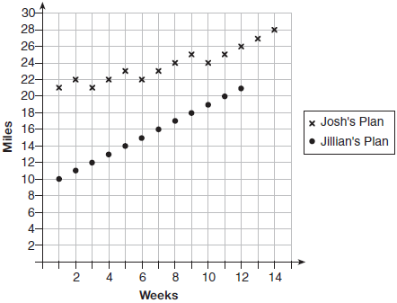

Which one of the plans follows an arithmetic pattern? Explain how you arrived at your answer. Write a recursive definition to represent the number of miles run each week for the duration of the plan you chose. Jillian’s plan has an alternative if Elaina wanted to train instead for a full 26-mile marathon. Week one would start at 13 miles and follow the same pattern for the half-marathon, but it would continue for 14 weeks. Write an explicit formula, in simplest form, to represent the number of miles run each week for the full-marathon training plan.
1 ANS: 1 REF: 081520a2

2 ANS: 1

REF: 012023ai

3 ANS: 1

REF: 082220ai

4 ANS: 4

REF: 062224ai

5 ANS: 1

REF: 081919ai

6 ANS: 3
1, 3, 6, 10, 15, 21, 28, ...

REF: 081715ai

7 ANS: 3
, , ,

REF: 061824ai

8 ANS: 1
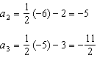

REF: 011623a2

9 ANS: 2
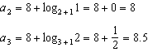

REF: 062221aii

10 ANS: 3 REF: 062321ai

11 ANS: 1 REF: 082319ai

12 ANS: 3 REF: 081724aii

13 ANS:
. . .

REF: 061233a2

14 ANS:

REF: 061931ai

15 ANS:
; No, because there is no common ratio: 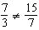

REF: 061830aii

16 ANS:

REF: 081832ai

17 ANS:
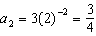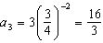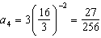

REF: 011537a2

18 ANS:

REF: fall0934a2

19 ANS:
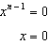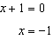

REF: spr1511aii

20 ANS:
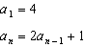

REF: 081729aii

21 ANS:
Jillian’s plan, because distance increases by one mile each week. 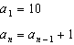

REF: 011734aii

