1 What is the common difference of the arithmetic sequence ?
1)
2)
3) | 3
4) | 9

2 In an arithmetic sequence, the first term is 4 and the third term is . What is the common difference?
1)
2)
3)
4)

3 The first term in a sequence is 5 and the fifth term is 17. What is the common difference?
1) | 2.4
2) | 12
3) | 3
4) | 4

4 Determine the common difference of the arithmetic sequence in which and .

5 Find the common difference in the arithmetic sequence, , in which and .

6 What is the common difference of the arithmetic sequence below?
1)
2)
3) | 3
4)

7 What is the common difference in the sequence , , , ?
1)
2)
3)
4)

8 Given the sequence:
Which expression can be used to determine the common difference of this sequence?
1)
2)
3) | 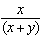
4) | 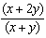

9 Given the following three sequences:
I.
II.
III.
Which ones are arithmetic sequences?
1) | I and II, only
2) | I and III, only
3) | II and III, only
4) | I, II, and III

10 Which arithmetic sequence has a common difference of 4?
1)
2)
3)
4)

11 A geometric sequence with a common ratio of is
1)
2)
3)
4)

12 Consider the following patterns:
I.
II.
III.
IV. 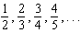
Which pattern is geometric?
1) | I
2) | II
3) | III
4) | IV

13 Which situation could be modeled using a geometric sequence?
1) | A cell phone company charges $30.00 per month for 2 gigabytes of data and $12.50 for each additional gigabyte of data.
2) | The temperature in your car is 79°. You lower the temperature of your air conditioning by 2° every 3 minutes in order to find a comfortable temperature.
3) | David’s parents have set a limit of 50 minutes per week that he may play online games during the school year. However, they will increase his time by 5% per week for the next ten weeks.
4) | Sarah has $100.00 in her piggy bank and saves an additional $15.00 each week.

14 Determine and state whether the sequence displays exponential behavior. Explain how you arrived at your decision.

15 What is the common ratio of the geometric sequence shown below?
1)
2) | 2
3)
4)

16 The common ratio of the sequence 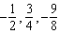 is
1)
2)
3)
4)

17 If then the common ratio of the sequence is
1)
2) | 2
3)
4)

18 What is the common ratio of the sequence 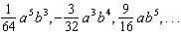?
1) | 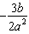
2)
3) | 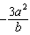
4) | 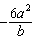

19 What is a common ratio of the geometric sequence whose first term is 5 and third term is 245?
1) | 7
2) | 49
3) | 120
4) | 240

20 The third term in a sequence is 25 and the fifth term is 625. Which number could be the common ratio of the sequence?
1)
2) | 5
3)
4) | 25

21 What is the common ratio of the geometric sequence whose first term is 27 and fourth term is 64?
1)
2)
3)
4)

1 ANS: 3 REF: 061001a2

2 ANS: 3
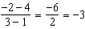

REF: 062223ai

3 ANS: 3
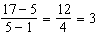

REF: 062215ai

4 ANS:
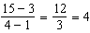

REF: 012328ai

5 ANS:
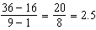

REF: 081630a2

6 ANS: 4 REF: 061411a2

7 ANS: 1

REF: 011401a2

8 ANS: 2 REF: 011610a2

9 ANS: 2 REF: 061919ai

10 ANS: 3 REF: 011110a2

11 ANS: 4 REF: 082419ai

12 ANS: 1
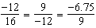

REF: 012017aii

13 ANS: 3 REF: 061910aii

14 ANS:
Yes, because the sequence has a common ratio, 3.

REF: 081726ai

15 ANS: 3
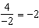

REF: 011304a2

16 ANS: 1
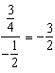

REF: 011508a2

17 ANS: 1
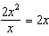

REF: 082202ai

18 ANS: 2
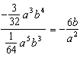

REF: 061326a2

19 ANS: 1
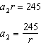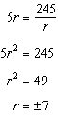

REF: 081924ai

20 ANS: 2
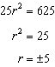

REF: 062412ai

21 ANS: 3
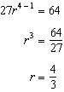

REF: 081025a2

