1 If , what are its domain and range?
1) | domain: ; range:
2) | domain: ; range:
3) | domain: ; range:
4) | domain: ; range:

2 What is the domain of ?
1)
2)
3)
4)

3 Which statement about the function 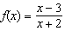 is true?
1) | Its domain does not include 2.
2) | Its domain does not include 3.
3) | Its range does not include 1.
4) | Its range does not include .

4 What is the domain of the function 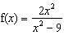?
1) | all real numbers except 0
2) | all real numbers except 3
3) | all real numbers except 3 and –3
4) | all real numbers

5 What is the domain of the function 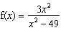?
1)
2)
3)
4)

6 The domain of the equation 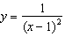 is all real numbers
1) | greater than 1
2) | except 1
3) | less than 1
4) | except 1 and

7 Which negative real number is not in the domain of 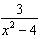?

8 What is the domain of the function 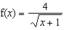 over the set of real numbers?
1)
2)
3)
4)

9 What is the domain of the function 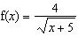 over the set of real numbers?
1)
2)
3)
4)

10 In the set of real numbers, what is the domain of 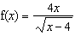?
1)
2)
3)
4)

11 For 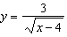, what are the domain and range?
1) | and
2) | and
3) | and
4) | and

12 What is the domain of the function 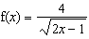 over the set of real numbers?
1) | 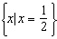
2) | 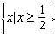
3) | 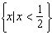
4) | 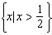

13 If 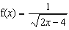, the domain of is
1)
2)
3)
4)

14 The domain of 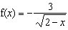 is the set of all real numbers
1) | greater than 2
2) | less than 2
3) | except 2
4) | between and 2

15 What is the domain of 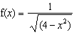?
1)
2)
3)
4) | all real numbers

16 In which function is the range equal to the domain?
1)
2)
3)
4)

1 ANS: 1 REF: 011313a2

2 ANS: 2
For real solutions, the expression under the radical must be greater than or equal to zero. 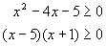. For the product of these two binomials to be positive, both binomials must be either positive or negative. 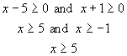 or 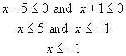. 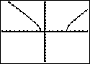

REF: 010218b

3 ANS: 3
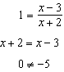

REF: 081623a2

4 ANS: 3
If x = 3 or -3, the denominator of the function is zero, which is undefined. 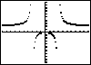

REF: 060407b

5 ANS: 2
If x = 7 or -7, the denominator of the function is zero, which is undefined. 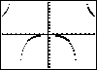

REF: 010504b

6 ANS: 2 REF: 069725siii

7 ANS:

REF: 010005siii

8 ANS: 4 REF: 068728siii

9 ANS: 1 REF: 010228siii

10 ANS: 4 REF: 010424siii

11 ANS: 1 REF: 011416a2

12 ANS: 4 REF: 080227siii

13 ANS: 4
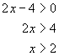. 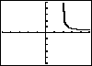

REF: 010314b

14 ANS: 2 REF: 011521a2

15 ANS: 3 REF: 069829siii

16 ANS: 4 REF: 088716siii

